Forum: Environment Commission
Issue: The use of nuclear energy as an alternative to fossil fuels
Student Officer: John Park
Position: Chair of Environment Commission

Introduction
Since the industrial revolution of the 19th century, fossil fuel has been a prominent source of energy. Despite its long-term use, it is not until recently that the dangers of fossil fuels have been addressed. Recent discoveries of the effects of greenhouse gases released from fossil fuel combustion show that the greenhouse gases cause the Earth to heat up. As Earth heats up, many consequences follow: melting of polar ice caps, changes in habitat leading to extinction, and extreme weather. To halt such consequences from being realised, the United Nations' sustainable development goals aim to achieve net zero carbon emissions by 2050. However, the goal of net zero emission seems far, and the possibility of nuclear energy replacing fossil fuels is being considered.
Nuclear energy is a widely used energy source with more than 400 active nuclear power plants. Although nuclear energy is very efficient, three major concerns remain: the radioactive waste material, the risk of a malfunctioning nuclear power plant, and the increased access to nuclear materials posing the possibility of them being used in weapon programmes. These issues pose a threat to the environment and the security of the globe. When unresolved, they could lead to similar consequences brought by fossil fuels. With these problems unresolved, the implementation of nuclear energy as an alternative to fossil fuels could pose a greater threat to the world than fossil fuels. Therefore, this report will assess the feasibility and challenges of implementing nuclear energy as an alternative energy source to fossil fuels.
Key definitions
Fossil fuel
An umbrella term for non-renewable energy sources such as coal, oil, and gas that release greenhouse gases after combustion.
Greenhouse gas
All gases that have the property of absorbing infrared radiation (heat energy) emitted from the Earth’s surface and reradiating it back to the Earth’s surface. Examples of greenhouse gases are carbon dioxide, methane, and water vapour.
Nuclear energy
A form of energy released from the nucleus, the centre of an atom. Energy can be released from either nuclear fusion or nuclear fission. However, for this issue, nuclear energy extensively refers to energy released from nuclear fission.
Nuclear fission
A reaction where a large nucleus of an atom splits into two or more smaller nuclei, releasing energy. The process is used in nuclear power plants, where radioactive isotopes uranium-235 or thorium-232 are used as fuel, in the form of nuclear fuel rods, lasting 3 to 8 years before needing replacement.
Radioactive waste (Nuclear waste)
Byproducts from nuclear reactors, fuel processing plants, hospitals and research facilities. They are classified into high-level waste and low-level waste. High-level waste is mostly the spent fuel from reactors: strontium-90, cesium-137, and plutonium 239. low-level waste is everything made from commercial uses of radioactive materials. High-level waste requires extensive care compared to low-level waste that can be disposed of in landfills without special treatment. High-level waste is generally put into deep geological disposal for long-term storage for radiation to wear down.
General Overview
Threats posed by fossil fuel
The combustion of fossil fuels generates greenhouse gases that are responsible for heating the Earth. This increase in temperature has many well-known consequences such as changing weather patterns, rising sea levels due to melting polar ice caps, loss of species, reduction in agricultural output, and many more. Some consequences are already being seen, Tuvalu, an archipelago nation in Oceania, has declared a project to create a metaverse copy of their government online due to rising sea levels threatening the existence of the nation. It is estimated that Tuvalu will be uninhabitable by 2100 with current rates of rising sea levels. Tuvalu is not the only nation that is threatened by rising sea levels, as 40% of the world’s population lives near the coast. Additionally, extreme weather events have become more common as a result of factors such as the disruption of polar jets that have retreated 2 kilometres northward every year since the 2000s.
Unstoppable increase in the usage of fossil fuel
In tackling carbon emissions, the primary goal is replacing the numerous power plants that burn fossil fuels to generate electricity. 73.2% of global greenhouse gas emissions come from using fossil fuels as energy, which means that decisive action needs to be taken to replace fossil fuels.
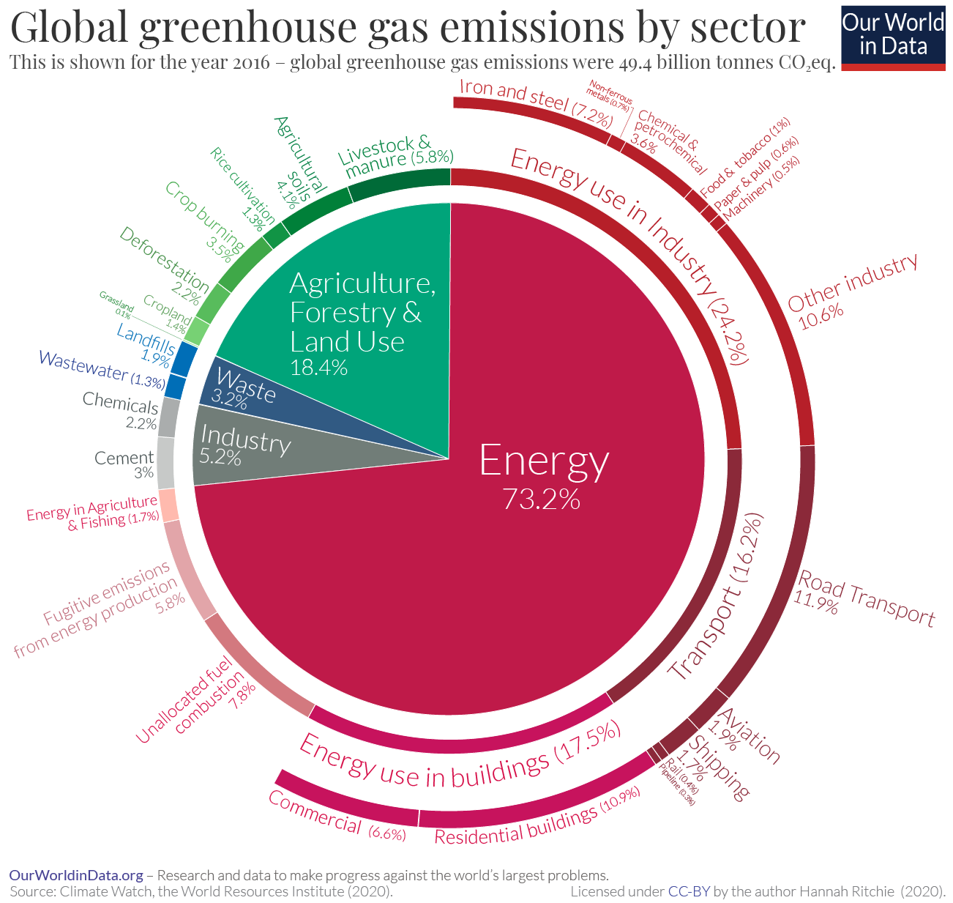
2016 greenhouse gas emissions, broken down by industry
Renewable energy
Renewable energy has been the traditional approach to combating fossil fuel usage. Since the 1990s, electricity production from renewable energy has doubled. However, renewable energy has not been able to replace fossil fuels, as fossil fuel usage has never seen a decline.
Solar
Solar energy is the third most prominent renewable energy, producing 4.5% of the world’s electricity. The most well-known type of solar energy is photovoltaic (PV) solar energy. As good as solar energy may sound, they have two major issues: PV waste and their inability to generate electricity at night. Photovoltaic cells are made of crystalline silicon that have a life span of about 30 years. They become unrecyclable waste after their use, which leads to the estimation that about 8 million tonnes of solar panels will become garbage by 2030 and 80 million tonnes by 2050.
Wind
Wind energy is the second largest renewable producer of electricity, producing 7.33% of the world’s electricity in 2023. Wind energy is estimated to have immense potential when placed offshore, collecting energy from the violent ocean winds. Wind energy is one of the least problematic of the three renewable energies introduced in the report, with its only problem being that it harms the natural landscape and needs to be in an area with strong wind, which is often far from rural areas that have the highest energy demand.
Hydro
Hydroelectric energy is currently the most widely used renewable energy in the world, generating 17% of the world’s electricity in 2020. Currently, hydro energy is contributing 50% more than nuclear energy in terms of global electricity production. Hydroelectric power works by spinning a turbine by flowing water from a higher area to a lower area; this process requires a dam to collect water from a river. Dams have many positive uses for humans as they reserve water in case of a drought or other instances. However, they have detrimental effects on the river, blocking water from flowing downstream.
Nuclear Energy
Nuclear energy was first used in a power plant in 1954, in the USSR. Since then, nuclear energy has taken off, with 440 nuclear power plants spread around more than 30 countries. Nuclear power plants produce about 10% of the world’s electricity. Nuclear energy is an efficient source of energy; a pill-sized uranium pellet generates energy equivalent to a tonne of coal. However, with great power comes great risks, as nuclear power brings three significant risks: nuclear waste, nuclear disasters, and the spread of nuclear weapons.
Nuclear waste
Contrary to some beliefs, nuclear fuel is not eternal; it does run out eventually. When nuclear fuel is spent, it creates a dangerous high-level waste that requires extensive care when storing and disposing. Currently, some 30 nations have adopted nuclear energy in producing electricity. Among these 30, none have been able to decide a final destination for spent nuclear fuel, storing them in facilities near the powerplant they were used in. If nuclear fuel is used at the same or greater magnitude than today, a permanent solution for nuclear fuel rods is essential.
Nuclear disaster
Throughout the use of nuclear reactors, there have been two major failures in nuclear power plants: the Chornobyl disaster of 1986 and the Fukushima nuclear accident of 2011. The Chornobyl disaster was a result of flawed design and inadequately trained personnel, while the Fukushima accident was due to a 15-metre tsunami disabling the power and cooling for the three Daiichi reactors. The fatalities due to these incidents are –surprisingly- 1 for Fukushima and 31 for Chernobyl. The unbelievably low figures are partly due to difficulties in tracking deaths from radioactive contaminants from nuclear fallout.
Price of nuclear reactors
Nuclear reactors are not cheap machines; they require significant funds and technology to construct, maintain, and disassemble. Nuclear power plants cost $5,500 to $8,100 per kilowatt of energy that the plant intends to produce, while fossil fuel plants' construction costs range from about $1,000 to $4,500 per kilowatt of energy they intend to produce. For less economically developed nations (LEDCs) there is little incentive to adopt nuclear power over fossil fuels, as nuclear power is a more expensive alternative. Additionally, decommissioning nuclear power plants is an expensive issue. In the case of Germany’s Brokdorf, Grohnde, and Gundremmingen, each plant is expected to cost $1.25 Billion and take about 20 years to decommission.
Weaponisation of nuclear energy
The world has always been alerted to nuclear arms programmes. As of today, efforts have been successful, to an extent, in stopping several nuclear bomb projects. When considering the expanded use of nuclear energy, the risk of expanded accessibility of nuclear material cannot be neglected. Current procedures ensure that nuclear materials are being used for peaceful purposes. However, increasing nuclear power plants to such a scale that they cover global energy demands could cause failure in current measures. Considering the factors needed for creating a nuclear bomb, a few points can be used to stop such development: nuclear raw material, uranium enrichment technology, and researchers. Nuclear raw material is self-explanatory, as no weapon-grade uranium or plutonium would mean no nuclear weapons. Uranium enrichment technology is also a part of obtaining weapon-grade uranium or plutonium, as these isotopes have to be separated from other substances for high-purity uranium or plutonium suited for a chain reaction in a nuclear bomb. Finally, stopping researchers who may contribute to such weapons programmes is the last possible measure, as stopping key individuals from joining the weapons programme can cause severe drawbacks for the programme.

Major Parties Involved
International Atomic Energy Agency (IAEA)
An autonomous organisation within the UN, the IAEA is an organisation seeking to promote peaceful use of atomic energy. The IAEA is responsible for ensuring nuclear safety; they provide guidelines and standards for nuclear safety in nuclear power plants. It makes efforts for nuclear energy to be adopted as a part of the efforts to achieve net zero carbon emissions. Additionally, the IAEA has the authority to monitor research and development of nuclear technologies; uranium and thorium production, irrelevant of whether they are traded or not; and nuclear-related imports and exports. Using these authorities, the IAEA makes sure nuclear materials are being used for peaceful purposes.
World Nuclear Association
World Nuclear Association is an international organisation that promotes the use of nuclear energy. It has 44 member nations, spanning different continents. The association has members that take part in every step of nuclear energy from mining uranium to running power plants. The association takes part in policies and technical areas of nuclear energy. It is the founder of Net Zero Nuclear: the movement supporting tripling nuclear energy by 2050 to achieve net zero emissions.
European Union (EU)
The EU is a political and economic union with 27 members. A quarter of the EU’s electricity is provided through nuclear energy. Due to their member states’ high dependency on nuclear energy, the EU defines nuclear energy as a ‘low carbon alternative’ that they can utilise to meet their climate goal for 2050: net zero carbon emissions.
Greenpeace
Greenpeace is an international non-governmental organisation (NGO) that fights against the climate crisis and protects the environment. Greenpeace is against nuclear energy, as they believe that nuclear energy poses an unacceptable risk to the environment and humanity.

Relevant Treaties
The Declaration to Triple Nuclear Energy Capacity by 2050 is a declaration made by more than 20 countries during the 28th Conference of Parties (COP28), November 30th-December 12th, 2023. It recognises nuclear energy as a key factor to achieving net zero carbon emissions; to achieve this, several nations-namely America, Japan and the UK-have agreed to triple energy output from nuclear energy by 2050. The initiative urges member nations to further develop and enhance nuclear technology and widen the use of nuclear power plants in their energy policies. The declaration joins hands with the IAEA and various energy companies to realize its goals. As the declaration was made very recently, the effects of the declaration are yet to be seen.
Timeline of Events
Date | Description of event
December 1938 | Discovery of nuclear fission
27th June 1954 | First commercial nuclear power plant started operating in Obninsk, USSR
26th April 1986 | Chernobyl disaster
21st March 1994 | First global treaty tackling climate change signed by 197 nations.
11th December 1997 | Kyoto Protocol was adopted; it ensured industrialised nations to limit and reduce greenhouse gas emissions.
11th March 2011 | Fukushima Nuclear Accident: scepticism towards atomic energy grew.
4th November 2016 | Paris Climate Accords (Paris Agreement) enters force; 195 parties sign the agreement agreeing to limit climate change to 1.5 degrees Celsius above preindustrial levels.
2020 | The COVID pandemic decreases carbon emissions for the first time since the Industrial revolution
6th to 20th November 2022 | The Atoms4NetZero initiative was launched by the IAEA during COP27. With the aim of using nuclear energy as a replacement for fossil fuels.
2nd December 2023 | Declaration to triple nuclear energy by 2050, agreed by more than 20 nations.
Previous Attempts to Resolve Issue
France
France –though not initially intended- has been able to combat carbon emissions by replacing fossil fuels with nuclear energy. Subsequent to the oil crisis of the 1970s, France engaged in a large-scale buildup of nuclear power plants in the 1970s to ensure that they had a secure source of energy that was not influenced by foreign powers. This led to a great increase in energy production, which meant that the French did not need to increase their fossil fuel usage. Despite the success of nuclear energy for France, they are experiencing problems of implementing nuclear energy; in 2022, France experienced a 24% decline in nuclear energy production due to ageing reactors.
Onkalo, Finland
The Onkalo spent nuclear fuel repository is Finland’s solution to one of the issues of nuclear energy. Onkalo is the first long-term spent nuclear fuel repository in the world, planned to store spent nuclear fuel for 100,000 years, 520 metres underground. The storage is expected to be able to accept spent fuel canisters for 100 years. The bill for the project comes at about 818 million euros (6,350,000,000 yuan).
Possible Solutions
Changing to nuclear power plants and decommissioning fossil fuel plants
Assuming that nuclear energy is being implemented, the first step is to provide sufficient funding for the change. For most countries that have public energy companies, the change is a matter of introducing plans for new nuclear power plants and increasing government funds for new nuclear power plants. Current plans for expanding fossil fuel plants wouldn’t have to be cancelled, however, it is most likely that all new power plant plans will have to be nuclear or other renewables.
Establishment of long-term nuclear waste storage
Like the case of Onkalo, deep geological storages are the most prominent solution to spent nuclear fuel. Urging construction and plans for such facilities may not be feasible for some nations due to geographical restraints. To ensure all nuclear waste is handled safely, organising a system for borrowing other countries’ storage for monetary compensation could be considered.
Strengthen safety procedures and regular checks for nuclear power plants
To prevent a disaster like the two previous nuclear disasters, tighter and more universal safety measures would have to be implemented. These could come in the form of regular checks of nuclear power plants by the nations running the facility and reporting to the IAEA.
Establish training programmes for nuclear power plant workers
For nations with no prior experience in running a nuclear power plant, programmes to aid in educating workers will be necessary. This could be organised with the assistance of the IAEA or other nations that have experience operating a nuclear power plant sending professionals.
Establish a long-term plan for converting to renewable energy
Nuclear energy is not the long-term solution to achieving net zero emissions. It is most likely going to serve as a stepping stone to converting to renewables; therefore, sufficient planning has to be implemented to replace nuclear reactors when they reach their life span, of 40 to 60 years.
Research Guide
Additional research
A good place to start research is by learning how nuclear power plants work. After that, research could be on topics such as alternative methods of reducing fossil fuel usage, efforts that have been made to reduce fossil fuel, and technology that could help resolve the issues at hand. When researching for preambulatory resolutions, try searching for past efforts at tackling the issue that is being resolved; for example, the Nuclear Proliferation Treaty (NPT) trying to stop the weaponisation of nuclear energy.
Country’s stance
Relevant treaties
To find your nation’s stance on this topic, the first step is to check if they are a part of the 25 nations that agreed to the Declaration to Triple Nuclear Energy Capacity by 2050. If they are a part of the 25 nations, it is the most explicit evidence that they are in support of using nuclear fuel to replace fossil fuels.
Official statements
Official statements by your country’s energy ministry may help. Try searching for your country’s opinion on nuclear energy and their stance on fossil fuels, search ‘[country name]’s views on nuclear energy’. Assessing their opinion of the two may help you grasp an understanding of the country’s stance on the motion.
Other factors
When the opinion of the country cannot be found, assess factors such as the dependency of the country on nuclear energy, search ‘how much is nuclear energy used in [country name]’; level of economic development; and the stance of the ruling party or ruler of your nation, search for the ruling party or ruler first then search ‘[party name/ruler]’s views on nuclear energy’. Also, you can check for ongoing construction of nuclear power plants and future plans for nuclear power plants in the country, which could indicate that the country is keen to accept nuclear energy over fossil fuel.

Bibliography
“Annual Percentage Change in Fossil Fuel Consumption.” Our World in Data, ourworldindata.org/grapher/annual-percentage-change-fossil-fuels?time=latest. Accessed 18 Dec. 2023.
“Atoms4NetZero.” IAEA, IAEA, 4 May 2023, www.iaea.org/atoms4netzero.
“Backgrounder on Radioactive Waste.” NRC Web, www.nrc.gov/reading-rm/doc-collections/fact-sheets/radwaste.html. Accessed 16 Dec. 2023.
BBC News. “Why Is Egypt Worried about Ethiopia’s Dam on the Nile?” BBC, 13 Sept. 2023, www.bbc.com/news/world-africa-66776733.
“Causes and Effects of Climate Change.” United Nations, United Nations, www.un.org/en/climatechange/science/causes-effects-climate-change. Accessed 30 Dec. 2023.
“Chernobyl Disaster.” Chernobyl | Chernobyl Accident | Chernobyl Disaster - World Nuclear Association, world-nuclear.org/information-library/safety-and-security/safety-of-plants/chernobyl-accident.aspx. Accessed 19 Dec. 2023.
“Chernobyl Disaster.” Wikipedia, Wikimedia Foundation, 12 Dec. 2023, en.wikipedia.org/wiki/Chernobyl_disaster.
“Enriched Uranium.” Wikipedia, Wikimedia Foundation, 14 Dec. 2023, en.wikipedia.org/wiki/Enriched_uranium#:~:text=There%20are%20currently%20two%20generic,of%2020%22%20more%20efficient).
Extreme Weather | Facts – Climate Change: Vital Signs of the Planet, climate.nasa.gov/extreme-weather/. Accessed 1 Jan. 2024.
“Fossil Fuels.” Our World in Data, 3 Dec. 2023, ourworldindata.org/fossil-fuels.
Gross, Samantha. “Why Are Fossil Fuels so Hard to Quit?” Brookings, 26 Oct. 2023, www.brookings.edu/articles/why-are-fossil-fuels-so-hard-to-quit/.
“How Hydropower Works.” Energy.Gov, www.energy.gov/eere/water/how-hydropower-works. Accessed 3 Jan. 2024.
“Iea. “Executive Summary – Hydropower Special Market Report – Analysis.” IEA, www.iea.org/reports/hydropower-special-market-report/executive-summary. Accessed 3 Jan. 2024.
“Iea. “Solar.” IEA, www.iea.org/energy-system/renewables/solar-pv. Accessed 1 Jan. 2024.
“International Atomic Energy Agency.” Wikipedia, Wikimedia Foundation, 13 Nov. 2023, en.wikipedia.org/wiki/International_Atomic_Energy_Agency.
“Joint Convention on the Safety of Spent Fuel Management and on the Safety of Radioactive Waste Management.” IAEA, IAEA, 25 July 2014, www.iaea.org/topics/nuclear-safety-conventions/joint-convention-safety-spent-fuel-management-and-safety-radioactive-waste.
“Managing Spent Nuclear Fuel Rises on Global Agenda.” IAEA, IAEA, 4 July 2006, www.iaea.org/newscenter/news/managing-spent-nuclear-fuel-rises-global-agenda.
“Managing Spent Nuclear Fuel: Global Overview.” IAEA, IAEA, 25 July 2014, www.iaea.org/newscenter/focus/radwaste-management/managing-spent-nuclear-fuel-global-overview.
Mark Peplow, special to C&EN. “Solar Panels Face Recycling Challenge.” Chemical & Engineering News, American Chemical Society, 25 Mar. 2023, cen.acs.org/environment/recycling/Solar-panels-face-recycling-challenge-photovoltaic-waste/100/i18.
“Nuclear Energy in the EU.” ENSREG, www.ensreg.eu/members-glance/nuclear-eu#:~:text=It%20is%20the%20responsibility%20of,all%20electricity%20in%20the%20EU. Accessed 19 Dec. 2023.
“Nuclear Fuel.” Nuclear Energy Institute, 1 Apr. 2020, www.nei.org/fundamentals/nuclear-fuel.
“Nuclear Power Plant Construction Costs - July 2008 - Synapse Energy.” www.synapse-energy.com/sites/default/files/SynapsePaper.2008-07.0.Nuclear-Plant-Construction-Costs.A0022_0.pdf. Accessed 20 Dec. 2023.
“Nuclear Power Plants Generated 68% of France’s Electricity in 2021.” Homepage - U.S. Energy Information Administration (EIA), www.eia.gov/todayinenergy/detail.php?id=55259#:~:text=Although%20France’s%20first%20commercial%20nuclear,significant%20share%20of%20France’s%20electricity. Accessed 20 Dec. 2023.
“Nuclear Proliferation.” Wikipedia, Wikimedia Foundation, 29 Nov. 2023, en.wikipedia.org/wiki/Nuclear_proliferation#Additional_Protocol.
“Only 11 Years Left to Prevent Irreversible Damage from Climate Change, Speakers Warn during General Assembly High-Level Meeting | UN Press.” United Nations, United Nations, press.un.org/en/2019/ga12131.doc.htm. Accessed 18 Dec. 2023.
“Onkalo Spent Nuclear Fuel Repository.” Wikipedia, Wikimedia Foundation, 29 Dec. 2023, en.wikipedia.org/wiki/Onkalo_spent_nuclear_fuel_repository.
“Photovoltaics and Electricity - U.S. Energy Information Administration (EIA).” www.eia.gov/energyexplained/solar/photovoltaics-and-electricity.php#:~:text=Photovoltaic%20cells%20convert%20sunlight%20into,or%20particles%20of%20solar%20energy. Accessed 1 Jan. 2024.
“Plans for New Nuclear Reactors Worldwide.” Plans for New Nuclear Reactors Worldwide - World Nuclear Association, world-nuclear.org/information-library/current-and-future-generation/plans-for-new-reactors-worldwide.aspx#:~:text=Today%20there%20are%20about%20440,10%25%20of%20the%20world’s%20electricity. Accessed 18 Dec. 2023.
Published by Lucía Fernández, and Jul 24. “Global Wind Energy Share in Electricity Mix 2022.” Statista, 24 July 2023, www.statista.com/statistics/1302053/global-wind-energy-share-electricity-mix/#:~:text=Wind%20energy%20sources%20accounted%20for,percent%20share%20a%

