Forum: Environment Commission
Issue: Measures to mitigate the effects of climate change in LEDCs
Student Officer: A Jin Chang
Position: Chair of Environment Commission

Introduction
Climate change is one of the biggest challenges that humanity is facing, and it is an issue that everyone is involved. According to the Intergovernmental Panel on Climate Change (IPCC), it is said that the climate change of the last 50 years is attributable to humans. The main cause of climate change is due to greenhouse gas emission, which involves burning fossil fuels, human land use, and many more. This leads the global temperature is rise, which leads to devastating impacts to the environment and humanity such as: increased number of natural disasters, health risks, loss of species, sea level rise, etc. Despite many member states are investigating methods to mitigate the effects of climate change, National Oceanic and Atmospheric Administration (NOAA) presents in November 2023, the global surface temperature was 1.41°C, which is +0.39°C above the previous record from 2015. Like this, the climate of Earth is increasing rapidly, and the side effects of temperature increase is becoming more significant and permanent. Due to this temperature anomalies, the consequences have followed, which are shown by the statistics of 18 severe storm events, 1 tropical cyclone event, 1 wildfire event, 1 winter storm event only in 2023. According to Global Carbon Atlas as of 2021, More Economically Developed Countries (MEDCs) such as China, U.S, and India together produces half of the world’s carbon dioxide, whereas the rest of the world including the Less Economically Developed Countries (LEDCs) only contribute to 21.7% of greenhouse gas emission. Despite are low carbon emitters, they are more vulnerable in its effect compared to MEDCs. This is an irony because LEDCs emit less carbon dioxide compared to MEDCs, however LEDCs are the ones who are heavily affected by the consequences of climate change. Since LEDCs have lacking technology, infrastructure, and are highly dependent on agriculture sector, climate change’s effect on these countries is tremendous. Therefore, it is crucial for the Environment Commission to devise effective and pertinent solutions that will mitigate the effects of climate change to the LEDCs to support every member state and individual who are especially vulnerable to the effects of climate change.
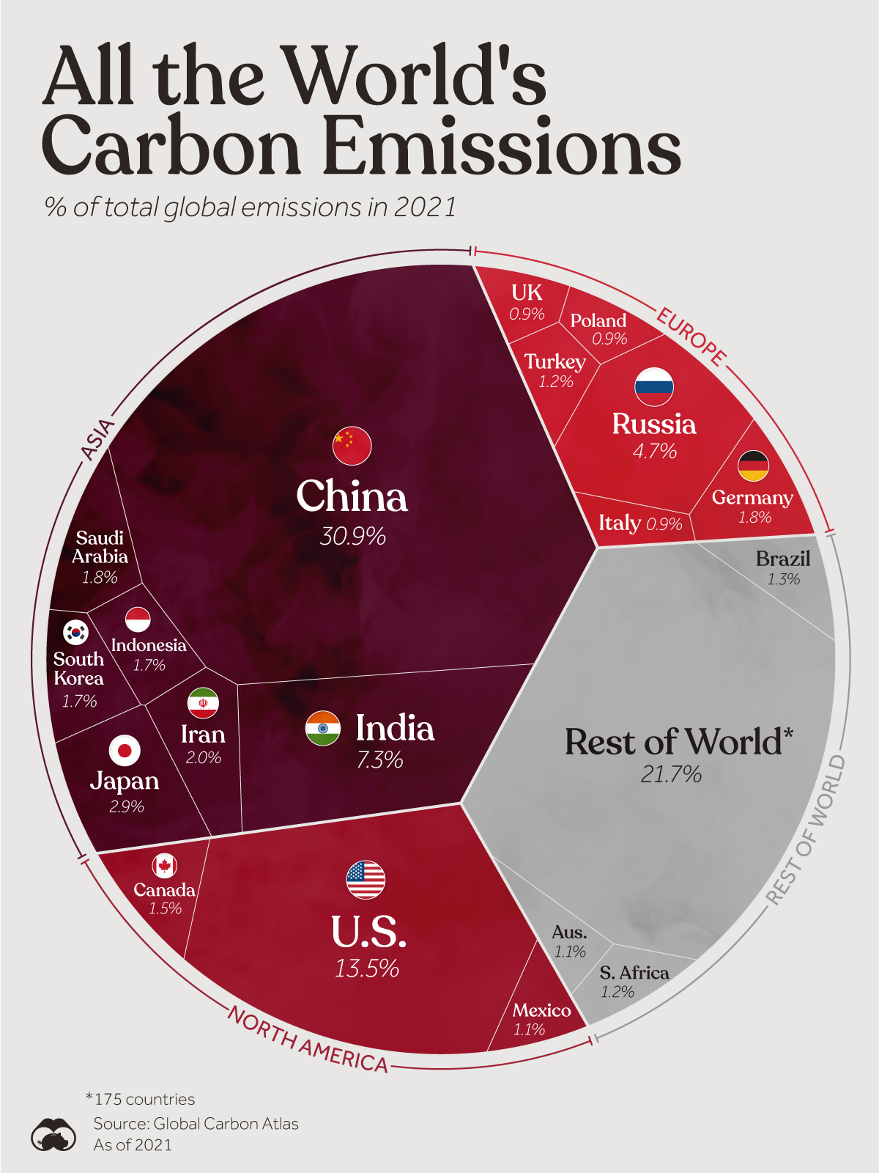
Caption 1: All the World’s Carbon Emitters represented in a sector

Definition of Key Terms

Climate Change
Climate change refers to long term shifts in temperatures and weather patterns. These shifts may be natural, however since 1800s, human activities have been a major shifter to climate change.
LEDCs
LECDs refer to less economically developed countries and are countries that are highly vulnerable to economic and environmental shocks. There are 49 LEDC countries recognized by the UN, and in order to be considered as a LEDC country, the Gross Domestic Product (GDP) should be less than $900, low levels of capital, human and technological development.
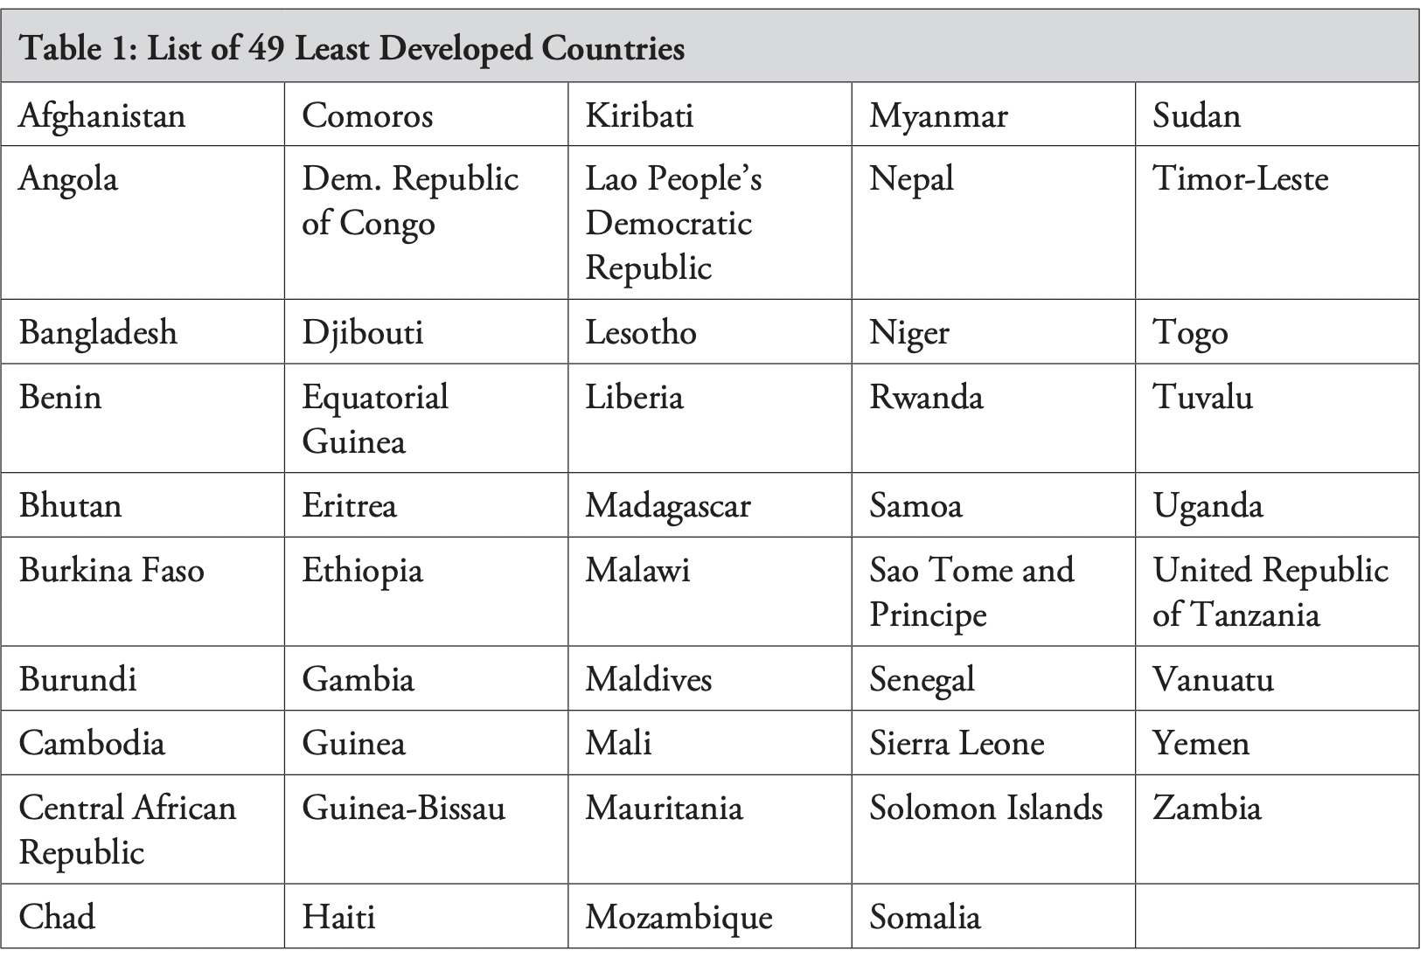

General Overview

Causes of Climate Change
Climate change has been caused by various human activities since 1800s after the Industrial Revolution as people started to heavily burn fossil fuels, as well as other factors such as cutting down forests, transportation, producing food and overconsuming. These human activities will emit greenhouse gas, which involves carbon dioxide and methane, and this emission will create an outer layer that surrounds the Earth, trapping the sun’s heat and ultimately raising temperatures. According to research presented by the United Nations (UN), burning fossil fuels are the biggest contributor to climate change. Moreover, the emission of greenhouse gas accounts nearly 90% of the carbon dioxide emissions. Generating power is one of causes to greenhouse gas emission. Although many countries are adapting to utilizing sustainable energy, majority of the countries generate electricity through burning coal, oil, or gas, which creates toxic carbon dioxide and nitrous oxide. Furthermore, manufacturing goods are considered as a significant contributor to greenhouse gas emission. Majority of the factories burn fossil fuels to produce cement, iron, steel, electronics, plastics, clothes etc. Therefore, this makes the manufacturing industry the largest contributor to greenhouse gas emission worldwide. As well as this, cutting down forests causes emissions since trees emit the carbon dioxide that they have been storing when they are cut.

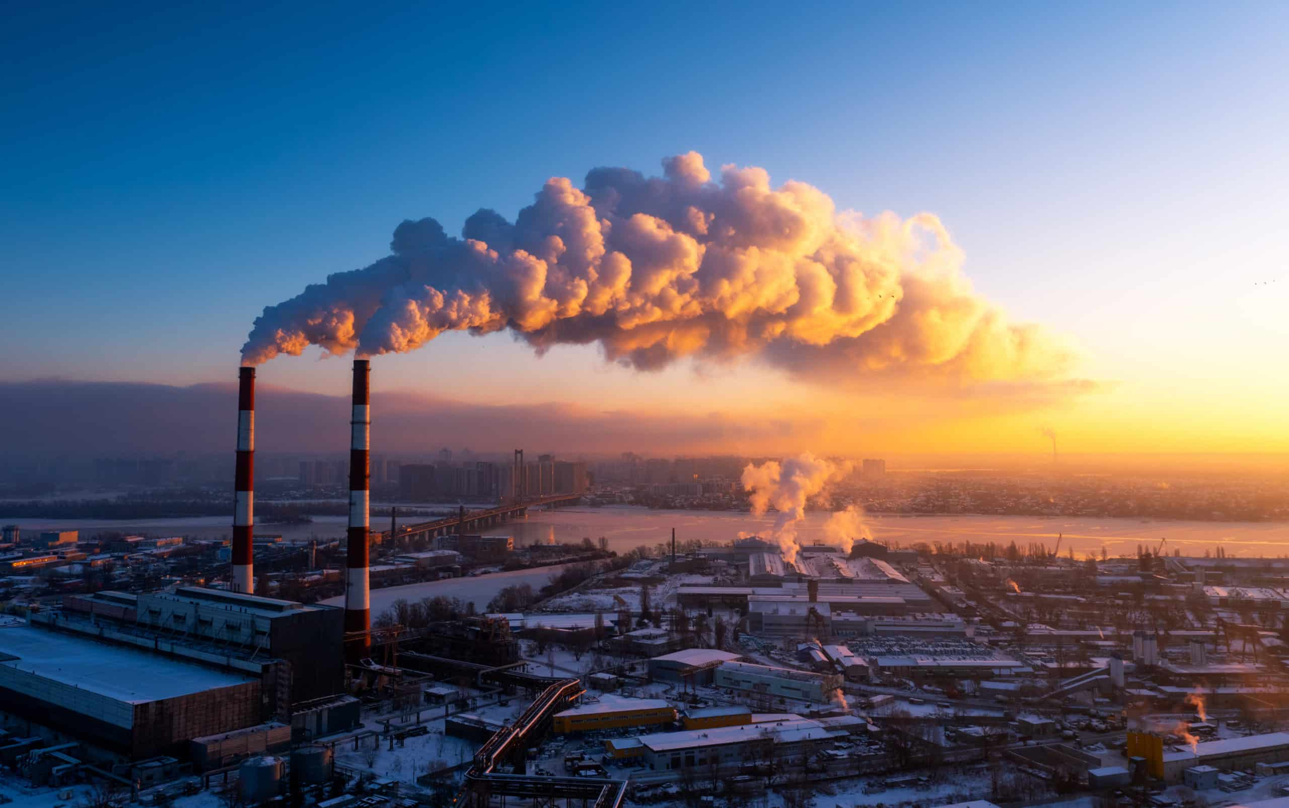

Caption 2: Greenhouse has emitting from factories

Struggle of LEDCs to tackle Climate Change

One of the biggest reasons why LEDCs are struggling to mitigate the impacts that climate change has on the country is due to the lack of finance and technological development. Since LEDCs have constrained finance due to various reasons like low GDP, high debt burdens, their main priority is shifted to healthcare and education, which leads to LEDCs not prioritizing environmental concerns. Although many MEDCs such as Germany implement carbon tax according to how much a firm emits greenhouse gas to mitigate problems rising from climate change, the finance needed for managing and monitoring these environmental policies are too high, therefore LEDCs cannot afford implementing policies or practices towards mitigating the issue of climate change. Moreover, LEDCs have lack of expertise and research to investigate in renewable energy sources and waste management. Therefore, in the long-term, if LEDCs continue to onlook the issue of climate change instead of coming up with practices, it will be harder for them to recover from the devasting effects of climate change.

Effects of Climate Change on LEDCs

Extreme Weather Events

Climate change cause extreme and unpredictable weather events. One of the examples is hurricanes, because as the global temperature rises, these storm systems draw their energy from warm ocean waters. In 2017, Hurricane Maria has devasted an entire island of Puerto Rico. This led to majority of the residents to having lack of electricity and water supply. It has been 6 years since the hurricane has occurred, however, Puerto Rico is still in its recovering process due to the permanent effect the hurricane left to the countries’ infrastructure and place of residence. Moreover, as the sea levels rise due to climate change, due to melting of glaciers and ice caps, has caused the sea level to increase by 8 inches in the last 150 years. The Gulf of Mexico and Atlantic coast of United States are severely affected by experiencing heavy rainfall leading to catastrophic flooding, which leads to deaths and loss of homes. These unpredictable and ruinous weather events have been happening frequently around the world, and these are brining long-term detriment, especially to the LEDCs.

Environmental and Socio-Economic Vulnerabilities

Majority of the LEDCs are part of the Sub-Saharan Africa region, and for the past few decades, they have been struggling through severe drought. However, in countries like Nepal, have been dealing with severe flooding due to melting of glaciers. It is predicted that the changes in Africa’s precipitation will affect the levels of water storage in lakes and reservoirs. The lack of water is a challenge to the agriculture sector of LEDCs. Water is needed for the process of agriculture, but with climate change, it will cause drought and impact the soils and land, therefore the length of growing seasons and yield potential will decrease. Since LEDCs are highly dependent on food and agricultural production for their economic growth, these challenges will affect the GDP and economic well-being of the citizens. Furthermore, LEDCs are vulnerable to spreading of diseases due to the lack of technological health development. The UN has assessed that the spreading of Malaria will increase as temperatures become more warmer since warmer temperatures can shorten the time for mosquitoes to develop from larvae to adults. Even more, the increase in temperature and changes in rainfall patterns are predicted to increase vector-bones diseases in Asia, which will lead to serious human health implications.

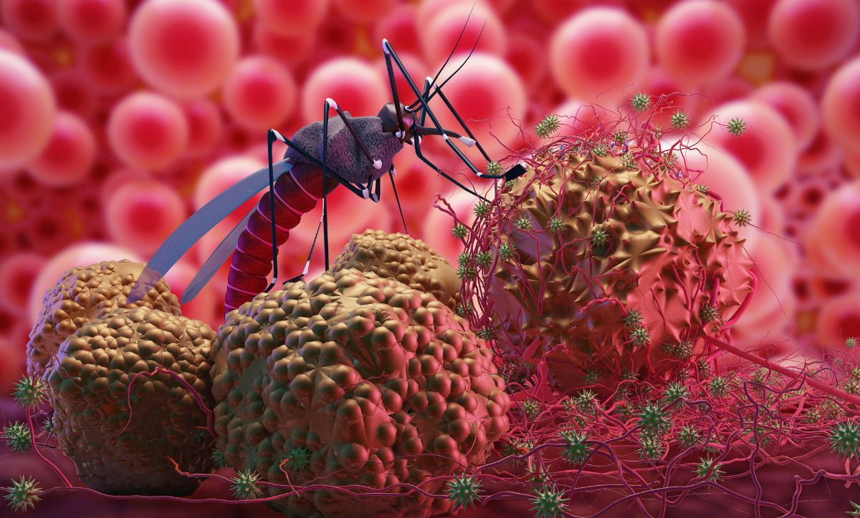

Caption 3: Malaria infection

Major Parties Involved

Small Island Developing States (SIDS)
As mentioned above, Sub-Saharan Africa is one of the regions that is significantly affected by climate change. However, Small Island Developing States (SIDS) such as Maldives, Kiribati, and Tuvalu are especially vulnerable, since these countries are located by the sea. Hence, as the sea level rise, they have a higher risk of facing natural disasters which may lead to harms to citizens, widespread destruction, population displacement, and even making efforts towards sustainable development futile.

Green Climate Fund (GCF)
Green Climate Fund is a financial mechanism established under the United Nations Framework Convention on Climate Change (UNFCC), to support climate related programs in LEDCs. It has been established as a global commitment in 2020 with $100 billion per year. These funds are mainly used for supporting LEDC’s usage of sustainable resources and energy. Furthermore, they design, implement, and manage climate projects according to the country’s need. For instance, in 2022, GCF has supported the climate project for Zambia for increasing private sector investments to renewable sources to reduce greenhouse gas emission. Moreover, in Bangladesh, GCF provided financial support to rebuild the infrastructure, early warning systems to recover and prevent the effect from extreme weather events.

World Health Organization (WHO)
The World Health Organization (WHO) is playing a significant role to manage and control the spreading of malaria. They consistently monitor the number of malaria cases, as well as identifying hotspots then assigning doctors and healthcare workers to support the LEDC citizens suffering through malaria. Even more, they have campaigns and hold frequent community projects to help the citizens to recognize the severity of malaria even to the people who have access to lower education. WHO is currently continues to investigate vaccines and medical treatment for those patients and to prevent the spreading of diseases.

Climate Action Network (CAN)
Climate Action Network is a global network that includes more than 130 countries to drive collective and sustainable action. Their main focus is centering people and climate impacts, through spreading awareness by sharing the stories of those who have been impacted by climate crisis; ending fossil fuels, stropping fossil fuel companies; transformative national climate action plans, support governments to keep global warming below 1.5 degrees Celsius; and multilateral action and advocacy, pushing for political outcomes to ensure climate safe future.

UN Involvement, Relevant Resolutions, Treaties and Events
The UN is fully aware of the effects that climate change has on the LEDCs and their vulnerability, therefore they are making significant involvement to address this issue. Firstly, the UN had started the United Nations Framework Convention on Climate Change (UNFCC) in 1992 to stabilize greenhouse gas concentrations. Then in 1994, more countries started to join the UNFCCC, which was the formal beginning of the treaty. Kyoto Protocol was adopted in 1997 for helping emission reduction for LEDCs, and suggested methods such as emissions trading, clean development mechanism, and joint implementation which is especially beneficial and feasible for LEDCs. Furthermore, by 2015, UNFCCC adopted a legally binding international treaty on climate change known as Paris Agreement; it was adopted by 196 countries in 2015 including the LEDCs. It is significant because it has been the first collective approach to combat climate change and adapt its effects. Moreover, UN crisis relief is run by UN Office for the Coordination of Humanitarian Affairs (OCHA). The UN crisis relief aims to help people when crisis strikes. The most recent conference held by UNFCCC was in November and December of 2023. They announced new funding arrangement for responding to loss and damage, which will help mitigate the effects of climate change to LEDCs.

Timeline of Events
Date | Description of event
May 9th, 1992 | UNFCCC Founded
March 21st, 1994 | Countries join the UNFCCC
December, 1997  December, 2015  12 December 2023 | Adaptation of Kyoto Protocol  Paris Agreement  COP 28- UN Climate Change Conference

Previous Attempts to Resolve the Issue

Previous attempts to mitigate the effect of climate change to LEDCs are listed below.

United Nations Office for Disaster Risk Reduction (UNDRR) has stated that LEDCs only contribute to 1% of the world’s greenhouse gas emission, but they experience the most consequences of climate change. According to UNDRR, 70% of the causes of death in LEDCs are due to climate disasters over the 50 years. UNDRR suggests that these effects have an impact on LEDC’s economy around 10 times worse than MEDCs, which is shown through GDP rates; In 2021, there was 8.5 million people living in LEDCs who were displaced. Therefore, UNDRR has relevant and adequate solutions to resolve this issue. In June 2021, ECOSOC has created a resolution that recognized the severe impacts of climate change that have on LEDCs. This resolution’s main purpose was to support and development partnership between MEDCs and LEDCs for disaster risk reduction. Furthermore, Doha Programme of Action, including methods for reducing risks and building resilience for natural disasters is attempting to be put all LEDCs on the path to graduation from category by 2030. This Doha Programme of Action investigates to build resilient infrastructure, develop pre-warning systems and evacuation plans that governments can follow and adapt.

Additionally, many Non-Governmental Organizations (NGOs) such as The Red Cross helps LEDCs to recover from damaged caused by natural events. They support citizens who need shelter, meals, and even financial aid. More NGOs like Habit for Humanity, Registered Engineers for Disaster Relief (REDR), GlobalGiving, etc actively engage to rebuild the infrastructure, homes, and communities that were destroyed due to natural disasters.

Even more, many MEDCs are willing to share sustainable technology to the LEDCs. Denmark, known for their expertise in wind energy, has helped SIDS such as Fiji and Tonga to develop wind power projects. Moreover, United Kingdom offers training programs to many African countries to train local technicians and engineers to start using solar system, allowing for sustainable energy solution. Especially the European Union (EU) frequently collaborate with African countries through providing possible policy, and financial support to encourage sustainable energy. This would help to prevent the devasting effects of climate change in the long-term.

Possible Solutions

One possible solution to mitigate the impacts of climate change to LEDCs can be to encourage partnership with MEDCs and LEDCs. As mentioned above, collaborating, and receiving advice from how MEDCs are approaching to resolve the issue of climate change can be helpful for LEDCs to develop their sustainable technology. Through holding biannual conferences with the help of UN, may help LEDCs to gain the technology and initiative to use of renewable energy (from burning fossil fuels to using wind and solar energy). Certain expertise, such as engineers and technicians may hold a workshop to educate the locals to start using sustainable energy solutions. MEDCs may also provide possible suggestions of policies such as carbon tax that LEDCs can implement to encourage their approach to emitting less greenhouse gas emission.

Since LEDCs are especially vulnerable to natural disasters, building sustainable and resilient infrastructure, developing pre-warning systems and forming evacuation plans. To make these possible, there should be expertise from every field, such as emergency management specialists, urban planners and engineers, geographers, community leader etc. Since these solutions require extreme level of detail, knowledge, and time, LEDCs may lack the finance to do so. Therefore, they may seek help by recruiting experts from NGOs, or even other UN member states. Another way can be to seek help in the financial aspect.

Because the effects of climate change negatively impact the economy of the country, it is important that LEDCs can maintain agriculture (which is their main economic sector) and is able to recover quick when there is a natural disaster. The government may implement policies to cultivate variety of crops that will prevent complete crop failure during disasters. Moreover, the government could pay more attention to implementing crop insurance schemes and enhance risk management. This can be done by the NGOs if LEDCs lack the finance to implement and monitor these insurances. Early warning systems would allow protection of agriculture, such as timely harvest or moving livestock. Hence, if all the solutions that were mentioned previously is carried out, it would be extremely helpful to mitigate the impact of climate change to the countries.

Research Guide
In order to ensure that delegates conduct their own research, student officers are required to provide a guideline for delegates on how to engage in further information collection. For this section, you can reference the ‘How can you find out more about your country and its position on this?’ component on this sway document.

To ensure that delegates conduct their own research, the Chair will provide relevant sources that will help with coming up with a resolution. Note that delegates should conduct individual research for their own country’s position on the issue at hand.

First, begin with basic search terms. Delegates may type in the search bar: “[Country Name] position on the issue”. This can help you find direct statements or official positions. Then, you can explore news article. You can just type in your country with the issue and add news to access relevant news that were published about the country’s involvement. Some reliable news websites are BBC, The Guardian, New York Times, Politico, etc.

To deepen your understanding, you may search for diplomatic speeches and voting patterns for this issue, and dive into scholarly analysis. Remember to check the date so that delegates know the source is not too outdated and is still relevant to present. If delegates take notes and summarize the findings through research, it will be much easier for gaining the knowledge about the country’s position and even give a better idea on how to start planning for the resolution. (If delegates feel that the information is too difficult to understand, use Diffit to change information to cater to different reading levels!)

Remember that Preambulatory clauses are based on information that highlights the significance of the issue, therefore the information should be from reliable sources. You can reference the information from news article throughout your research process or can use the sources I have included for the bibliography. For operative clauses, you can get some general ideas by reading the last few sections of the chair report. However, you need to conduct your own research to come up with high quality, and feasible solutions. It is also possible to research on the UN website the document that involves resolutions on how countries are dealing with natural disasters, and how green energy is being encouraged among countries to prevent the effect that LEDCs experience from climate change (https://www.un.org/en/our-work/documents). After you have a general understanding, you can search how your country has set policies and carrying out actions to the issue. Make sure that your operative clauses are like how your country is willing to resolve this issue.

Bibliography
Climate Action Network, 30 Nov. 2023, climatenetwork.org/.
“Climate Change - United Nations Sustainable Development.” United Nations, United Nations, www.un.org/sustainabledevelopment/climate-change/. Accessed 27 Dec. 2023.
“Climate Change and the Developing World: A Disproportionate Impact.” USGLC, 29 Nov. 2023, www.usglc.org/blog/climate-change-and-the-developing-world-a-disproportionate-impact/.
“The Least Developed Countries Report 2022.” UNCTAD, 3 Nov. 2022, unctad.org/publication/least-developed-countries-report-2022.
Mizutori, Mami. “Disaster Risk Reduction in Least Developed Countries.” Disaster Risk Reduction in Least Developed Countries, 31 July 2020, www.undrr.org/disaster-risk-reduction-least-developed-countries.
“The Paris Agreement.” Unfccc.Int, unfccc.int/process-and-meetings/the-paris-agreement. Accessed 27 Dec. 2023.
Poynting, Mark. “What Is COP28 in Dubai and Why Is It Important?” BBC News, BBC, 13 Dec. 2023, www.bbc.com/news/science-environment-67143989.
“Sustainable Renewable Energy Key to Unlocking Developing Countries’ Potential, Achieving Global Goals, Speakers Tell High-Level Political Forum | UN Press.” United Nations, United Nations, press.un.org/en/2023/ecosoc7136.doc.htm. Accessed 27 Dec. 2023.
“UN Crisis Relief.” United Nations, United Nations, crisisrelief.un.org/. Accessed 27 Dec. 2023.
Unfccc.Int, unfccc.int/. Accessed 27 Dec. 2023.
“What Is Climate Change?” United Nations, United Nations, www.un.org/en/climatechange/what-is-climate-change. Accessed 27 Dec. 2023.

