Forum: World Health Assembly
Issue: Measures to safeguard adolescent mental health
Student Officer: Kaden Fei
Position: Chair of World Health Assembly

Introduction
The constitution of the World Health Organization states, “Health is a state of complete physical, mental, and social wellbeing,” emphasizing the importance of mental health. To consider measures to safeguard adolescent mental health, root causes must be identified. According to the World Health Organization, 1 out of 7 adolescents experience a mental disorder (one of the effects on adolescents), and approximately accounts for 13% of the global burden of disease for adolescents. Moreover, there are persistent obstructions in safeguarding adolescent mental health, including stigmas. This report emphasizes the necessity for why adolescent mental health must be protected, as well as examines possible solutions.

Definition of Key Terms
Safeguard
“Is to protect and give safety” would be the dictionary definition; however, it would be directed to mental health under the topic. This would concern aspects of a multipronged approach, which accounts for the entire process, from identifying the problem to helping with a constructive recovery.

Adolescent
Adolescence is the ages between childhood and adulthood, ranging from 10 to 19 years. Adolescence is a crucial period that impacts development and a foundation phase for good health. This phase is stigmatized as a healthy stage; however, many casualties occur during adolescence. This correlates with patterns of behavior instilled through habits, including diet, physical activity, substance abuse, and sexual activity. During this period, support (Age-appropriate sexual education, opportunities to develop life skills, health services, and safe environments) is strongly suggested to aid development.
Mental Heath
Mental health regards emotional, psychological, and social well-being and factors that enable people to handle hurdles experienced. Mental health impacts the ability to make decisions, build relationships, and manifest lives. Mental health is not only about not having mental illnesses but the overall state. Mental health does deal with mental illness, which mental illnesses are disorders that affect a person’s ability to perform. For further understanding of mental health, refer to this video: https://m.youtube.com/watch?v=G0zJGDokyWQ&pp=ygUObWVudGFsIGhlYWx0aCA%3D.
Mental Illness
Mental Illnesses concern health conditions changing mental health. Mental illnesses and mental health differ in that mental illnesses are diagnosable mental disorders, including depression, post-traumatic stress disorder (PTSD), Schizophrenia, et cetera. These are all examples of mental illnesses that are usually characterized by significant changes in thinking and functioning socially. Mental illnesses have been stigmatized as untreatable, but they are entirely treatable, just like diabetes and obesity. Mental illness has opportunities to affect the entire population. For understanding the experiences of victims of mental illnesses, refer to this video: https://m.youtube.com/watch?v=_y97VF5UJcc&pp=ygUOTWVudGFsIGlsbG5lc3M%3Der.

General Overview
Reasons for Mental Illnesses in Adolescent

Psychological Trauma

Mental health problems related to trauma have been increasing in adolescents. Psychological trauma is rooted in “violent or dangerous events overwhelm` a child or adolescent’s ability to cope” (“Recognizing and Treating Child Traumatic Stress”). Psychological trauma can only be worsened if previous trauma is left mistreated, as well as the risk of increasing psychological illnesses related to trauma. Group trauma is also another prevalent cause of psychological trauma, in which a population experiences something detrimental and causes psychological trauma. Further information about trauma can be seen in this video: https://youtu.be/bl-5FMaoSOQ?si=PrfeTtUjoaJVWxg5.

Biological Factors

Not all mental illnesses are linked directly to biological factors that affect the brain circuits or the nervous system. Physical factors will cause chemical levels within the brain to be unbalanced, and a similar approach can be used to treat mental illnesses. Other biological factors affect mental illness development, including genetics (heredity, also known as mental illnesses passing down a family), infections, injury, substance abuse, and other factors.

Environmental and Socioeconomic Factors

Environmental factors contribute to mental illnesses due to stressors that trigger reactions that overwhelm one’s coping abilities. The most common stressors include dysfunctionality, low self-esteem, drastic changes, expectations, as well as substance abuse.

Poor mental health can also be because of socioeconomic factors. The most common socioeconomic factors contributing to mental illnesses include but are not limited to low income, poverty, unstable living conditions, and maleducation. Socioeconomic factors are codependent on environmental factors.

Causes of the Stigmatization of Mental Wellbeing

“People avoid or delay seeking treatment due to concerns about being treated differently” (Stigma, Prejudice, and Discrimination Against People with Mental Illness). This section will aim to explore the stigmatization of mental health.

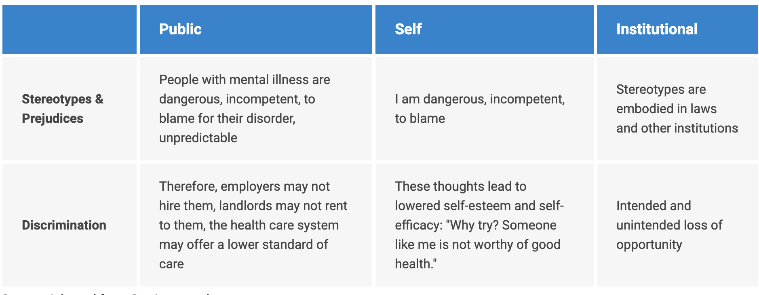
Figure 1 Table of examples of each type of stigma

Publicity

The stigma caused by publicity is mainly rooted in the media; this would involve negative and discriminatory attitudes toward those with mental illnesses. Refer to Figure 1 for more details. Public stigmas and other forms of stigma are rooted in a lack of understanding or fear. Stigmas affect individuals and those around them directly. A common source of manifestation of stigmas is rooted in social media, an example towards how social media can quickly negatively impact a adolescents mentality is how “46% of adolescents aged 13-17 said social media makes them feel worse” referring to their body image.

Self-Infliction

Self-infliction is an internalized shame from those who suffer from mental health issues. These negative attitudes further worsen their conditions and deter them from regular lives because they will be reluctant to seek help, isolate themselves socially, and have other effects.

Institutional Stigmas

Institutional stigmas have issues rooted in the system and have an inseparable involvement with policies that limit opportunities for those with mental illnesses. Institutional stigmas will worsen self-inflicted stigmas by emphasizing these “flaws.”

Effects of Mental Illnesses on Wellbeing

Behavioral Problems

Mentally healthy people will have differences in daily behavior from those with mental illnesses. Mental illnesses are not the only cause of behavior changes but are one of the most prominent factors. Doctors generally categorize the warning signs of behavioral changes due to mental illnesses as disorganized speech, hallucinations, and mood extremes. There is also the concern of evaluating whether the symptoms are due to psychological or physical illnesses.

Damages to Physical Health

The mind and the body must be considered as a whole. Positive mental states enable one to be physically healthy. Mental illnesses can cause chronic diseases; for example, studies discovered the relationship between depression, diabetes, and cancer. Similarly, chronic diseases can also affect mental health. Mental illnesses can also cause sleep problems around “50% to 80% of people with mental health conditions” (“How Does Mental Health Affect Physical Health”), whereas “only 10% to 18% of the general population experience sleeping problems”. (“How Does Mental Health Affect Physical Health”) Those with mental health issues also demonstrate tendencies to smoke.

Causes for the Mal-Safeguarding of Mental Health

Social and Economic

Mental health affects society by deciding productivity, employment, healthcare, and insurance. According to the World Economic Forum, more than half of the global economic burden will be due to mental illnesses by 2030 and lose around 6 trillion USD annually. Given these burdens on society due to mental disorders, policy policymakers need to make changes to compensate for the losses. These statistics do not apply directly to adolescents, but trends will impact a school or the environment in which the adolescent grows up.

Public Health Emergencies

Public health emergencies will have long-term impacts on the well-being of people and communities; long-term impacts are severe consequences of high levels of crisis exposure. Traumatic events have always had ramifications on mental health. During times of global pandemics, increases in Post-Traumatic Stress Disorder (PTSD) are observed, as well as depression and anxiety. The effects of mental health issues are only amplified in adolescents, considering the lower ability to cope with trauma and crisis, thus overwhelming the mind. A case study would be the COVID-19 pandemic, as seen in the diagram below from Statista (Richter).

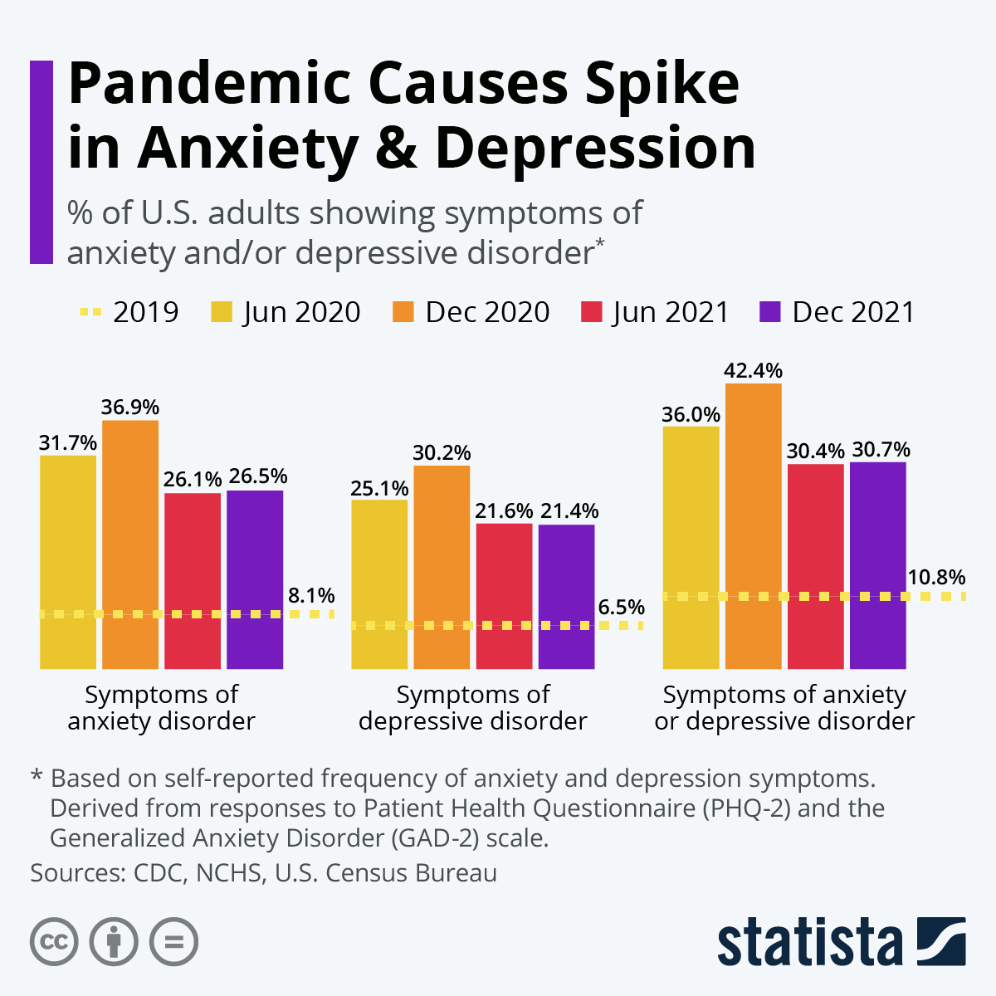
War

Exposure to war will proceed to demonstrate a variety of mental health issues. It should be noted that there are different reactions based on varying levels of development. Adolescents and children also show stress levels and responses tend to be higher compared to the general population and the prevalence of mental illnesses. “Child and adolescent refugees and asylum seekers reported a 22.7% prevalence of PTSD, 13.8% of depression, and 15.8% of anxiety disorders” (Bürgin et al.).

Major Parties Involved

United States of America
There is a rapid rise in youth mental health issues in the United States, and Washington has acted on it. According to the White House (White House), youth and adolescent rates of depression and anxiety have risen nearly 30% in recent years, and statistics demonstrate that certain groups of people have seen higher rates than others; for example, 69% of LGBQ+ have considered suicide. President Biden has called for Congress to pass legislation that would strengthen the safeguarding of mental health in social media. They have established a Task Force on Kids Online Health and Safety, and they are utilizing resources from the Department of Education, Department of Justice, Department of Homeland Security, and Centers for Disease Control, but they are not limited to these.

American Psychological Association
The American Psychological Association aims “to promote the advancement, communication, and application of psychological science and knowledge to benefit society and improve lives.” To do this for adolescents, they have created a task force named the Interdivisional Task Force for Child and Adolescent Mental Health (IDTF). This task force has 12 APA divisions and is seeking the creation of a new model that can be applied nationwide. The APA is also one of the critical parties pushing for change as well as policies in protecting adolescent mental health.

Massachusetts Institute of Technology
“MIT cares about the well-being of its community members” (Behavioral/Mental Health MIT Human Resources). Massachusetts Institute of Technology (MIT) is one of the top institutes in the world; however, it persists in having one of the highest suicide rates. The leading cause of suicides at MIT is due to depression and stress. MIT has taken measures to account for this, including increasing campus-based therapy and facilities.
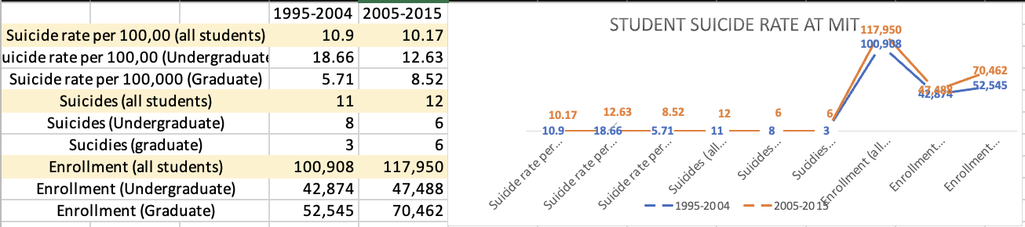
Figure 2 Student Suicide Rate at MIT
This is extremely serious and must be considered, considering that the national average for the United States is 6.5-7.5 per 100,000.

Republic of Korea
The Republic of Korea’s suicide rate for adolescents has starkly increased at an unpredictable rate. In Korea, the leading causes of suicides are related to mental health problems as well as family conflict. From 2016 to 2020, 654 students committed suicide, male dominant. Further research indicates that a large percentage of these students who committed suicide have demonstrated signs of mental health issues. Also, the ROK isn’t the only nation that suffers from these issues; it is merely one statistic that stands out as a prevalent trend that must be addressed. The ROK’s mental health policy mainly consists of organizing services, downsizing large mental hospitals, developing a mental health component in primary health care, human resources, and more (WHO-AIMS).
Federal Republic of Germany
The Federal Republic of Germany has found that 21.9 percent of 2863 adolescents and children showed signs of mental health problems. The most common mental health problems that were determined were anxiety, conduct disorder, and depression, according to a study conducted by Bundesgesundeheitsblatt Gesundheitsforschung Gesundheitsschutz, The Federal Republic of Germany has begun funding the campaign “Healthy for Life,” which is created for “children and young people to remain healthy or recover more quickly” (7.5 Mental Health), with it focusing “on child-oriented approaches preventing and treating chronic diseases and mental health”( 7.5 Mental Health). They have also been working with the parents of the adolescent suffering from mental health issues to have their legal guardians intervene and to protect themselves from being mentally ill. The German Social Code has provided guidelines for guardians, and an interdisciplinary task force was appointed to improve the situation.

World Health Organization
As an organization coordinating health under the United Nations, it has the most authority to safeguard adolescents' mental health. The WHO aims to bring the highest possible level of wellness: "The individual realizes his or her abilities, can cope with the normal stresses of life, can work productively and fruitfully, and can contribute to his or her community” (PAHO). Realizing a practical approach to safeguarding adolescent mental health is lacking isn’t in the development agenda. On the 28th of September 2020, the WHO recommended guidelines promoting mental health and preventing mental health issues. The recommendations can be applied in schools through digital platforms. These guidelines also account for adolescents having an increased risk of self-harm. The World Health Organization is also “developing a toolkit to facilitate the implementation of the new guidelines. The kit will include strategies for supportive policies and laws and implementation of interventions in different settings.” (WHO)

UN Involvement, Relevant Resolutions, Treaties and Events

Resolutions

A/HRC/RES/43/13

This resolution was adopted on 19 June 2020 by the Human Rights Council (HRC). This resolution “Reaffirms the obligation of States to protect, promote and respect all human rights” (Mental Health and Human Rights: Resolution/: Adopted by the Human Rights Council on 19 June 2020) regarding mental health. This resolution also calls for integrating a “human rights perspective into mental health” (Mental Health and Human Rights: Resolution/: Adopted by the Human Rights Council on 19 June 2020) and thus to benefit those suffering from mental health issues and discrimination.

Events

World Mental Health Day 2023

An annual event for adolescent mental health is World Mental Health Day, marked on the 10th of October. World Mental Health Day 2023 is essential considering the theme that circles around “Mental health is a universal human right,” thus promoting the protection and safeguarding of the mental health of all bodies.

Timeline of Events
Date | Description of Event
1930 | Leo Kanner, the first pediatric psychiatrist, joined the Harriet Lane Pediatric Clinic at John Hopkins University and opened a specified pediatric psychiatry service. This also created a team of child psychiatrists to help prevent issues.
1951 | George Gardner along with other child psychiatrists, led a meeting which discussed the formation of the American Academy of Child Psychiatry. This was then formed in February 22, 1953. This was also admist multiple conflicts including the Korean war, the Cold War, and a anti-communist movement.
1975 | Public Law 94-142 was passed by congress which entitled “every child has a right to a public education regardless of their handicap” which gave all children a right to education even if they had disabilities which include mental health issues.
April 14, 2000 | On this day Elizabeth Shin set herself on fire in her dorm room at M.I.T. This high-profile event led to a wave of reforms in M.I.T, this also brought the problems of mental health in MIT to a national level.

Previous Attempts to Resolve the Issue

Fact Sheets

Fact sheets may seem like an elementary solution, but they are effective. This considers accessibility to comprehension and a wide variety of audiences. The Education Bureau of the Government of the Hong Kong Special Administrative Region creates an example of an informative fact sheet. This fact sheet delivered the message to various audiences of different backgrounds.

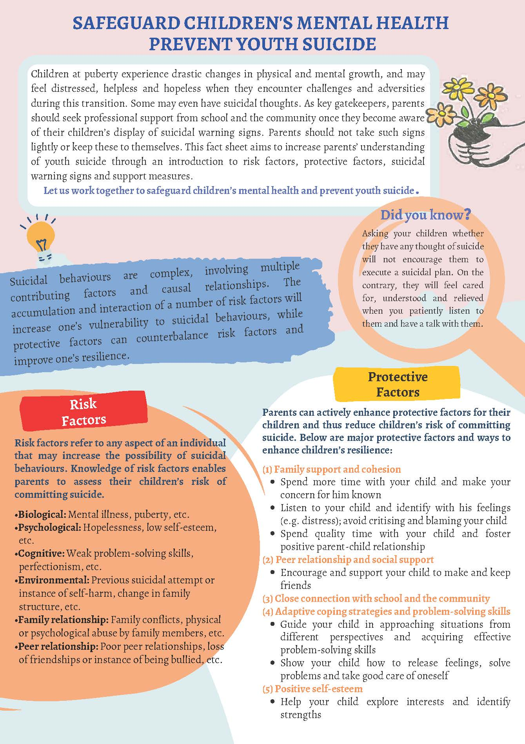
Figure 4 fact sheet issued by the Education Bureau of the Hong Kong Special Administrative Region (Student Mental Health Information Online -Parent Zone)

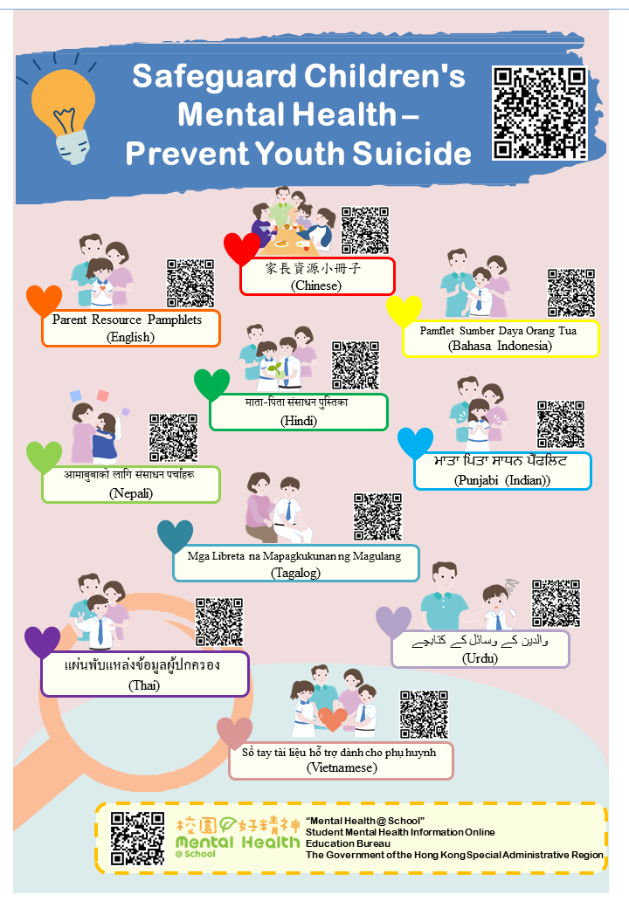
Figure 5 Second Part of the fact sheet issued by the Education Bureau of the Hong Kong Special Administrative Region (Student Mental Health Information Online -Parent Zone)
Passing of Legislation
This solution would be one of the best and most effective in safeguarding mental health. Protecting adolescent mental health mainly involves using legislation to affect it directly or indirectly. In Hong Kong, there was the legislature (ISE31/20-21); this act recognized that most cases of mental illnesses go undetected and was thus able to act upon it and adopt a three-tier model for youth mental care services. This was relatively successful as there is a way to efficiently detect, prevent, and intervene by utilizing healthcare resources.

Possible Solutions

Increasing Monitorization of the Internet

“We are all connected by the Internet, like neurons in a giant brain” – Stephen Hawking; postsynaptic neurons must be involved to maintain strong connections in neurons. This concept of applying a separate force in supporting and involving an external force to benefit the communications can be used in safeguarding adolescent mental health. Doing so will address one of the root causes of mental health issues, which is “the huge influx of information and stimulus maturely that they receive from online media, leading to feelings of confusion, emptiness, low self-worth, anxiety, or even depression.”(Online Media and the Adolescent Mental Health Crisis) The internet is also a great source of information but sometimes not constructive considering the “spread of information about self-harm and suicide techniques” (Lewis et al. 2011).

Establishing Mental Health Campaigns

“Intolerance of groups is often, strangely enough, exhibited more strongly against small differences than against fundamental ones” – Sigmund Freud. This intolerance within groups is destroying groups and obstructing the paths to address the fundamental differences or problems, which would be stigmas and inadequate awareness. Campaigns are effective in unifying groups to address fundamental differences. Some tools that can be included within a drive include fact sheets, infomercials, posters, and the utilization of social media. The campaign's content could consist of legislation, statistics, etc. It must be mentioned that one of the key messages within the campaigns is that mental health is a part of overall well-being.

Urging for the Passing of Effective Legislature

“Legislation is a matter of more or less intelligent improvisation aiming at palliating conditions by means of patchwork policies”- John Dewey; to successfully safeguard adolescent mental health or the “palliating condition” in this situation, there must be “intelligent improvisation” that can be drawn upon from current and past policy. Only then can there be successful legislation that safeguards adolescent mental health? To account for all these factors, some example legislation could include implementing a new model of diagnosis and intervention, addressing victims through aid, increasing the amount of education on the issue of mental health, etc. Legislation has been proven successful in the past, addressing a wide variety of topics in multiple fields, and can thus be deemed an effective solution.

Providing Constructive Resources

“Medical science has proven time and again that when the resources are provided, great progress in the treatment, cure, and prevention of disease can occur”-Michael J. Fox; to safeguard adolescent mental health, resources must be provided to the victims, families of victims, possible victims, as well as protected. To provide resources, the school platform is highly accessible and effective in helping adolescents realize the importance of mental health and recuperation. Resources are not and cannot be limited to information only but to means to recover and support them through the process. This proved effective through similar events, for example, COVID-19, in which valuable resources such as masks and vaccines were provided and helped the recuperation and prevention of diseases; the same logic can be applied to the issue at hand.

Research Guide
Research is one of the most critical components in crafting a successful resolution. Researching the country’s stance, perambulatory and operative clauses would be best. The website Diffit (https://beta.diffit.me/#topic), as well as Immersive Reader(https://support.microsoft.com/en-au/office/use-immersive-reader-in-word-a857949f-c91e-4c97-977c-a4efcaf9b3c1), is also suggested in aiding the comprehension of texts of high complexity.
Conducting Research for Preambulatory and Operative Clauses
Research for the perambulatory and operative clauses involves context for possible solutions. This context would help you craft an operative clause. Some methods that could be used include utilizing passed resolutions and voting patterns, allowing feasible clauses. Other research methods include this report, news websites, and the internet—a PDF document for the past legislature: https://phii.org/wp-content/uploads/2020/08/Summary-of-Laws-Related-to-CAMH.pdf.
Conducting Research on Country’s Stance
This section will help you conduct thorough and constructive research as the delegate. The main tips are to use open bar search, official statements, news articles, and voting patterns.
Using open-bar searches helps guide you into further research from websites. Then, the websites can be used for analysis and cross-referencing your information.
Official statements aid the research into the country’s stance. The use of official government websites helps in conducting the research. Guiding phrases such as “[Name of Country] stance on safeguarding adolescent mental health” can be used.
News articles are also a good source. They’re also beneficial in looking for past approaches. Reliable sources include The Wall Street Journal, BBC News, and the AP News.

Bibliography
“7.5 Mental Health.” National Policies Platform, national-policies.eacea.ec.europa.eu/youthwiki/chapters/germany/75-mental-health. Accessed 20 Jan 2024.
“About APA.” APA, www.apa.org/about. Accessed 19 Dec 2023.
“Adolescent Health.” WHO, 26 Nov. 2019, www.who.int/health-topics/adolescent-health#tab=tab_1. Accessed 12 Dec 2023.
Arenas-Arroyo, Esther, Daniel Kranz and Natalia Nollenberger. “Online Media and the Adolescent Mental Health Crisis.” CEPR, 9 Apr. 2023, cepr.org/voxeu/columns/online-media-and-adolescent-mental-health-crisis. Accessed 20 Dec 2023.

“Behavioral/Mental Health.” Human Resources MIT, hr.mit.edu/worklife/mental-health#:~:text=MIT%20cares%20about%20the%20well,services%20can%20find%20resources%20here. Accessed 17 Dec. 2023.
Bertolote, Jose. “The Roots of the Concept of Mental Health.” National Library of Medicine Pub Med Central, 7 June 2008, www.ncbi.nlm.nih.gov/pmc/articles/PMC2408392/#:~:text=The%20First%20International%20Congress%20of,of%20recommendations%20on%20mental%20health. Accessed 16 Dec 2023.
“CAUSES OF MENTAL ILLNESS.” WebMD, 6 Feb. 2003, www.webmd.com/mental-health/mental-health-causes-mental-illness. Accessed 17 Dec 2023.
“Coming of Age: Adolescent Health.” WHO, www.who.int/news-room/spotlight/coming-of-age-adolescent-health. Accessed 20 Dec 2023.
“CONSTITUTION OF THE WORLD HEALTH ORGANIZATION.” World Health Organization, 7 Apr. 1948, apps.who.int/gb/bd/PDF/bd47/EN/constitution-en.pdf?ua=1. Accessed 16 Dec 2023.
First, Michael B. “Personality and Behavior Changes.” MSD Manual Consumer Version, 6 Dec. 2023, www.msdmanuals.com/home/mental-health-disorders/overview-of-mental-health-care/personality-and-behavior-changes. Accessed 18 Dec 2023.
“Interdivisional Task Force for Child and Adolescent Mental Health.” APA, www.apadivisions.org/division-37/leadership/task-force/mental-health. Accessed 19 Dec 2023.
Li, Fengxiao. “Impact of COVID-19 on the Lives and Mental Health of Children and Adolescents.” Frontiers in Public Health, vol. 10, 18 Oct. 2022, https://doi.org/10.3389/fpubh.2022.
Lockett, Eleesha. “How We Can Change the Stigma Around Mental Health.” Healthline, 26 Oct. 2022, www.healthline.com/health/mental-health/mental-health-stigma-examples#examples. Accessed 17 Dec 2023.
McCarthy, Claire. “The Mental Health Crisis Among Children and Teens: How Parents Can Help.” Harvard Health, 8 Mar. 2022, www.health.harvard.edu/blog/the-mental-health-crisis-among-children-and-teens-how-parents-can-help-202203082700. Accessed 17 Dec 2023.
“Mental Disorders.” WHO, 8 June 2022, www.who.int/news-room/fact-sheets/detail/mental-disorders. Accessed 12 Dec 2023.
“Mental Health.” PAHO/WHO | Pan American Health Organization, www.paho.org/en/topics/mental-health. Accessed 12 Dec 2023.
Ravens-Sieberer, Ulrike. “Psychische Gesundheit Von Kindern Und Jugendlichen in Deutschland.” Bundesgesundheitsblatt - Gesundheitsforschung - Gesundheitsschutz, vol. 871–878, no. 5–6, 1 May 2007, https://doi.org/10.1007/s00103-007-0250-6.
Rocheleau, Matt. “Suicide Rate at MIT Higher Than National Average.” BostonGlobe, 17 Mar. 2015, www.bostonglobe.com/metro/2015/03/16/suicide-rate-mit-higher-than-national-average/1aGWr7lRjiEyhoD1WIT78I/story.html. Accessed 17 Dec. 2023.
“Student Mental Health Information Online - Parent Zone.” mentalhealth.edb.gov.hk/en/promotion-at-the-universal-level/parent-zone/68.html. Accessed 20 Dec 2023.
“Suicide.” WHO, 28 Aug. 2023, www.who.int/news-room/fact-sheets/detail/suicide. Accessed 12 Dec 2023.
Trafton, Anne. “Neuroscientists Reveal How the Brain Can Enhance Connections.” MIT News | Massachusetts Institute of Technology, 18 Nov. 2015, news.mit.edu/2015/brain-strengthen-connections-between-neurons-1118. Accessed 20 Dec 2023.
Vaingankar et al. “Understanding the Relationships Between Mental Disorders, Self-reported Health Outcomes and Positive Mental Health: Findings From a National Survey.” Health and Quality of Life Outcomes, vol. 18, no. 1, 4 Mar. 2020, https://doi.org/10.1186/s12955-020-01308-0. Accessed 12 Dec 2023.
“What Are the 5 R’s of Safeguarding?” Online Dbs, onlinedbschecks.co.uk/blog/five-r-of-safeguarding. Accessed 12 Dec. 2023.
“What Is Mental Health?” SAMHSA, www.samhsa.gov/mental-health. Accessed 12 Dec 2023.
“WHO-AIMS REPORT ON MENTAL HEALTH SYSTEM IN Republic of Korea.” WHO-AIMS, 2006, cdn.who.int/media/docs/default-source/mental-health/who-aims-country-reports/korea_who_aims_report.pdf?sfvrsn=5b94a809_3&download=true. Accessed 19 Dec 2023.
“World Health Organization, 7 Apr. 1948,” WHO, apps.who.int/gb/bd/PDF/bd47/EN/constitution-en.pdf?ua=1. Accessed 16 Dec 2023.
“World Mental Health Day 2023.” WHO, 10 Oct. 2023, www.who.int/campaigns/world-mental-health-day/2023. Accessed 17 Dec 2023.

