Forum: Economic and Social Council
Issue: Measures to mitigate the global debt crisis
Student Officer: Mi Na Son
Position: Chair of Economic and Social Council

Introduction
Debt crisis is when a country is unable to pay back the money that the government borrowed. Specifically, it is when the tax revenue of a country is lower than the government expenditure for a continuous period. When the government can not pay back the loan for a long period of time, the investors will start to increase the interest rate, giving more pressure to the country. As a result, the government will face a huge debt load and end up with a serious debt crisis that leads to nation’s economy downturn. Global debt crisis happens to be more serious in emerging markets and low-income countries. As they lack the ability to pay back their debt, especially due to their unstable economy and insufficient governance system, the possibility for them to pay back their debt is less likely than in high-income countries. However, despite of their poor financial management, these developing or emerging countries are still tending to borrow money from investors for various domestic factors such as to develop or undertake national projects. Debt crisis does not only impact the country itself but also global wide. When there are more and more countries that are not willing to pay back their debt, the bank will face a huge loss and it will also cause a slowdown in international economy. Though global debt crisis has significantly decline for the past few years, it is still considered to be very high with a record of 238 percent of the global average gross domestic product. Mitigating the global debt crisis is not only a short-term issue but it is a prolonged issue that needs to be aware of.

Definition of Key Terms

Debt crisis

The debt crisis is a situation when the government lacks ability to pay back their governmental debt. When the government expenditure is more than the tax revenue for a prolonged period, the country may face a debt crisis.

Tax revenue

The tax revenue is revenues collected from taxes on income and profits, taxes levied on goods and services, payroll taxes, etc.

Government expenditure

The government expenditure, also known as government spending, is the money used in government consumption, investment, and transfer payments.

Gross Domestic Product (GDP)

The Gross Domestic Product is the monetary value of finished goods and services within a country for a specific period.

General Overview

Debt in the USA

In absolute terms, the USA is the country that owes the most money, currently about $33.5 trillion. These charts shows the growth of the US debt over time:

Figure 1: US Public Debt as a Percentage of GDP 1790-2011 (Phillips)

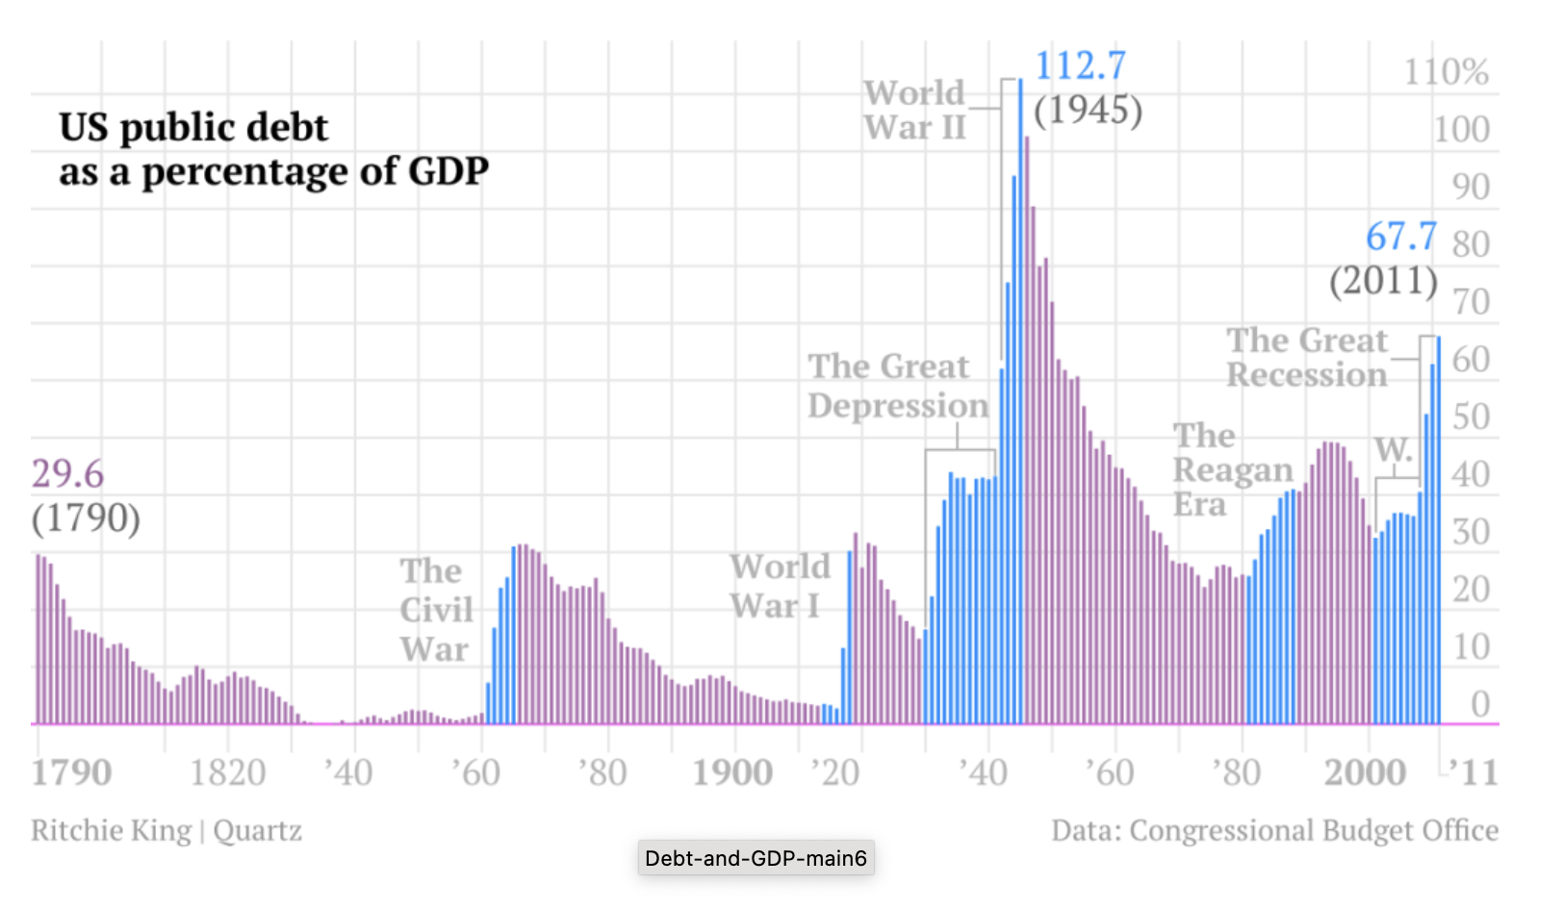

Figure 2: US Government Debt as a Percentage of GDP 1990-2021 (Macrotrends.net)

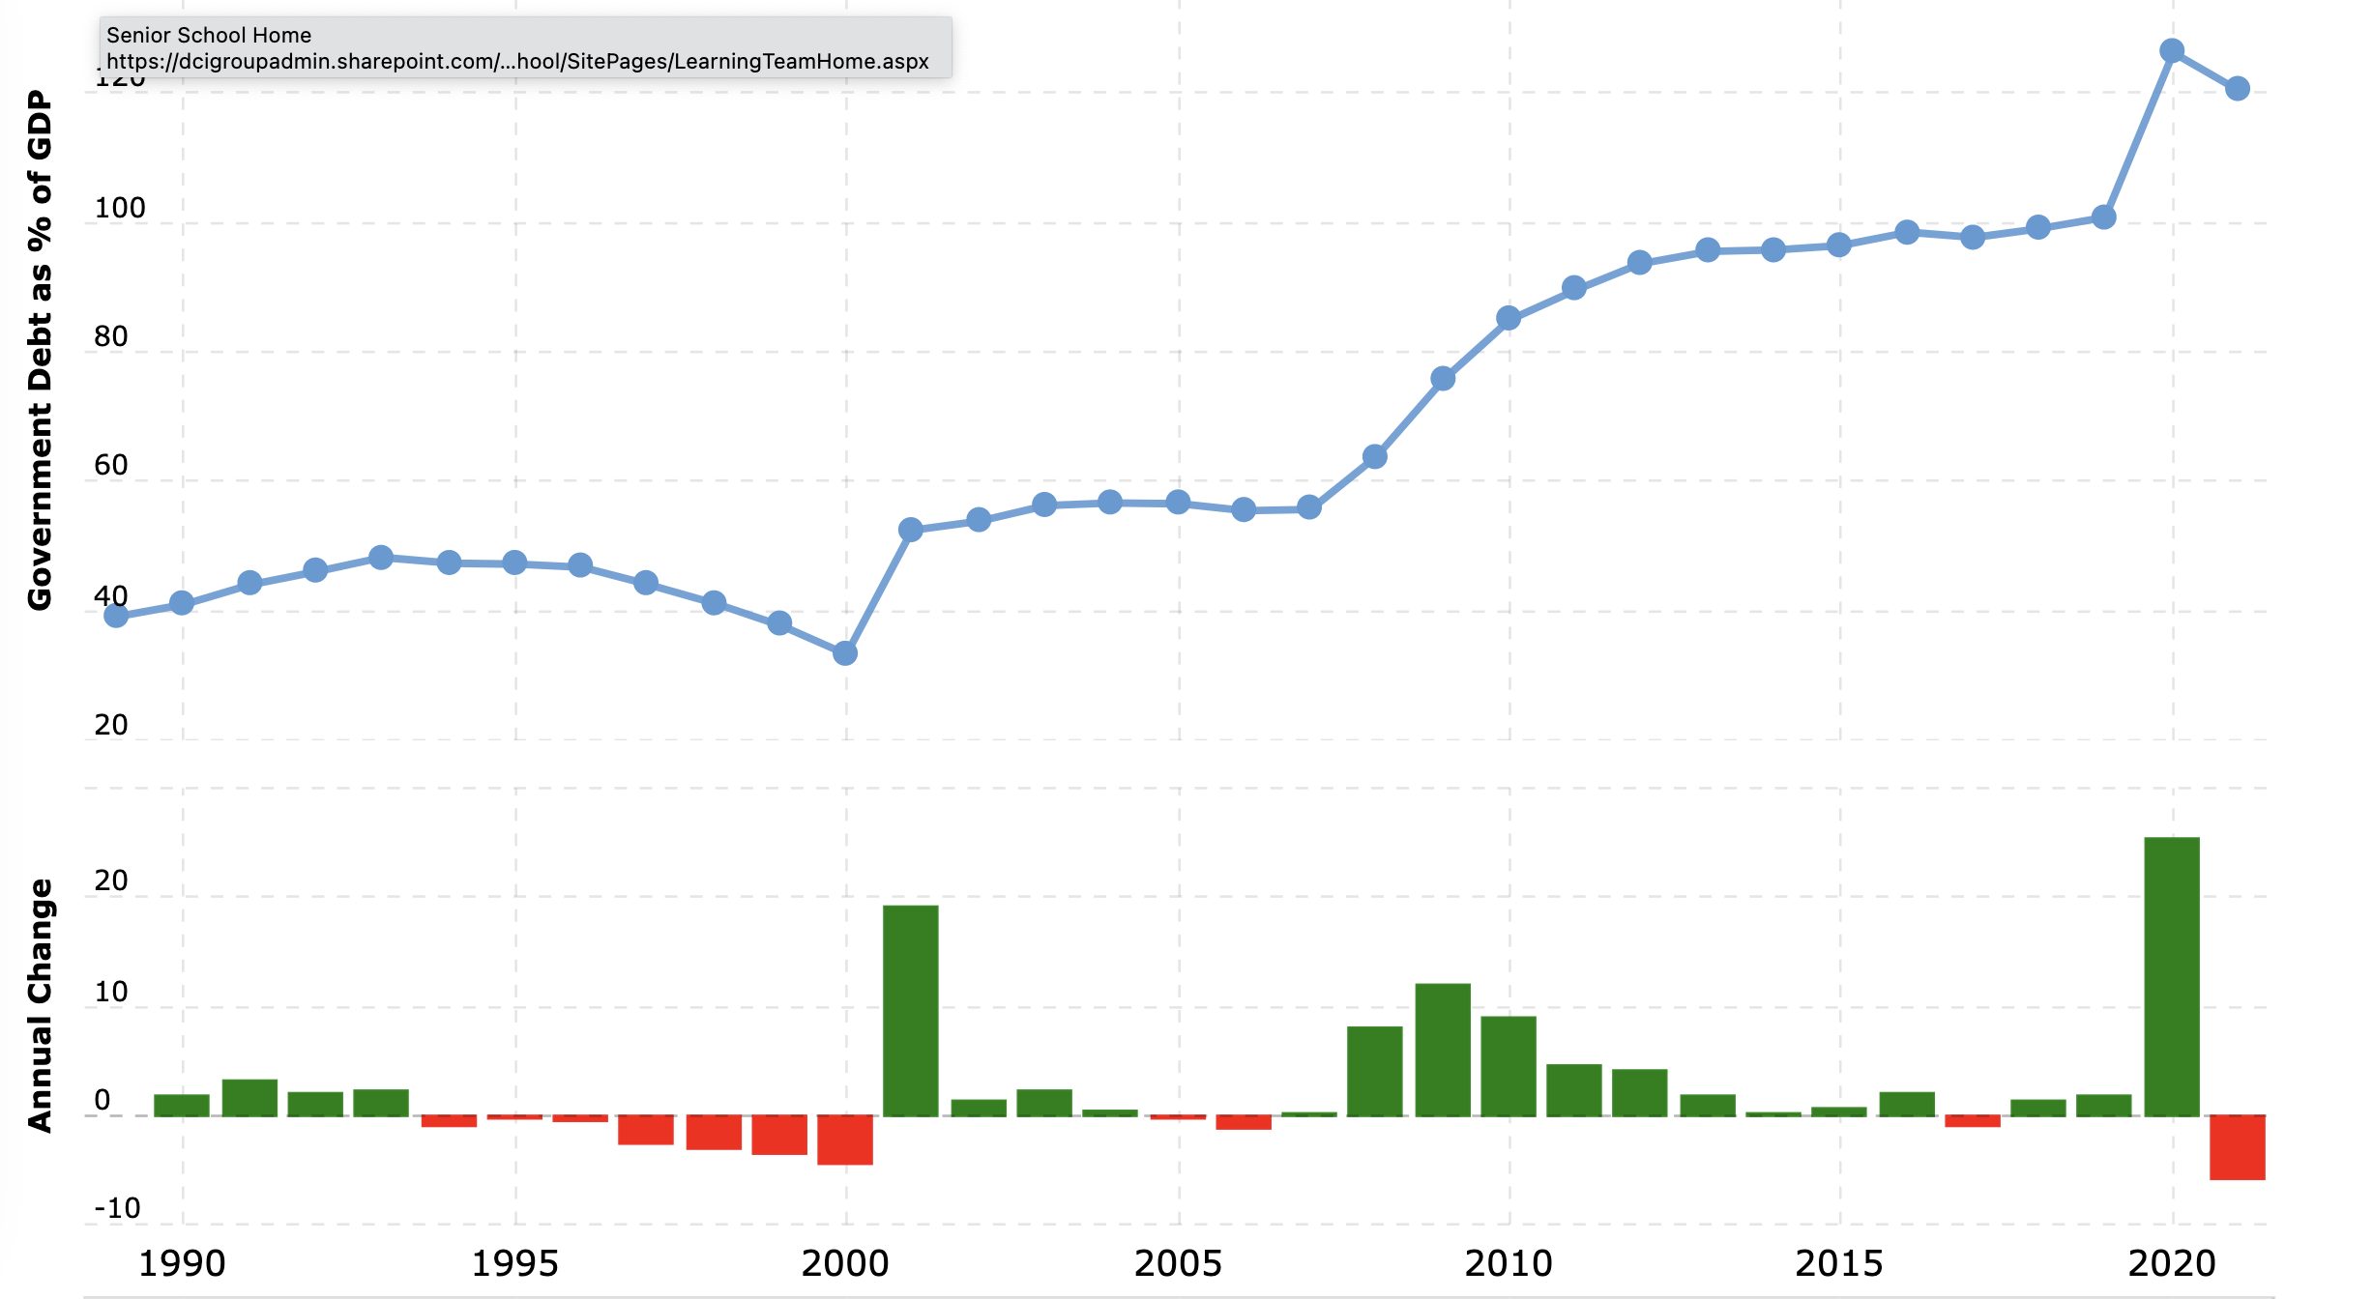

In 1938 during the Great Depression, the US debt ratio reached 45 percent of the GDP. In the late 1930s, it seems to have a debt reduction, but the World War II increased the debt again. As many countries started to borrow money to invest on weapons and machines, the indebtedness rose to 112.7 percent of GDP in 1946. In more recent year, the wars in Afghanistan and Iraq, the Recession of 2008 and the Covid Pandemic have caused US National debt to rise to more than 135% of GDP.

Although the USA owes the most money, it is actually not the country with the biggest debt problem. This is because it is a very large economy, so it is still possible for it to pay off its debts.

Japan

Japan is the most heavily indebted among the economically developed countries. Its national debt is currently 236% of its GDP.

Heavily Indebted Poor Countries

The biggest issue in the debt crisis concerns LEDCs facing unsustainable levels of debt. Many LEDCs in the past have taken out large loans to help finance economic development. In some cases, corrupt leaders embezzled the money or the money was not well spent due to incompetence. In other cases, natural disasters like the recent COVID Pandemic forced the government to spend more. Unpredictable factors like rising oil process and rising interest rates also contribute to government debts. If governments have to spend all their money paying interest on huge debts, they don’t have any money to finance economic development and they have no hope of climbing out of poverty. Sometimes the situation gets so bad that they are simply unable to pay the interest on their debts. This happened to Mexico in 1982, setting off the Latin American Debt Crisis. In 1996, the IMF introduced the Heavily Indebted Poor Countries Initiative. They identified 41 LEDCs facing unsustainable burdens, and attempted to help them. The idea was to help the countries to implement economic reforms, replace some high interest loans with low interest loans from the IMF and arrange for some loans to be forgiven altogether. The program has been criticized for forcing countries to cut government spending by eliminating government subsidies for struggling industries of famers, laying off government workers, repealing regulations in the labour market, ending government grants and privatizing many public services. Critics argue that these measures make it more difficult for governments to alleviate poverty. The program has since been reformed to include more debt relief and more investment in poverty reduction programs. Between 2001 and 2015, countries in the program have experienced a 15 percent decline in debt service payments.

Latin American debt crisis (1980s)

An example of the problems unsustainable debt can lead to is the Latin America Debt Crisis. When oil prices suddenly shot up at the end of the 1970s and interest rates rose, many Latin American countries found their debts soaring. In August 1982, Mexico declared their inability to pay their international debt. This caused a crisis in the banks and other institutions that had loaned money to Mexico. It also caused banks and other lending institutions to stop lending money to Latin American countries, leaving them unable to access capital to finance the kind of economic growth they would need to pay off their debts. Most commercial banks also refused to let Latin American countries refinance their unpaid debt, insisting that the loans be paid off immediately. This raised the prospect that more countries would default, leading to an international banking crisis. Eventually, the IMF stepped in. Banks that had loaned the money, many of them in the USA, had to accept that they would not get it all back, and sufferend huge losses. Meanwhile the debtor countries were forced to cut government spending drastically in order to qualify for IMF assistance, which in turn made it difficult for them to combat poverty.

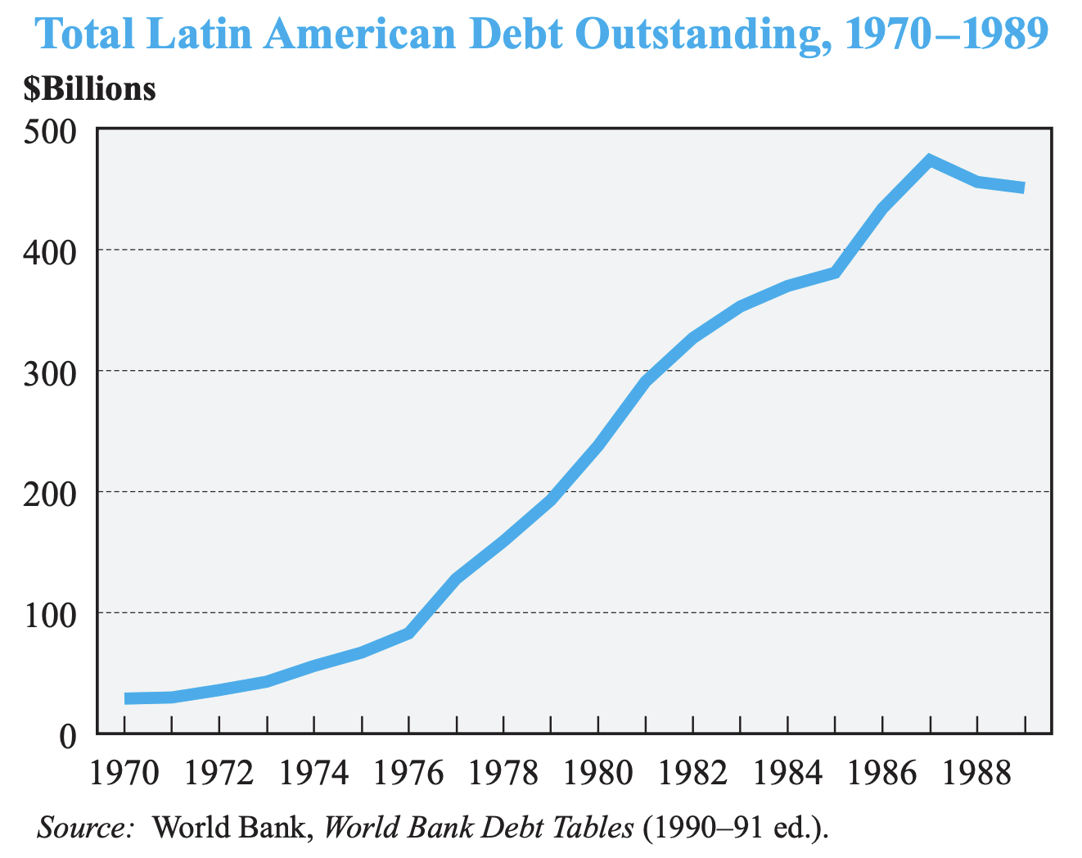

Caption 2: Graph showing the total Latin American Dept outstanding

Heavily Indebted Poor Countries Initiative (1996)

In 1996, the IMF introduced the Heavily Indebted Poor Countries Initiative. They identified 41 LEDCs facing unsustainable burdens, and attempted to help them. The idea was to help the countries to implement economic reforms, replace some high interest loans with low interest loans from the IMF and arrange for some loans to be forgiven altogether. The program has been criticized for forcing countries to cut government spending by eliminating government subsidies for struggling industries of famers, laying off government workers, repealing regulations in the labour market, ending government grants and privatizing many public services. Critics argue that these measures make it more difficult for governments to alleviate poverty. The program has since been reformed to include more debt relief and more investment in poverty reduction programs. Between 2001 and 2015, countries in the program have experienced a 15 percent decline in debt service payments.

Current issue with debt crisis

Nowadays, there are more debtor countries than the non-debtor countries. Due to the rapid technological development and competition between countries, borrowing money to be more advanced than others become normalized. As more technologically and economically advanced countries start to owe a huge amount of money, it has not been a big issue around the world, especially the less economically developed countries. Moreover, it is crucial to acknowledge the consequences that the debt crisis might bring to the human society and economy. During and after the pandemic period, a lot of countries suffered from a huge debt. As they invest a lot in health care systems and mitigating economic impacts from lockdowns, a lot of countries, especially the developing countries have grappled with high sovereign debt. Borrowing a huge amount of debt is not a big problem, however, losing the ability to pay back all the debt is a huge problem. There were a lot of private sectors who were planning to invest on an industry, so they borrowed a large amount of debt. However, due to COVID, their plans and goals become unachievable and left with an unmanageable debt. As a consequence of the debt crisis for private sector, the whole nation is in crucial debt crisis. In 2021, United Nations Conference on Trade and Development have stated that 52 countries, which takes 40 percent of the developing countries are facing a serious debt crisis. They have encountered the debt growing twice as fast as the developed world, recorded to be 855 and 484 in developed countries.

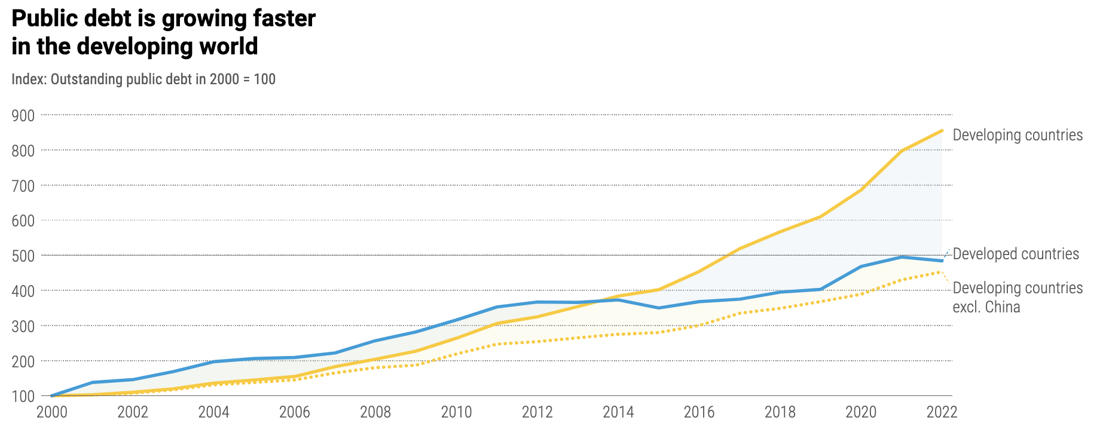

Caption 3: Graph showing the growth of public debt in developing countries and developed countries

Major Parties Involved

International Monetary Fund (IMF)
International Monetary Fund is a global organization that aims to foster financial stability of different countries. They mainly focus on providing policy advice, financial assistance, and capacity development to support countries. Rather directly helping the country with the crisis they face; IMF is aiming to provide breathing room for the country to stabilize their economic stability.

World Bank (WB)

World Bank is an international financial institution that helps both financial assistance and technological assistance. They provide international debt reports to spread awareness on global debt crisis and suggest possible ways for the countries with high debt to overcome the crisis.

United Nations Conference on Trade and Development (UNCTAD)

The UNCTAD is a United Nation secretariats group that encourage trading and development in developing countries. They target on diversify the economy and help them to be less dependent on commodities. More importantly, they aim to limit the exposure to financial volatility and debt for the developing countries around the world.

International Bank for Reconstruction and Development (IBRD)

The IBRD is an organization established after the World War. It is mainly targeted to provide financial assistance for reconstruction after the war. They also aims to develop private sector development in ways but not limited to enabling environment for private investment and entrepreneurship, and job creation.

World Trade Organization (WTO)

The World Trade Organization manage the international trading agreements. They help people to protect their goods, services, and intellectual property by enforcing the rules and regulations. They specifically target on giving trading opportunities for developing countries and helping them to enter the international trading system. Their strict and careful provisions on trading for developing countries helps them to regulate the imports and exports, limiting them from creating extensive borrowings for trade.

World Economic Forum (WEF)

The World Economic Forum is an international non-governmental organization. They are not only committed to improve the nations’ financial problem, but also improve political and academic problems which might triggers debt crisis within a country. With the involvement of the World Economic Forum, the nations are able to spread awareness through reports and data.

UN Involvement, Relevant Resolutions, Treaties and Events
UN have provided various resolution to mitigate the global debt crisis. They have shared their perspective regarding on the problem of less economically developed countries paying more for borrowing than the wealthier countries in Europe or United states. They have clearly stated that it was unfair for the LEDCs to undergo this unequal treatment. The disparity in interest rate for less developed and more developed countries have raised a great concern for UN. As a result, UN have responded for the reform in International Financial Architecture to develop a more inclusive system for developing countries to involve in international financial system in 2000. As a result of this reform, more developing countries were able to join in global economy have more opportunities for development. Moreover, in 2022 March, UN have established the UN Global Crisis Response Group on Food, Energy, and Finance (GCRG) which includes reports on ways to mount debt to recover from COVID-19 pandemic.
In 17 April 2020, United Nation have published a policy brief regarding on the relation between debt and COVID-19. They stated that COVID-19 did not only gave a huge impact on the low-income countries but also middle-income countries who became inaccessible to the market and the capital outflow. To relief from this global crisis, United Nation provided Addis Ababa Action Agenda. This agenda includes, “Debtors and creditors must share responsibility for preventing and resolving unsustainable debt situations”, “Debt restructurings should be timely, orderly, effective, fair and negotiated in good faith”, and “Debt workouts should aim to restore public debt sustainability, while enhancing the ability of countries to achieve sustainable development, growth with greater equality and the sustainable development goals”.
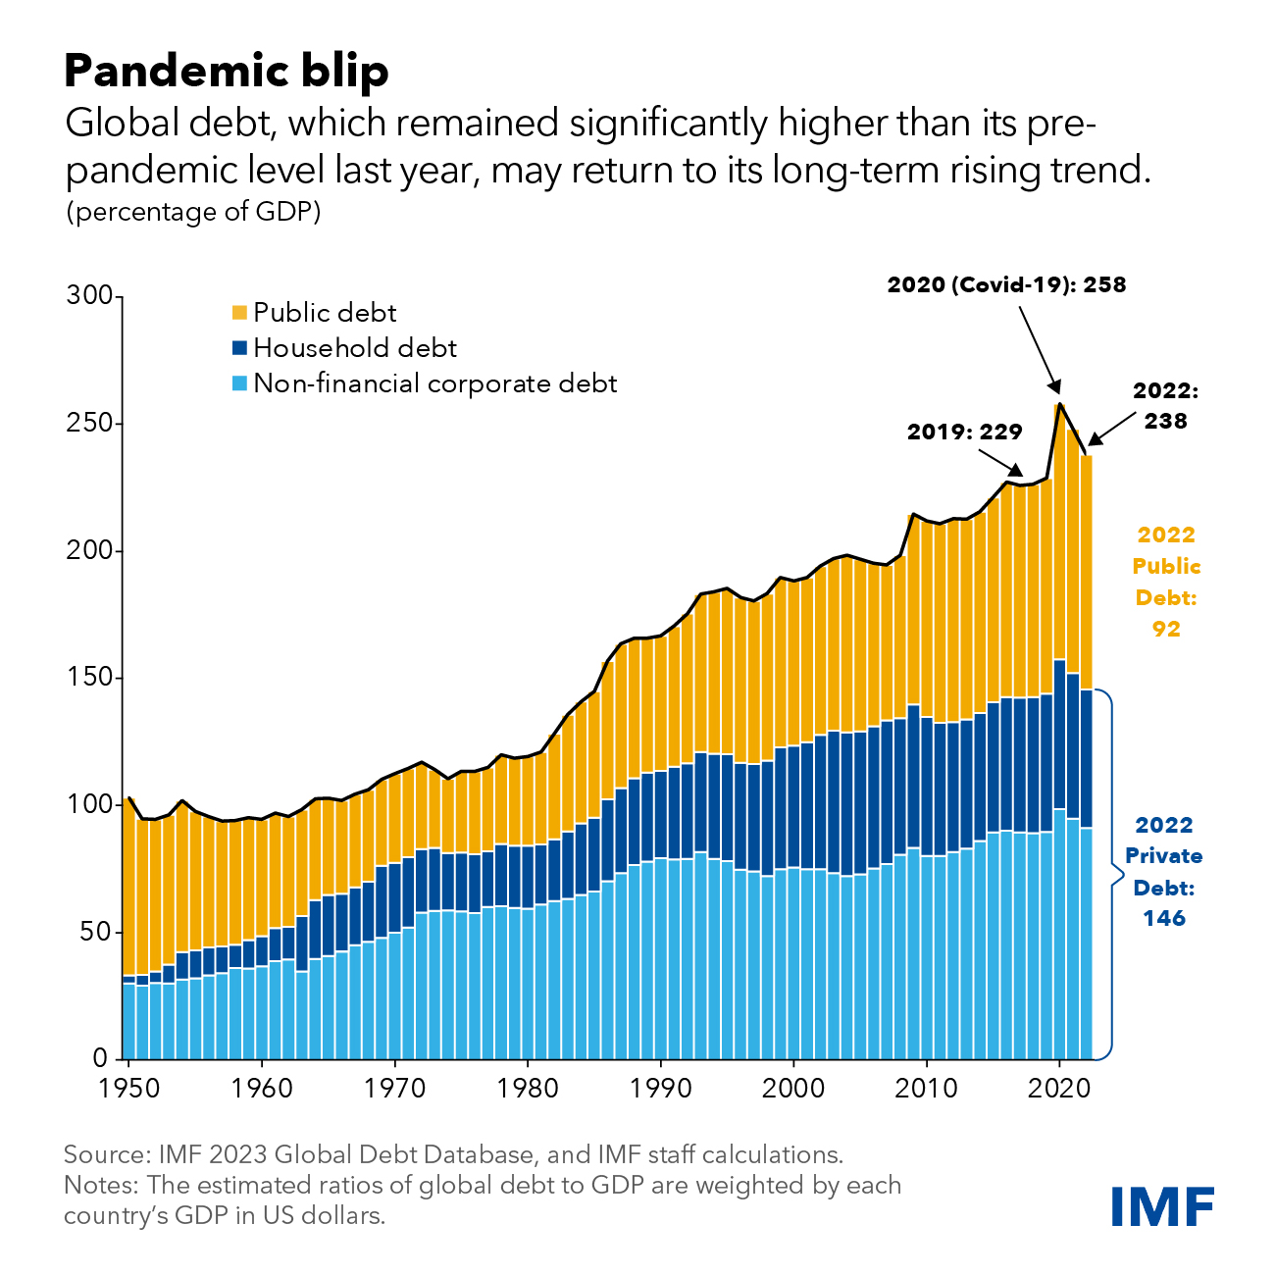

Caption 4: Graph showing the growth of debt during pandemic

Timeline of Events
Date | Description of event
1929-1939  October 29, 1956  1994-2002  April 8, 2008 | The Great Depression and the Great Peak  Suez Crisis  Latin America debt crisis  IMF warning the potential loss may reach 1 trillion dollars from commercial property, consumer credit, and company debt
2009-2010 | European Sovereign Debt Crisis
December 2019  31 March 2020  March 2021 | COVID-19 Outbreak  IMF declaring that the world has entered a recession  UN’s policy brief for liquidity and debt solutions to invest in the Sustainable Development Goals (SDGs)

Previous Attempts to Resolve the Issue

In 1989, as the debtor nations in Less developing countries and Latin America was not able to repay their debt due to the rapidly growing economy, Secretary of the Treasury Nicholas Brady came up with a plan to establish perpetual reduction in debt principals and debt servicing obligations. From 1989 to 1994, the private lenders supported 61 billion dollars of loans for eighteen countries who have agreed to Brady plan. This was a domestic economic reform that helped the debtor nations to recover from their debt crisis. From this attempt to resolve the issue, the market participants still did not acknowledge the problem regarding on debt. As a final attempt, the United States decided to weaken the regulatory standards for large banks that have been exposed to Less developing countries and Latin America. They established the Brady Plan which was named after US Treasury Secretary Nicholas Brady. This plan was brought up to convert the bank loans to tradable bonds and it was able to be sold in the open markets. As a result of this newly established plan, Latin America countries such as Mexico, Brazil, and Argentina was able to have liquidity.

Possible Solutions

Encourage more structured plan for national projects

The country should have a better financial management and planning before starting a national project. In order to have a better financial management, the government should consider carefully on where the government expenditure is going to be spent. For example, if they are planning to build more bridge within the country, they should collect some financial and architectural experts to estimate the total expenditure that is going to be spent on this project. Without this planning, they will face some unexpected problem such as having not enough money or resources to build the whole bridge. As a result, when the government are planning for development, they should consider the government expenditure and tax revenue and decide whether they are able to manage the national project without any problems. If they started the national project without any plannings, they should stop and raise fund first.

Balance National Budgets

One way to alleviate the debt crisis is to have countries stop taking on new debt and try to pay off the debt they already owe. As you can see from Figure 1, the USA was able to pay off much of its debt from World War II in the 1950s and 60s by using some of its income every year to pay off debt. If countries stop running deficits and start paying down debt in years when the economy is going well, they will be in a better position when crises occur and they are forced to run deficits. However, this is more easily said than done. One of the reasons why the USA was able to pay down debt in the 50s and 60s was that its economy was booming. As the economy grew, the national debt became a smaller percentage of the GDP even before they began paying it off. Countries suffering from crises or severe economic problems can’t raise taxes or cut government spending without causing their economies to contract even further and pushing their populations into worse poverty. Furthermore, crises like wars and pandemics can occur at any time and force governments to spend more money.

Raising Taxes

If the country is highly developed, they should consider raising tax from the citizens. Especially for the families or countries with high income, they should pay more tax if the country is facing a debt difficulty. However, this should not apply this to the low-income countries as raising tax will make the citizens more pressured and forced to leave the country. For low-income countries, they should rather lower the tax for the citizens so there will be people willing to contribute to the economy development.

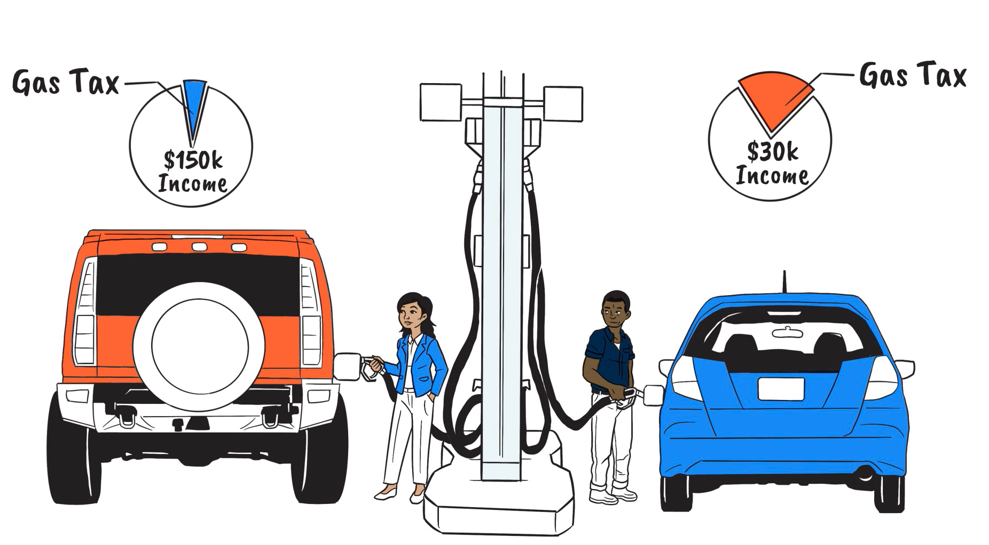

Caption 5: showing the tax difference for people with different income

Keeping Interest Rates Low

By not raising the interest rate from the investor, the countries will have less pressure to pay back the money. This will provide a breathing room for them to regulate the economy and gather money from tax revenue. If they are not paying back the money within the time agreed, the investors consider raising the interest rate after knowing the country’s economy status. If they are facing an economy downturn, the investors shall not raise the interest rate, but they shall help the country to overcome the situation.

Debt Forgiveness

Especially with the heavily indebted Poor countries (HIPCs), the banks and institution should consider debt forgiveness. Through debt forgiveness, the HIPCs are able to recover from economic downturn. In order to mitigate global debt crisis, debt forgiveness can be the fastest but also the most complicated solution. By doing this, the money spent on paying for the debt can be used to develop the country’s well being.

Research Guide

To begin your research on the issue of measures to mitigate the global debt crisis, make sure that you are aware of your delegation. First, you can type “debt crisis in (your delegation)” in the search bar to look for recent news or basic background knowledge regarding on the issue. Second, you can search up for official statements in your country. Official statements can be from the governments, organizations or institutions. To look for the government statements, you can try to type “(your delegation) government’s statement on debt crisis”. Another source that you may use is the news articles. While you are searching up for the news articles, make sure to pay attention in the dates and whether the information is biased. To deepen your understanding towards the issue, you can also try and look for scholarly analysis. To find this analysis, you can type “(your delegation) academic articles on debt crisis”.
A very clear description of the problem can be found at this link: https://www.weforum.org/agenda/2023/12/what-is-global-debt-why-high/

These are some video links that might be helpful to start your research:

Greece Debt Crisis: https://www.youtube.com/watch?v=Kv7FhmjMHMk

US Debt Ceiling Crisis: https://www.youtube.com/watch?v=MOxxDCarjf8

US at the beginning of the late Big Cycled Debt crisis: https://www.youtube.com/watch?v=WxVFLUq9n3c

US Debt Crisis Situation Explained: https://www.youtube.com/watch?v=bAlF39Y_Lvw

Asia’s Financial Crisis: https://www.youtube.com/watch?v=7FL0Lz_UX68

If you have trouble understanding anything you read on the internet, a great tool you can use is https://beta.diffit.me/#url. Just paste the URL of the article you have trouble with into the app and it will convert it to a simpler reading level.

Bibliography
“Debt Relief under the Heavily Indebted Poor Countries Initiative.” IMF, 3 Feb. 2023, www.imf.org/en/About/Factsheets/Sheets/2023/Debt-relief-under-the-heavily-indebted-poor-countries-initiative-HIPC.
Drishti, IAS. “Global Debt Trends and Implications.” Drishti IAS, 28 Sept. 2023, www.drishtiias.com/daily-updates/daily-news-analysis/global-debt-trends-and-implications#:~:text=Reasons%20Behind%20Rising%20Global%20Debt,activity%20and%20provide%20financial%20support
World Politics Review. “Daily Review: The Global Debt Crisis.” World Politics Review, 15 Dec. 2023, www.worldpoliticsreview.com/daily-review-global-debt-crisis/
Fleming, Sam, and Mary McDougall. “US Interest Rates Add to ‘Silent Debt Crisis’ in Developing Countries.” @FinancialTimes, Financial Times, 7 Nov. 2023, www.ft.com/content/b8a9fd5d-868c-41c8-b03c-e9c0cc01aecd.
“International Monetary Fund.” IMF, 19 Apr. 2023, www.imf.org/en/home
Investopedia. “How a Country’s Debt Crisis Can Affect Economies around the World.” Investopedia, Investopedia, www.investopedia.com/ask/answers/051215/how-can-countrys-debt-crisis-affect-economies-around-world.asp#:~:text=This%20can%20happen%20through%20a,linked%20to%20the%20global%20economy
Macrotrends. “US Debt to GDP Ratio 1989-2024.” Macrotrends, 2024, https://www.macrotrends.net/countries/USA/united-states/debt-to-gdp-ratio.
Phillips, Matt. “The Long Story of U.S. Debt, From 1790 to 2011, in 1 Little Chart”. The Atlantic, 13 Nov 2012, https://www.theatlantic.com/business/archive/2012/11/the-long-story-of-us-debt-from-1790-to-2011-in-1-little-chart/265185/
Thomas, David. “World Bank: Developing Countries on Path to Debt Crisis and Lost Decade.” African Business, 14 Dec. 2023, african.business/2023/12/finance-services/world-bank-developing-countries-on-path-to-debt-crisis-and-lost-decade
World Economic Forum “What Is ‘Global Debt’ - and How High Is It Now?” WEForum, World Economic Forum, 2 Oct. 2023, www.weforum.org/agenda/2023/10/what-is-global-debt-why-high/#:~:text=Global%20debt%20is%20at%20%24307,it%20matter%3F%20%7C%20World%20Economic%20Forum

