Forum: Economic and Social Council
Issue: The usage of Genetically Modified (GM) crops
Student Officer: Ryeohun Kim
Position: Chair of Economic and Social Council

Introduction
Basic knowledge of genes is required to understand what a Genetically Modified (GM) crop is. A gene is a unit of inheritance that is inherited from parent to offspring and plays an important role in determining the characteristics of a offspring. A gene is made up of DNA, which is a molecule that contains genetic information, and millions of pieces of DNA are gathered to form genes. This link will help for better understanding about genes.
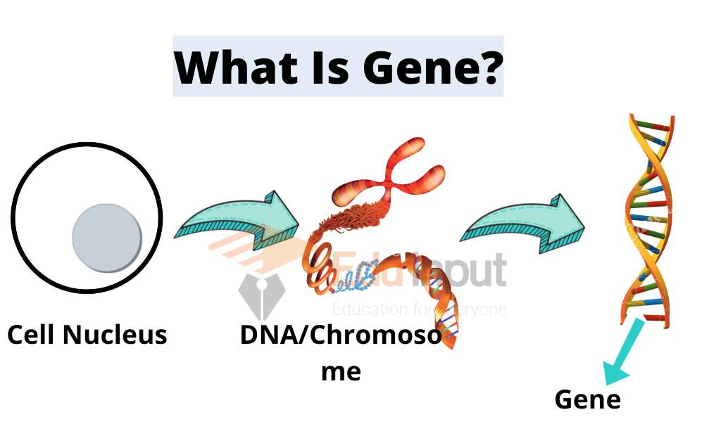
Caption 1: The Composition of a Gene
A GM crop is simply adding or removing DNA from a crop. Adding or removing DNA from crops can result in crops with much higher production, or crops that are highly immune to pests. Full-scale research on GM crops began in the 1980s. Many scientists studied changing the characteristics of plants through a technology called genetic engineering, and eventually the first Genetically Modified Organism appeared in the marketplace in the 1990s. The world's first GM crop was a delayed-ripening tomato, developed by a company named Monsanto in 1996. Starting with the development of delayed-ripening tomato, the crops that people often encounter in their daily lives, such as corn, bean, and cotton, were also genetically modified. This link might help you understand the process of producing GM crops.
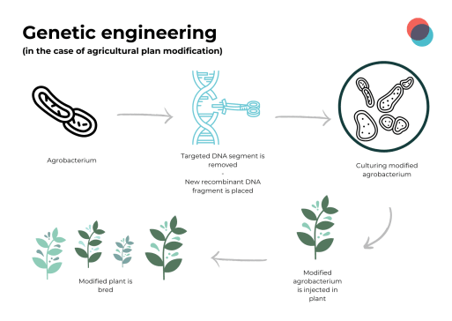
Caption 2: The Process of Genetic Engineering

There are many advantages to the use of GM crops. First, the biggest advantage is the increase in yields. On average, the yields of GM crops are 22 percent higher than that of ordinary crops. In addition, because GM crops are generally resistant to pests, the use of chemical pesticides was reduced by 37 percent on average, and as a result, farmers' income increased by 68 percent. Crops developed through genetic engineering also have the advantage of having beneficial effects on people's health with a larger amount of nutrients.

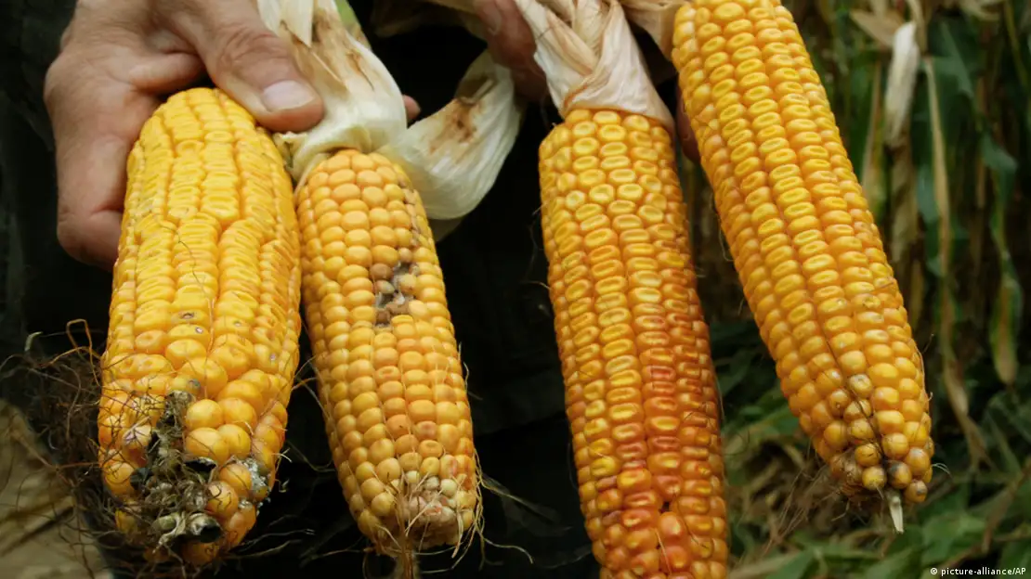

Caption 3: Comparison between GM crop and non-GM crop

There are also drawbacks to the use of GM crops. One of the biggest problems is the impact of GM crops on the environment. Excessive use of GM crops has a great impact on the environment, such as biodiversity loss and pollutant emissions. GM crops can have a negative impact on the economy as well. Typically, there are growing concerns about the economic problems that GM crops can cause, such as deteriorating the economy of small farmers and vulnerable farmers and posing a serious risk to the Less economically developed countries’ (LEDC) economy.

Definition of Key Terms
Genetically Modified (GM) crops
Plants used in agriculture, the DNA of which has been modified using genetic engineering methods
Genetic engineering
Process of altering the DNA in an organism's genome.
Yield
An amount produced of an agricultural or industrial product.
Gene
The basic physical and functional unit of heredity.
Less Economically Developed Countries (LEDC)
LEDC refers to countries that are less economically developed. There are three factors that determine if a country is LEDC: People have low incomes; people have poor nutrition, health care, and education; the country’s economy is based on primary industries.
Monopoly

Exclusive ownership or control of the supply or transaction of goods or services. Usually, monopolies have negative impacts on the economy, such as charging higher prices for goods or reducing the sovereignty of consumers.

General Overview

GM crops are factors that have a great impact on the economy. When first think about GM crops, the question of how they are related to the economy may arise. In order to connect GM crops to economic aspects, several factors must be observed, studied, and considered from various perspectives. Simply, GM crops further develop economic inequality among farmers and increase economic risks from LDCs. A closer examination of the problems with GM crops also reveals economic problems associated with environmental and social problems caused by them.

Growing economic inequality among farmers

As the use of GM crops becomes popular, economic inequality among farmers is growing. Due to the many advantages of GM crops described above, global consumption of GM crops continues to increase. With GM crops containing up to 80% of processed foods, GM crops are very attractive products in the market, and as a result, many farmers have begun to cut GM crops. This is why the problem arises. First, the seeds of GM crops are many times more expensive than those of regular crops. Therefore, for small poor farmers, buying seeds of CM crops comes as a huge economic burden. On the contrary, farmers on large farms can buy seeds of GM crops without burden than poor farmers. Rich farmers who purchase seeds from GM crops benefit much more from the economy because they get 22% more output on average. In contrast, poor farmers do not benefit much, which widens the economic gap with rich farmers. The economic gap between poor farmers and large farms can lead to secondary social and economic problems.

Increasing economic risks for LEDCs

Most LEDCs tend to rely on primary industries such as agriculture, mining, and fisheries for their economies. In particular, countries that depend on agriculture for their economy have sharply increased their dependence on GM crops. Nineteen LEDC countries, including India, Pakistan, and Vietnam, control large amounts of GM crops, accounting for 53% of global GM crop production. However, the excessive dependence of GM crops can pose a great threat to LEDC's economy. There are currently four companies that develop GM seeds, namely Bayer, Corteva, ChemChina, and Limagrain, which account for 60% of global seed supply. If the monopoly of these four companies continues, the price of the original expensive GM crop seeds may rise, and the price of the raised seeds may hurt LEDC's economy, which heavily relies on agriculture. If you want to learn more about monopolies and their impact on the economy, you can refer to this link.

The rise of agricultural commodity prices

A total of 26 countries, including France, Germany, Italy, Mexico, Russia, and China, have officially banned the cultivation and use of GM crops, and approximately 60 other countries implemented significant restrictions on GM crops. An economic problem that is developing accordingly is the rise of the price of commodity. One of the economic advantages of GM crops is its yield, which is significantly higher than that of regular crops. The price of GM crops is significantly cheaper than that of regular crops as even small pieces of land can produce large amounts of crops by using GM crops. However, many countries are prohibiting GM crops. Many countries have banned the use of GM crops due to the potential health problems and ethical concerns that GM crops will bring, which has led to an increase in commodity prices. If GM crops were completely banned worldwide, the price of corn would increase by 28%, and that of Soybean would increase by 22%. Now that the economic recession is continuing due to inflation around the world, if the price of grains that people consume a lot increases, there will be a greater economic burden.

The financial burden of potential health/environmental problems

Numerous studies have shown that GM crops have a negative impact on human health. Because GM crops contain multiple plant genes, it is highly likely that they contain foreign genes, and the possibility that foreign genes will cause an allergic reaction to an unspecified number of people cannot be ignored. For example, in the 1990s, scientists discovered that GM soybeans combined with the protein of Brazilian nuts may cause an allergic reaction to certain people. GM crops can have a negative impact on the environment, too. Most GM crops are resistant to pesticides, so many farmers used them without harming their crops. However, weeds are also starting to become resistant to pesticides, which led farmers to spray larger amounts of them. Excessive use of pesticides can lead to serious environmental problems, such as soil pollution. Addressing health and environmental problems caused by GM crops requires a large amount of money for individuals or countries, which can cause a financial burden.

Caption 4: Allergic Reaction

Major Parties Involved

(United States of America)

The U.S. is the country that currently occupies the largest portion of GM crop production. The U.S. alone accounts for 37.5 percent of global GM crop production. Also, the U.S. was the first country to develop GM crop and introduce it to market. It developed the first GM crop, delayed-ripening tomato, in 1994, and introduced it to market for the first time in the world in 1996. As such, the U.S. is a country that plays an important role in the production and development of GM crops.

(LEDCs)

LEDCs also play an important role in the development of GM crops. LEDCs contribute greatly to production of GM crops, accounting for 53% of global GM crop production every year. LEDCs are also the countries that may be most affected by GM crops. Since the country's economy is mostly focused on agriculture, there is a high possibility that the economy will be negatively affected when the price of GM crop seeds rises or the price of GM crop falls. If you want to learn more about LEDCs, you can check this link.

(The European Union)

One of the most prominent examples of the ban on GM crop cultivation is the European Union (EU). From the past, many European countries have shown concerns about the environmental, social, and economic problems that GM crops will bring. Eventually, since 2015, the EU has given countries in the EU the ability to opt out of growing GM crops. As a result, total of 19 European countries, including Austria, France, Germany, and Greece, have decided to abandon GM crop cultivation. EU is one of the factors that have a great influence on the cultivation of GM crops as it has been actively implementing sanctions on GM crops since 2015.

Caption 5: The European Union’s Logo

UN Involvement, Relevant Resolutions, Treaties and Events

As mentioned earlier, GM crops also have a lot of positive effects. It has more nutrients and much more production than general crops, so GM crops are attracting attention as the key to solving the global hunger crisis. Nevertheless, the UN periodically holds conferences on GM crops due to the lack of research on them and the risk of damaging the environment or negatively affecting the economy by accelerating economic inequality among farmers. One of the most important conferences is the one held in 2002. This conference was held at the Economic and the Social Council, and the name of the passed resolution is GUIDELINES ON ACCESS TO INFORMATION, PUBLIC PARTICIPATION AND ACCESS TO JUSTICE WITH RESPECT TO GENICULLY MODIFIED ORGANISMS. The main theme and purpose of the resolution passed in this conference is to develop public awareness of GM crops. At the conference, various countries, including Germany, Italy, Portugal, and Spain, gathered to find ways to further develop public awareness, access to information, and public partnerships on GM crops. Since 2002, a total of three more conferences have been held in 2013, 2016, and 2019. At the three conferences, amendments were made, including access to information on environmental issues, participation in public decision-making, and addition of amendments to the Convention on Judicial Access.

Timeline of Events
Date | Description of event
December 16, 2019 | Joint Global Round Table on LMOs/GMOs
November 15, 2016 | Global Round table regarding living/genetically modified organisms (LMOs/GMOs)
October 16, 2013  October 21, 2002 | Round table on access to information, public participation and access to justice regarding LMOs/GMOs  Key guidance and other material related to GMOs

Previous Attempts to Resolve the Issue

The EU decided to ban GM crops in order to prevent the possible problems that GM crops can cause. Since 2015, the EU has given countries in the EU the authority to give up growing GM crops. As a result, a total of 19 European countries, including Austria, France, Germany, and Greece, decided to ban cultivation of GM crops. Since 2015, the EU has been actively implementing sanctions on GM crops, which is one of the factors that have a great influence on GM crop cultivation.

The Food and Drug Administration (FDA) is imposing tough sanctions against GM crops. The FDA, an agency that examines all food and drug-related matters in the United States, has been strictly screening and sanctioning GM crops in particular since the past. Many scientists are concerned about possible problems GM crops may cause to people and the environment. In particular, because the effects of GM crops on the human body have not been fully studied, the FDA has a rigorous screening process before importing or approving them. Visit the FDA's official website to learn about their role.

Possible Solutions
Prevent GM crop seed supply monopoly
The current world's GM crop seed production is led by four major companies: Bayer, Corteva, ChemChina, and Limagrain. These four companies account for more than 60 percent of the global GM crops seed market, and many farms and countries rely on these four companies' GM crops seeds. However, companies have prevented GM crops from breeding to preserve their seeds. This has forced farmers to purchase new GM crops seeds every year. Because of this, first, poor farmers cannot buy seeds, and second, GM crops consumers have to rely heavily on four companies. The most effective way to solve this problem is to prevent monopolies of the four companies. By preventing monopolies, giving GM crops consumers more options, it will lower consumers’ dependence and lower prices due to more competition in the market. However, this method may be limited by the four major companies. For example, restricting and regulating a company's trade to prevent monopoly violates one of the company's fundamental rights, the legal right to own, buy or sell property. Therefore, it is important to find an effective solution that can prevent companies’ monopolies without infringing the rights of the four companies.

Provide financial support to poor farmers unable to purchase GM crop seeds to mitigate the economic gap

Financially supporting poor farmers opens up the possibility of reducing economic inequality among farmers. The seeds of GM crops are several times more expensive than those of ordinary crops, so poor farmers cannot even start farming GM crops. However, because GM crops have higher production, poor farmers can sustain economic growth for their farm if they have the opportunity to acquire and cultivate the GM crop seeds. However, the question of this solution is who will provide financial support for poor farmers. It will be difficult to provide seeds for GM crops to all poor farmers because the seeds of GM crops are very expensive compared to those of ordinary crops. Also, dividing the standards of poor can limit this solution. If the standards of poverty are not set properly, there is a possibility that economic inequality among farmers will increase.

Lower the dependence on GM crops

Now, GM crops have become main dish for many people. The world's dependence on GM crops has increased to the point that most of the crops normally consumed, such as corn and soybeans, are already dominated by GM crops. However, 26 countries have completely banned GM crops, and more than 60 other countries have also imposed restrictions on them. When GM crops are sanctioned, people have to consume normal crops, which are about 20 percent more expensive than GM crops, and this can cause economic burden. A possible solution to reduce this possible financial burden is to slowly reduce the dependence on GM crops. By slowly reducing the dependence on GM crops, prices of grains may be stabilized in the long run. However, the limit to this problem is that people have to experience all of the bad effect of GM crops. Slowly reducing the dependence on GM crops is the key because reducing consumption of GM crops in short time can cause huge fluctuations in the price of the grain market. However, the limitation of this solution is that people will experience all the adverse effects of on the environment, economy, or health due to GM crops.

Sanctions on the use of pesticides

Many GM crops are not affected by pesticides, so it was not a problem to use strong pesticides when cultivating them. However, as time passed, weeds and pests also became immune to pesticides, and farmers started to use more pesticides. With the increased use of pesticides, soil pollution has accelerated even more, and the cost of solving them is also increasing. One way to prevent this is to restrict the use of pesticides in advance. By sanctioning the use of pesticides, soil pollution can be gradually reduced, and thus the money spent to solve them can be reduced. However, if the use of pesticides is indiscriminately reduced, there is a high possibility that crops will be attacked by diseases and pests. This can lead to economic crisis due to a decrease in grain exports along with food crisis due to a decrease in grain production, so it is important to find ways to maintain stable grain production while reducing the use of pesticides.

Research Guide

In order for delegates to participate in the conference more actively, it is very important for them to research on their own. The first thing that delegates need to research is their country. They need to develop their knowledge about the country they represent by researching their country's history, culture, and current situation that the country is experiencing. The second thing to do is to find out their country's own stance on the topic. It will help the delegates to set their own stance on the topic by researching their country's position on the topic. The last thing to research is background information of the topic. If the delegates do not know information about the topic, it will be difficult to participate in the conference or write a resolution. Here’s useful link that will help you through your research. Please note that, the most important thing for researching is to use only reliable sources. Please refer to this link to find out how to determine reliable sources.

Bibliography
Acker, Rene V., et al. "Pros and Cons of GMO Crop." Environmental Science, 26 Oct. 2017, oxfordre.com/environmentalscience/display/10.1093/acrefore/9780199389414.001.0001/acrefore-9780199389414-e-217. Accessed 19 Dec. 2023.
Conrow, Joan. "Developing Nations Lead Growth of GMO Crops." Alliance for Science, 29 Jun. 2018, allianceforscience.org/blog/2018/06/developing-nations-lead-growth-gmo-crops/. Accessed 19 Dec. 2023.
"Genetically Engineered Foods." MedlinePlus, 30 Jul. 2022, https://medlineplus.gov/ency/article/002432.htm. Accessed 19 Dec. 2023.
"GMOs — What Eaters Need to Know." Farmaid, 17 Mar. 2016, https://www.farmaid.org/issues/gmos/gmos-what-eaters-need-to-know/#:~:text=It%20is%20estimated%20that%20up,of%20processed%20foods%20contain%20GMOs. Accessed 19 Dec. 2023.
Klümper Wilhelm, and Matin Qaim. "A Meta-Analysis of the Impacts of Genetically Modified Crops." National Library of Medicine, 3 Nov. 2014, www.ncbi.nlm.nih.gov/pmc/articles/PMC4218791/#:~:text=On%20average%2C%20GM%20technology%20adoption,than%20for%20herbicide%2Dtolerant%20crops. Accessed 19 Dec. 2023.
"Prices for Genetically Modified Seeds Have Risen Much Faster than Non-GM Seeds." USDA, 28 Jun. 2023, https://www.ers.usda.gov/data-products/chart-gallery/gallery/chart-detail/?chartId=106785. Accessed 19 Dec. 2023.
Raman, Ryan. "GMOs: Pros and Cons, Backed by Evidence." Healthline, 24 Mar. 2023, www.healthline.com/nutrition/gmo-pros-and-cons. Accessed 19 Dec. 2023.
Sadler, Alexandra. "Investigating the Human Costs of Contemporary GM Corporations." The University of Edinburgh, 30 Mar. 2023, www.ed.ac.uk/global-agriculture-food-systems/gaafs-news/blogs/investigating-the-human-costs-of-contemporary-gm-c#:~:text=Currently%2C%20four%20companies%20control%2060,genetically%20modified%20organisms%20(GMOs). Accessed 19 Dec. 2023.
Tyner, Wally, et al. "Study: Eliminating GMOs Would Take Toll on Environment, Economies." Purdue University, 29 Feb. 2016, www.purdue.edu/newsroom/releases/2016/Q1/study-eliminating-gmos-would-take-toll-on-environment,-economies.html#:~:text=With%20lower%20crop%20yields%20without,to%20%2424%20billion%20per%20year. Accessed 19 Dec. 2023.
"The History of GMOs." Gmo Answers, https://gmoanswers.com/explore/history-crop-modification#:~:text=The%20History%20of%20GMO%20Crops,the%20gene%20pool%20of%20plants. Accessed 18 Dec. 2023.
"What Is a Gene?" MedlinePlus, 22 Mar. 2021, https://medlineplus.gov/genetics/understanding/basics/gene/#:~:text=A%20gene%20is%20the%20basic,do%20not%20code%20for%20proteins. Accessed 18 Dec. 2023.
"What Is Genetic Modification (GM) of Crops and How Is It Done?" The Royal Society, https://royalsociety.org/topics-policy/projects/gm-plants/what-is-gm-and-how-is-it-done/#:~:text=GM%20is%20a%20technology%20that,will%20inherit%20the%20new%20DNA. Accessed 18 Dec. 2023.

