Forum: Security Council
Issue: The situation in Yemen
Student Officer: Rachel Chi
Position: Co-Chair of the Security Council

Introduction
The ongoing Yemen civil war began in 2014 when the Houthi rebel group ousted the Yemeni official government. Since then, the Houthis have taken control of most of the country, and other parties including a Saudi-led coalition, a Southern separatist party, and al-Qaeda have become involved in the conflict. There have been many short-lived ceasefires ranging from days to the longest at 6 months, but a permanent peace deal has yet to emerge. In conjunction, the situation in Yemen has been called “the worst humanitarian crisis in the world” by the UN: more than two-thirds of the population (21.6 million) require humanitarian aid, and almost half (46%) of all healthcare facilities are partially or completely non-operational (WHO).
An effective resolution to this issue requires all parties’ demands to be addressed, a holistic appraisal of the legitimacy of the numerous claims to power, as well as palliative solutions to humanitarian issues and the destruction of Yemen’s social, political, and economic infrastructure. This report will examine relevant historical factors in the genesis of the crisis, survey pivotal actors, and discuss possible solutions for delegates to evaluate.

Definition of Key Terms

Sectarian violence
Violence motivated by religious, ideological, or political differences.
Insurgency/coup d’état
A sudden uprising and seizure of power from a government, often illegal.
Ceasefire/truce/armistice
A temporary stoppage of a war in which each side agrees with the other to suspend aggressive actions.
Rapprochement/détente
An establishment or resumption of harmonious relations.
Arms embargo
A restriction or sanctioning that applies only to weaponry.

General Overview

1990 Reunification
After the Ottoman Empire’s collapse, Yemen, which had been a province of it, split into two territories. North Yemen became an independent democratic republic, while South Yemen later became a secular Marxist state governed by the Yemen Socialist Party (YSP).
In the late 1980s, oil exploration near North-South borders engendered interest in bilateral collaboration to exploit resources and mutually boost economic growth. In 1988, they established a Joint Investment Area for oil exploration along their undefined border as well as the Yemeni Company for Investment in Mineral and Oil Resources (Whitaker).
In November of 1989, Abi Abdullah Saleh of North Yemen and Ali Salem al-Beidh of South Yemen accepted a unity constitution for the unification of the two countries; as the Northern population was, and remains, four to five times larger than that of the South, Sanaa became the seat of government while Saleh served as president and al-Beidh as vice-president. A 30-month transitional period to unify the two political and governmental systems was set.
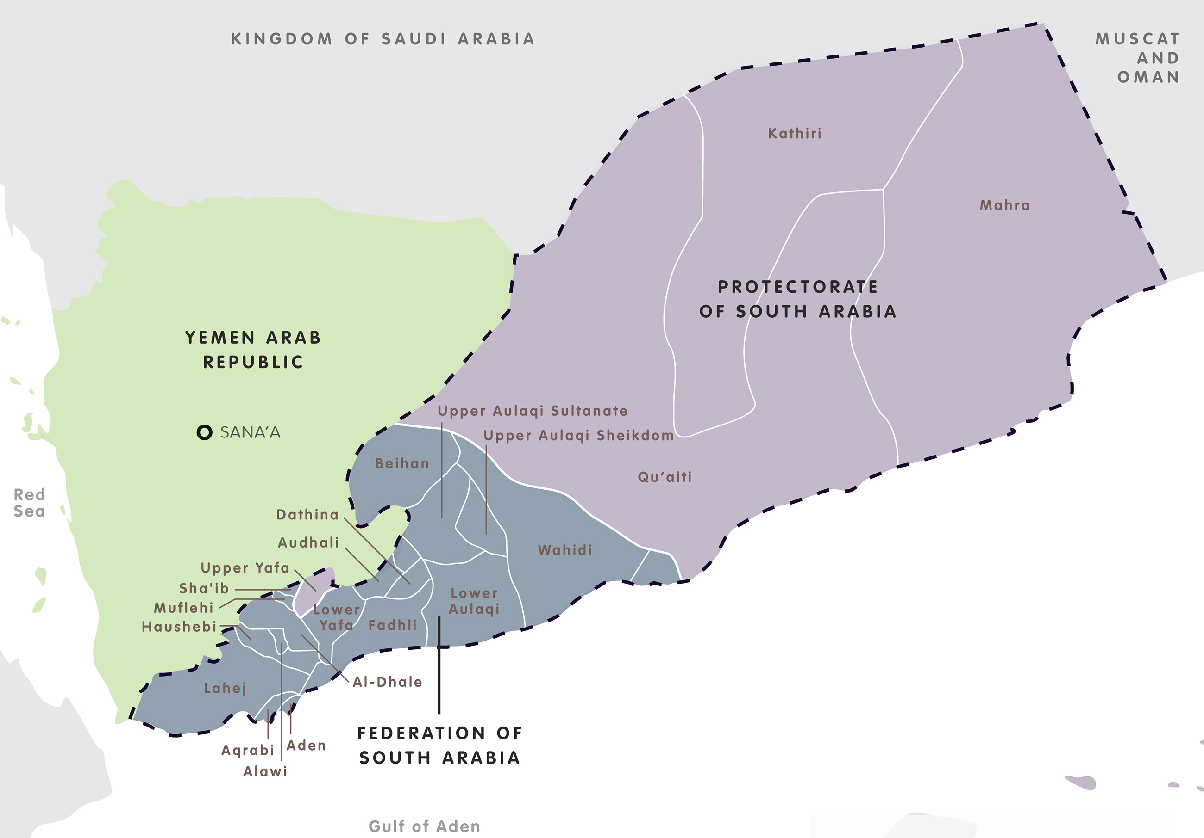
Figure #1: Borders between Yemen Republic (North Yemen) and South Arabia (South Yemen) as of 1962

Inequality between North and South
The transitional government attempted to balance North and South political power until the first democratic elections could be held. The executive governmental authority was composed of 3 Northerners and 2 Southerners, and cabinet posts were almost equally distributed between Northerners and Southerners. Yemen’s first national elections were held on April 27, 1993. The YSP placed third, with 18% of seats in parliament and 18% of votes, sweeping votes in the South by a landslide and affirming its dominance as a regional representative party. The General People’s Congress (GPC) and the Yemeni Congregation for Reform (frequently called Islah), parties affiliated with Saleh, gained 61% of seats, and remaining seats were won by small parties and independent candidates (IPU).
The YSP argued that because of its extreme popularity in the South, it had the right to govern that area, while Saleh proposed a 3-way coalition with the GPC holding majority seats, but the YSP refused to accept anything other than a 50/50 power split as established during the interim. As such, fighting broke out in late April of 1994 between the unintegrated armies of North and South but ended quickly on July 4th of the same year, when Northern troops entered Aden. Despite certain ranged strikes occurring against cities in the North, almost all of the actual fighting occurred in the South (Day).
In the weeks following, there was an influx of Northerners entering Southern cities, occupying homes of fled YSP officials and seeking to profit from the North’s victory, followed by a spread of corruption in provincial bodies. Southerners felt that their land, less densely populated than the North’s but nearly twice as large and and containing the majority of the country’s oil reserves, was being inequitably appropriated by the rulers of North Yemen. This remains a grievance today (al-Beidh).

The Sunni-Shia divide

Sunni Islam and Shia Islam are the two main denominations of Islamic teachings, with roughly 90% of Muslims being Sunni and 10% Shia. Sectarian violence has emerged from this ideological disagreement: one of the most significant in modern history is the proxy war between majority-Sunni Saudi Arabia and majority-Shia Iran. In Yemen, Zaydis (a subsect of Shia Islam common in Yemen) faced discrimination due to Sunni-dominated governments and resulting “Sunnification” policies (Ganguli).

The Zaydi-Shia Islamist Houthi movement emerged in the 1990s partially because of the Sunni-Shia divide; it claimed to fight for economic development, reducing corruption, and ending Shia marginalisation in Yemen.

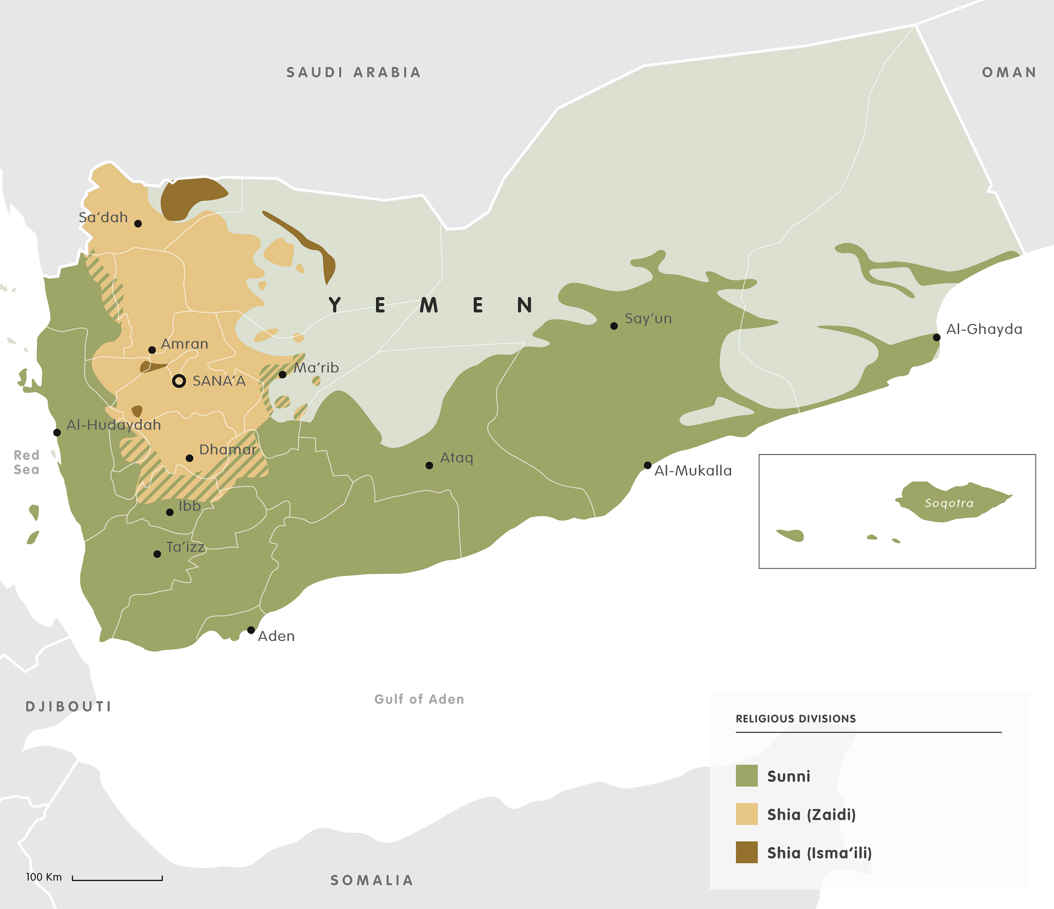
Figure #2: Religious divisions in Yemen

2004 Houthi insurgency
In 2004, the Yemeni government attempted to arrest Hussein Badreddin al-Houthi, a Zaydi religious leader and former parliamentarian, issuing a $55000 bounty for his arrest. Al-Houthi, in turn, accused Saleh of financial corruption and seeking to enrich his own family rather than the betterment of the nation. Starting in June, the government began to arrest hundreds of Houthi members, with the situation quickly devolving into full-scale civil war between Houthi movements and the Yemeni army.
On 10th September, 2004, Hussein al-Houthi was killed and one of his brothers, Abdul-Malik al-Houthi, became the rebellion’s leader, while his father, Badreddin al-Houthi, became the spiritual leader (Al Jazeera).
The violent insurgency continued until 11 August 2009, when the government launched Operation Scorched Earth, meant to be an “iron fist” against the rebels. Hundreds of thousands were displaced by the offensive, carried out through tank and aircraft warfare in the Sadaa region.
On January 1st, 2010, the Yemeni government offered a conditional ceasefire. The conditions included “the re-establishment of safe passage on roads, the surrender of mountain strongholds, a full withdrawal from all local authority property, the return of all military and public equipment seized during hostilities, and the release of all the detained civilians and soldiers”. On the 30th, Abdul-Malik al-Houthi accepted these ceasefire conditions (Al Jazeera).

Arab Spring

In 2011, a wave of pro-democracy protests known as the Arab Spring spread across the Arab world. Shortly after the successful Tunisian Revolution, demonstrations protesting against the Yemeni government and Saleh’s 33-year rule began. On January 27th, a protest with over 16000 participants took place in Sanaa; on February 2nd, Saleh was forced to make the concession that he would not run for re-election in 2013. However, discontent only grew, with several major tribes joining the protests by the end of February and demonstrations increasing to over 100000 on several days. There were calls from opposition leaders for Saleh to step down immediately.

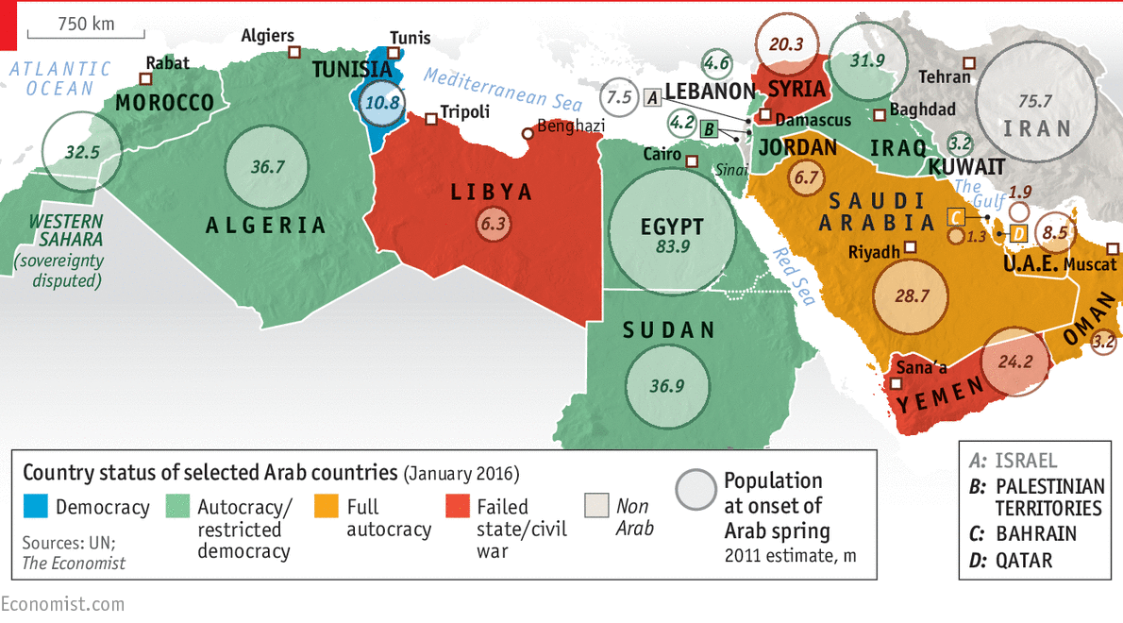
Figure #3: Effects of the Arab Spring as of 2016

In April, the Gulf Cooperation Council (GCC) attempted to draft several proposals for a transfer of power. Saleh agreed to sign a plan stipulating his resignation within 30 days and the formation of a national unity government leading up to elections, but he reversed the decision by the end of the month. This happened twice again in early May and late May, with Saleh accepting and then rejecting the GCC plan.

On November 23rd, 2011, Saleh finally signed the GCC plan, agreeing to transfer power to Vice-President Abdrabbuh Mansur Hadi within 30 days in exchange for immunity from prosecution for him and his family. A presidential election was held on February 21st, 2012; Hadi won 99.8% of the vote with a reported 65% turnout despite the lack of choice in candidacy (Kasinof).

Houthi takeover

On September 21, 2014, the Houthis took control of Sanaa after a series of violent clashes with governmental forces. As the moral guidance division of the Yemeni armed forces declared its "support for the people's revolution", the army did not formally intervene; unsuccessful opposition attempts were by forces affiliated with Islah. Throughout the rest of 2014 and January 2015, the Houthis continued to obstruct governmental processes, taking control of the port city Hodeidah, attacking Hadi’s residence at the presidential palace, and fortifying their presence at key locations, including intelligence headquarters (26sep).

On January 22nd, Hadi and Prime Minister Khaled Bahah resigned from their posts after having been placed under house arrest by the Houthis. In the power vacuum, chaos erupted - senior Houthi officials rejoiced, some Southern cities declared that they would no longer accept orders from Sanaa, and protesters in Aden flew the flag of South Yemen. With the Houthis now “the official authority” in Yemen, Hadi fled to Saudi Arabia (Newsweek).

Saudi-led coalition

Following pleas from Hadi in March, Saudi Arabia led a coalition of nine countries and launched Operation Decisive Storm, an intervention consisting of a bombing campaign and later naval blockade onto Houthi forces in Yemen. In April, Operation Decisive Storm was declared ended because they had "successfully eliminated the threat” posed by Houthi weaponry and a new phase called Operation Restoring Hope was launched. Despite this, the coalition continued air strikes against the Houthis (Hamid).

2022 Truce

The conflict persisted from 2014 to 2022 punctuated by short-term ceasefires, but in April of that year, they reached an agreement for a 2-month ceasefire mediated by the United Nations. This truce, which was the most significant break in hostilities since the commencement of the war, resulted in a considerable decrease in violence and casualties and was extended twice. Despite the expiration of the truce's official terms in October 2022 at 6 months, the cessation of fighting between the Houthis and the Saudi-led coalition has been mostly upheld.

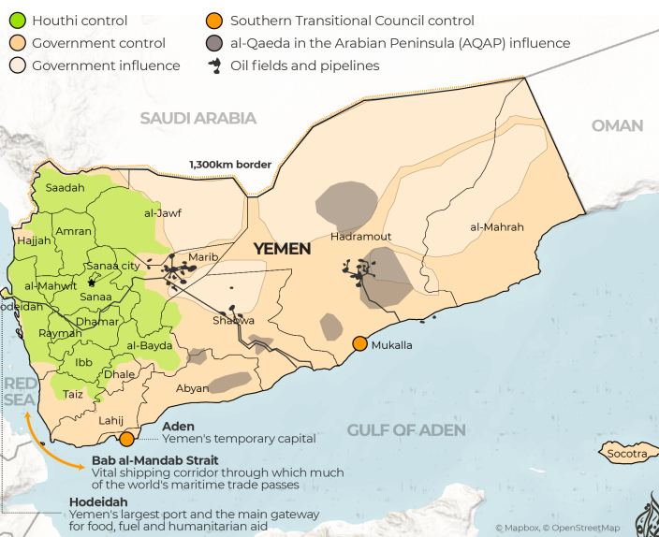

Figure #4: Territorial control as of January 2022

Saudi-Iranian proxy war

Saudi Arabia portrays itself as the Sunni authority while Iran portrays itself as the Shia authority; this has led to a struggle for dominance in the Middle East that affects almost every regional conflict, with the two providing support to opposite sides in wars in Syria, Yemen, Bahrain, Lebanon, Qatar, and Iraq to varying degrees. The situation has been described as a new cold war (WPR).

In the case of Yemen, Saudi Arabia openly supports the official Yemeni government with the Saudi-led coalition, while Iran is widely suspected to be arming the Houthis as well as providing support through Hezbollah, a Lebanese proxy, and its paramilitary network. Though any accusations of involvement have been denied by Iranian officials, Iranian supreme leader Ali Khamenei announced his “spiritual” support of the movement in 2019 (Reuters).

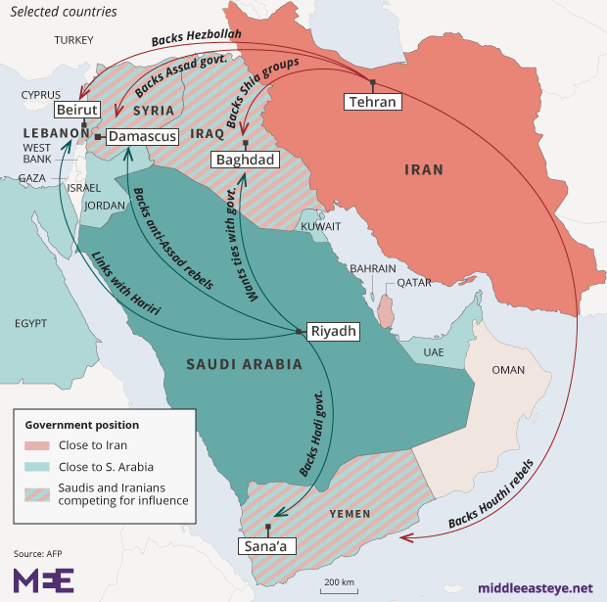

Figure #5: Saudi and Iranian influence in the Middle East

Major Parties Involved

Official Yemeni Government

The official and internationally recognised Yemeni government is a democratic republic; its political capital is Sanaa in the North, while its economic capital is Aden in the South. Post-reunification, it has been constantly unstable due to religious and political disagreement between North and South Yemen. As it stands, the Yemeni government is not in control of most of Yemen, and the country has no functional central government.

Houthi insurgents

The Houthi insurgents, officially Ansar Allah (Supporters of God) is a Zaydi-Shia political and military movement with its namesake being Hussein Badreddin al-Houthi. Its motto reads: “God is Great, Death to America, Death to Israel, Curse on the Jews, Victory to Islam”. It can be argued that the Houthis currently control more of Yemen than the government.
Southern Transitional Council (STC)

The STC, formed in April 2017, now controls most of South Yemen, including Aden. It is part of the southern independence movement, rooted in dissatisfaction with Saleh’s exclusionist and North-favouritist politics. It was decried as illegitimate by Hadi immediately upon its establishment but has continued to gain power since (Al Jazeera).
Saudi-led Coalition

The Saudi-led coalition in Yemen is comprised of nine countries (Saudi Arabia, the United Arab Emirates, Sudan, Bahrain, Kuwait, Qatar, Egypt, Jordan, Morocco, and Senegal) and was formed at the request of ousted President Hadi. It is currently active in carrying out attacks, most notably airstrikes and bombing campaigns, against the Houthis and has faced international backlash for escalating the conflict.
United States

The Obama and Trump Administrations continually supplied weapons to the Saudi-led coalition despite widespread public and governmental backlash; the Biden Administration declared an end to support for the coalition but continued to vehemently denounce the Houthis. Since 2015, the U.S. has provided more than $5.5 billion in humanitarian aid to Yemen.

Iran

Iran has been widely accused of backing the Houthis, and the war between the Houthis and the Saudi-led coalition is speculated to be at least partially a proxy war between Saudi Arabia and Iran. Iranian and Hezbollah officials have denied these claims. However, the U.S. in coordination with Saudi Arabia has presented evidence of arms transfers to the Houthis.
Al-Qaeda in the Arabian Peninsula (AQAP)

AQAP is a Sunni Islamist group that is part of the al-Qaeda network and active in Yemen and Saudi-Arabia. It has been designated a terrorist organisation by the UN, the U.S., Saudi Arabia, and the UAE among others. It has exploited Yemen’s insecurity to gain territory in majority-Sunni areas and carry out terror activities, most notably the 2015 mosque bombings (Ghobari).

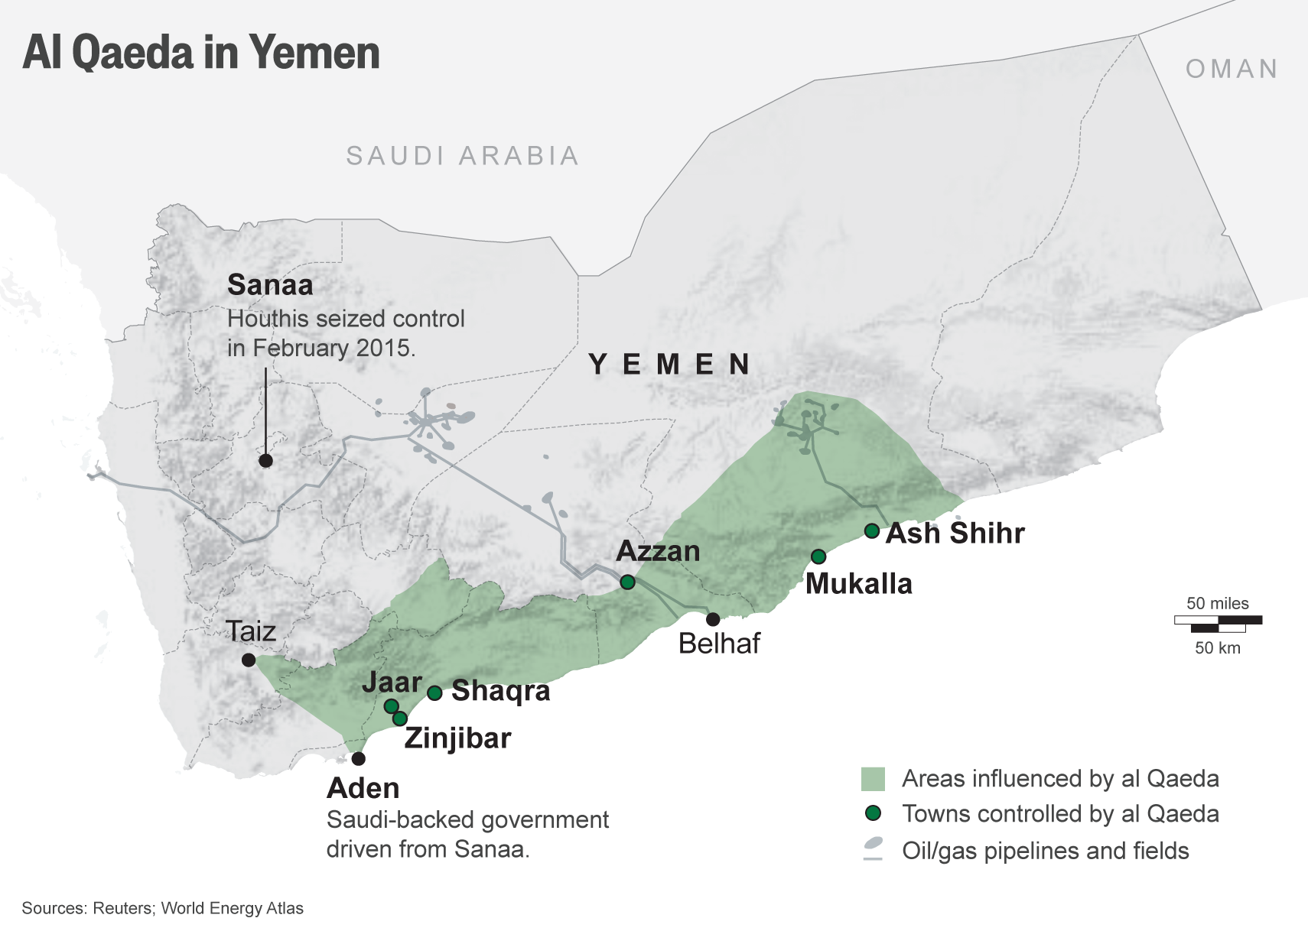

Figure #6: AQAP presence as of 2016

China

China has remained strategically neutral in the conflict and developed cordial relations with all parties, including implicitly recognising the Houthis and STC. As such, it has positioned itself as a diplomatic broker in both the Saudi-Iranian and Yemeni-Houthi conflicts.

UN Involvement, Relevant Resolutions, Treaties and Events
The UN first denounced the Houthis when they forcibly took over Sanaa in 2014. It also attempted to broker and maintain ceasefires several times over the course of the conflict, including in 2016, 2016, 2020, and 2022 to varying degrees of success.
In 2021, the Human Rights Assembly voted against renewing the mandate for the Group of Eminent International and Regional Experts on Yemen (GEE), the only independent body monitoring all parties to the conflict.
In 2014, the Security Council imposed a travel ban, asset freeze, and arms embargo on the Houthis in Resolution 2204. These measures have been unanimously extended several times (UN).

Timeline of Events
Date | Description of event
May 22, 1990 | North Yemen and South Yemen reunify, forming the Republic of Yemen under Ali Abdullah Saleh
April 7, 1993 | Yemen’s first national parliamentary elections occur
July 4, 1994 | First Yemeni civil war between North and South ends
June 2004 | The Yemeni government issues an arrest warrant for Hussein Badreddin al-Houthi and begins arresting Houthi members
August 11, 2009 | Yemeni government launches Operation Scorched Earth to crush Houthi resistance in Sadaa
December 17, 2010 | The Tunisian Revolution and the Arab Spring by extension begins
February 2, 2011 | Saleh announces that he will not run for reelection in 2013, ending his 33-year streak in office
November 23, 2011 | Saleh signs GCC’s transition agreement and passes power to Vice-President Abdrabbuh Mansur Hadi
February 12, 2012 | Presidential elections with Hadi as the only candidate are held and he is sworn in for a two-year period; despite this, there is a high 65% turnout
February 26, 2014 | UNSC passes resolution imposing travel ban, asset freeze, and sanctions on the Houthis
September 21, 2014 | Houthis seize control of Sadaa after weeks of protests against cuts to fuel subsidies, fighting Islah forces under General Ali Mohsen al-Ahmar
February 21, 2015 | Hadi flees to Aden and declares that he is still the constitutional president in a televised address, also declaring Aden Yemen’s temporary capital
March 20, 2015 | Sanaa mosque bombings occur, most likely carried out by AQAP, marking the deadliest terrorist attack in Yemen’s history with 137 killed and 357 wounded
March 26, 2015 | Saudi Arabia launches Operation Decisive Storm, leading a coalition of nine countries in an intervention following a request from Hadi
April 21, 2015 | Saudi Arabia announces the start of Operation Restoring Hope and declares the end of its airstrike campaign
May 8, 2015 | Following heavy pressure from the US, Saudi Arabia announces a 5-day ceasefire to start on May 12
May 13, 2015 | Humanitarian agencies try aid Yemen during the ceasefire period, docking supply ships at Houthi-controlled Hodeidah
June 14, 2015 | UN Secretary General Ban Ki-moon launches talks between the Yemeni government and the Houthis which collapse on June 19 due to each side accusing the other of breaching a truce
May 11, 2017 | The Southern Transitional Council (STC) is formed with the help of the UAE with former Governer of Aden Aidarus al-Zoubaidi as its leader; its legitimacy is immediately denounced by Hadi
January, 2018 | STC announces that it has “begun the process of overthrowing Hadi’s rule over the South”, taking control of Aden
August 9, 2018 | Air raid by Saudi-led coalition strikes school bus, killing 40, mostly children. Public opinion of U.S. support to the coalition plummets after it is reported that the bomb was U.S.-supplied
December 13, 2018 | The Stockholm Agreement is brokered by the UN and signed by all parties, committing to ceasefires in key port cities and a prisoner release
August, 2019 | STC effectively controls Southern governorates of Aden, Abyan, and Shabwa
November 5, 2019 | The Riyadh Agreement is signed by the Yemeni government, the UAE, and the STC, agreeing to unite against the Houthi insurgents
April 8, 2020 | Saudi Arabia initiates a unilateral two-week ceasefire to contain the spread COVID-19, a move that is applauded by UN Secretary-General Antóntio Guterres
April 26, 2020 | STC declares self-governance; this is dismissed by local authorities in most provinces and Socotra as “a clear and definite coup” but successful in Aden
April 1, 2022 | All parties accept a UN-brokered two-month truce starting with the holy month of Ramadan
April 7, 2022 | Hadi transfers power to a new eight-member Presidential Leadership Council which includes Zubaidi, President of the STC
March 10, 2023 | Saudi Arabia, Iran, and China state that an agreement has been reached between Saudi Arabia and Iran and that diplomatic relations between the two will be resumed

Previous Attempts to Resolve the Issue

Saudi intervention

Starting from Operation Decisive Storm, the Saudi-led coalition has been directly involved in Yemen’s situation. Although it is backed by most other Arab League states and some Western states, international reactions have been critical, even believing that Saudi intervention has caused Yemen’s landscape to devolve further into violence and chaos; evaluating its efficacy is difficult due to the opacity of the situation and how deeply entrenched it currently is, which muddies speculation.

Although it lent military legitimacy to resistance of the Houthi takeover, collateral damage to civilians and key infrastructure has been enormous, calling into question the decision-making process behind these occurrences. Saudi Arabia’s incentives for intervening may be concerned with its vested interest in preventing Iranian power from spreading more so than Yemen’s security. The Houthis have also begun probing the Saudi-Yemeni border and firing ballistic missiles towards Riyadh in recent years, so not only did the situation in Yemen not improve, Saudi Arabia may have inadvertently created a security threat for themselves (Darwich).

Stockholm Agreement (UNMHA)

The Stockholm Agreement, signed in 2018, has three components: a ceasefire in Hodeidah, a prisoner exchange, and an “understanding on Taïz”.

The first component received the most attention from the UN and has been largely effective: an estimated 150000 people who had evacuated the city returned after the ceasefire, and humanitarian aid channels have been significantly cleared. Before 2015, almost 80% of imports and 90% of wheat imports in Yemen were dependent on Hodeidah; the World Food Programme (WFP) alone in its best month of December 2019, provided food assistance to 12 million Yemenis, mostly through Hodeidah. Fighting has mostly ceased in that city with minor breaches, and a stronger UN presence has been established.

The second and third components have been notably less successful. The prisoner release has not reached the numbers promised in the agreement - only a few hundred have been returned to their families at most - and was mostly done through local mediators with only some involving the International Red Cross, excluding the UN from the process. No effort has been made to de-escalate fighting in the Islah-controlled Taïz governorate (OSESGY).

2022 ceasefire

The April 2022 UN-brokered truce was the longest lasting so far, leading to a substantial reduction in fighting even after the truce officially elapsed. In the first two months of the ceasefire, casualties from fighting across the country declined by over 85%, and neither the Houthis nor the Saudi-led coalition have launched cross-border attacks since it began. The ceasefire represents a valuable opportunity for long-term peace due to an obvious and dramatic de-escalation in military action even though it was not renewed (Stark).

Saudi-Iranian rapprochement

In early 2023, China brokered a détente between Saudi Arabia and Iran, promising to restore diplomatic relations and affirming “respect for the sovereignty of states and the non-interference in internal affairs of states” (PRC). Saudi Arabia and Iran formally cut ties in 2016 and have been engaged in various proxy wars since, including the one in Yemen. Although nothing concrete regarding Yemen has come out of this deal yet, it will likely cause a gradual de-escalation as both Saudi Arabia and Iran reduce support for the sides they back (Jalal).

Possible Solutions
The process of negotiating reform for Yemen and equitable representation of all parties will be a difficult one, so most international and UN efforts have been focused on securing a long-term ceasefire similar to the 2022 one to deliver aid and begin a restoration of infrastructure rather than determining a clear victor. Taking into account the aforementioned ceasefire and the recent Saudi-Iranian rapprochement, all parties may also be more amenable to a long-term or permanent ceasefire to recuperate and enter into formal negotiations regarding Yemen’s reform.
Additionally, the political insecurity in Yemen is rooted in the North-South divide and the Sunni-Shia divide which must be addressed. The former is because the South perceives the North as enriching themselves disproportionately on Southern oil, as well as the fact that their governance systems were vastly different before reuniting, causing long-term resentment and actors like the STC to appear. The latter is both because the Saudi-Iranian proxy war is rooted in sectarian differences, and because the Houthi movement itself is rooted in religious motives. A new system of government must take both of these into account; possible alternatives include re-separating South Yemen into a socialist state, forming a coalition government with representatives for all parties, or dividing the country into a federal system with separate governorates controlled by different parties under a centralised but less controlling government.

Research Guide

This is a collection of informative articles on various subtopics of the issue.

General information on Yemen: https://www.cia.gov/the-world-factbook/countries/yemen/
General timeline: https://arabcenterdc.org/resource/a-timeline-of-the-yemen-crisis-from-the-1990s-to-the-present/

Reunification of Yemen: https://carnegieendowment.org/files/yemen_south_movement.pdf
Sunni-Shia divide: https://www.cfr.org/article/sunni-shia-divide
Houthis: https://www.brookings.edu/articles/who-are-the-houthis-and-why-are-we-at-war-with-them/
Saudi-Iranian proxy war: https://www.worldpoliticsreview.com/israel-iran-saudi-arabia-battle-for-supremacy-in-the-middle-east/
Southern Transitional Council: https://www.crisisgroup.org/middle-east-north-africa/gulf-and-arabian-peninsula/yemen/yemens-southern-transitional-council-delicate-balancing-act
Al-Qaeda in the Arabian Peninsula: https://www.crisisgroup.org/middle-east-north-africa/gulf-and-arabian-peninsula/yemen/174-yemen-s-al-qaeda-expanding-base
Summary of UN intervention: https://www.securitycouncilreport.org/un-documents/yemen/

2022 ceasefire: https://www.rand.org/pubs/commentary/2023/07/yemens-year-long-truce-creates-opportunities-for-durable.html
Summary of reactions to Saudi intervention: https://en.wikipedia.org/wiki/International_reactions_to_the_Saudi-led_intervention_in_Yemen_(2015–present)
Stockholm Agreement: https://www.crisisgroup.org/middle-east-north-africa/gulf-and-arabian-peninsula/yemen/203-saving-stockholm-agreement-and-averting-regional-conflagration-yemen
Riyadh Agreement: https://www.mei.edu/publications/riyadh-agreement-yemens-new-cabinet-and-what-remains-be-done
Saudi-Iranian détente: https://www.mei.edu/publications/china-and-saudi-iran-rapprochement-implications-yemen

Bibliography
26sep. "he people of the moral guidance declare their support for the people's revolution." 21 September 2014. 26sep. <https://web.archive.org/web/20200317235750/http://www.26sep.net/news_details.php?sid=107024>.
Al Jazeera. "GCC rejects formation of Yemen transitional council." 13 May 2017. Al Jazeera. <https://www.aljazeera.com/news/2017/5/13/gcc-rejects-formation-of-yemen-transitional-council>.
Al Jazeera. "Profile: Yemen’s Houthi fighters." 12 August 2009. Al Jazeera. <https://www.aljazeera.com/news/2009/8/12/profile-yemens-houthi-fighters>.
Al Jazeera. "Yemen rebels renew ceasefire offer." 30 January 2010. <https://web.archive.org/web/20100131054310/http://english.aljazeera.net/news/middleeast/2010/01/2010130162418278418.html>.
al-Beidh, Ali Salem. "Al Beidh Speech 5/21/09 Official Translation." 21 May 2009. Armies of Liberation. <https://archive.ph/20120712201620/http://armiesofliberation.com/archives/2009/06/01/al-beidh-speech-52109-official-translation/>.
Darwich, May. "The Saudi intervention in Yemen ." 1 April 2018. University of Birmingham. <http://pure-oai.bham.ac.uk/ws/files/90966016/Darwich.pdf>.
Day, Stephen. "Yemen: On the Brink." March 2010. Carnegie Endowment for International Peace. <https://carnegieendowment.org/files/yemen_south_movement.pdf>.
Ganguli, Oyeshi. "Yemen: A Pawn in the Game of Middle Eastern Checkers?" 20 January 2021. The Pangean. <https://thepangean.com/Yemen-A-Pawn-in-the-Game-of-Middle-Eastern-Checkers>.
Ghobari, Mohammed. "Suicide bombers kill 137 in Yemen mosque attacks." 21 March 2015. Al Jazeera. <https://www.reuters.com/article/idUSKBN0MG11J/>.
Hamid, Nadeem. "Saudi Arabia Says Airstrikes in Yemen Succeeded in Ending Threat." 22 April 2015. Bloomberg. <https://www.bloomberg.com/news/articles/2015-04-21/saudi-arabia-says-airstrikes-in-yemen-succeeded-in-ending-threat>.
IPU. "ELECTIONS HELD IN 1993." n.d. Inter-Parliamentary Union. <http://archive.ipu.org/parline-e/reports/arc/2353_93.htm>.
Jalal, Ibrahim. "China and the Saudi-Iran rapprochement: Implications for Yemen." 5 April 2023. Middle East Institute. <https://www.mei.edu/publications/china-and-saudi-iran-rapprochement-implications-yemen>.
Kasinof, Laura. "Yemen Swears In New President to the Sound of Applause, and Violence." 25 February 2012. New York Times. <https://www.nytimes.com/2012/02/26/world/middleeast/abed-rabu-mansour-hadi-sworn-in-as-yemens-new-president.html>.
Newsweek. "Rise of the Houthis." 9 February 2015. Newsweek. <https://web.archive.org/web/20171112215529/http://www.newsweek.com/photo-essay-rise-houthis-305511>.
OSESGY. "A Year After the Stockholm Agreement: Where Are We Now?" 13 December 2019. Office of the Special Envoy of the Secretary-General for Yemen. <https://osesgy.unmissions.org/year-after-stockholm-agreement-where-are-we-now>.
PRC. "Joint Trilateral Statement by the People's Republic of China, the Kingdom of Saudi Arabia, and the Islamic Republic of Iran." 10 March 2023. Embassy of the People's Republic of China in Sweden. <http://se.china-embassy.gov.cn/eng/zgxw_0/202303/t20230311_11039241.htm#:~:text=The%20three%20countries%20announce%20that,and%20the%20agreement%20includes%20their>.
Reuters. "Iran's Khamenei backs Yemen's Houthi movement, calls for dialogue." 14 August 2019. Reuters. <https://www.reuters.com/article/us-yemen-security-iran/irans-khamenei-backs-yemens-houthi-movement-calls-for-dialogue-idUSKCN1V31W3/>.
Stark, Alexandra. "Yemen's Year-Long Truce Creates Opportunities for Durable Peace." 19 July 2023. RAND Corporation. <https://www.rand.org/pubs/commentary/2023/07/yemens-year-long-truce-creates-opportunities-for-durable.html>.
UN. "UN Documents for Yemen." n.d. Security Council Report. <https://www.securitycouncilreport.org/un-documents/yemen/>.
Whitaker, Brian. "The Birth of Modern yemen." n.d. Al Bab. <https://web.archive.org/web/20110123133107/http://www.al-bab.com/yemen/birthofmodernyemen/bmy2.htm>.
WHO. "Yemen Health Emergency." n.d. World Health Organisation. <https://www.who.int/emergencies/situations/yemen-crisis>.
WPR. "Iran and Saudi Arabia Battle for Supremacy in the Middle East." 9 August 2023. World Politics Review. <https://www.worldpoliticsreview.com/israel-iran-saudi-arabia-battle-for-supremacy-in-the-middle-east/>.

