Forum: Security Council
Issue: The question of military conflict in the Democratic People’s Republic of Congo
Student Officer: Minseo (Lian) Choi
Position: The Chair of the Security Council

Introduction
Democratic People’s Republic of Congo (DRC) is a nation located in Central Africa, and it is the second-largest African country in its area, bordered by nine countries including Angola, Rwanda, and South Sudan. DRC is projected to have the highest population growth rate, with it already having a population growth rate of 3.3% in 2023, the second highest in the world after Niger. This includes substantial immigration from other African countries to DR Congo, escaping from their conflicts and wars.
However, DRC itself is also suffering from civil war. Due to abundant natural resources such as diamond, gold, and coltan, DRC has been a place for unending conflict between different parties in DRC and foreign countries to take control of these rich resources. Rwanda and Uganda are continuously making unions with resistant forces in DRC to bring benefits to their countries, and it is worsened by Western countries’ desire to pillage natural resources. Most of the nations around the world, however, have not been taking action to solve DR Congo’s political instability, which eventually refrained the war to be ceased.
Although it is an internal conflict, 10 African countries were involved in the Congolese Civil War, causing the highest number of deaths after World War II, hence called Africa’s World War. The Second Congo War alone caused 4 million deaths, and there are a total of 25 million refugees around the world due to ceaseless combats. However, the seriousness of this prolonged conflict received minimal recognition on a global scale, evidently showing how the international community has turned away from one of the most serious ongoing humanitarian crises in the world. Furthermore, the UN had not shown a willingness to resolve the conflict. Although the UN had dispatched the peacekeeping force to DRC, there only have been minimal achievements, and the UN even decided to withdraw the force after 24 years on November 22nd, 2023.
Therefore, starting in 1996 but showing no sign of ending, the Congolese Civil War is one of the deadliest conflicts on Earth that needs to receive recognition from global society and a conflict that actions must be taken instantly.

Glossary
War
A conflict between political groups involving hostilities of considerable duration and magnitude.
Civil War
A violent conflict between a state and one or more organized non-state actors in the state’s territory – a war fought by two or more groups of people living in the same country.
Refugee
A person who is forced to leave the country due to a war or natural disaster.
Pretoria peace agreement
The peace agreement between the government of Rwanda and the Democratic People’s Republic of Congo on the withdrawal of Rwandan troops from the territory of DRC.
Internally Displaced Person (IDP)
A person or groups of persons who have been forced or obliged to flee or to leave their homes or places of habitual residence to avoid the effects of armed conflict, situations of generalized violence, violations of human rights, or natural or human-made disasters, and who have not crossed an internationally recognized State border.
Resource Depletion
The situation when renewable and non-renewable natural resources become scarce because they are consumed faster than they can recover, usually water, trees, and fossil fuels.
Coltan
A dull metallic mineral composed of columbite and tantalite, refined to produce tantalum, which is crucial in various industries, including semiconductors, surgical tools, and camera lenses.
Rwandan Genocide
The incident in 1994 when a group of Hutu tribes killed at least one million Rwandans, including 800,000 Tutsi tribes, as well as non-extremist Hutus, causing involvement of Rwanda in the Congolese civil war when DRC accepted and provided refuge to the Hutu extremists.
Adaptation
Ways a population tries to reduce vulnerability and absorb change without making a fundamental change or resolving the problem itself.
Mitigation
Strategies and ways to reduce the fundamental cause of an event – in this case, the Congolese Civil War – to slow down or ultimately terminate the event.

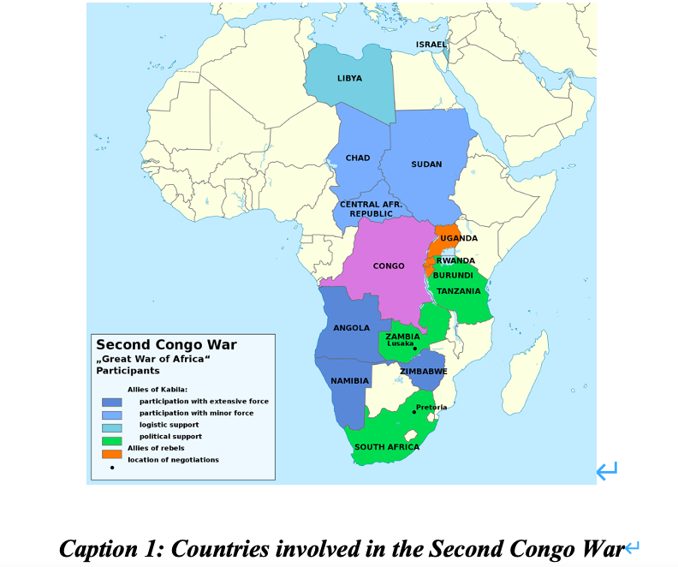
General Overview
Brief History
Mobutu Sesse Seco, who was the Chief of Staff of DRC, took power over the country in 1965. After 32 years of collusion with powerful countries such as the USA that wanted DRC’s underground resources, the First Congolese civil war occurred in 1996. Led by Laurent Desiree Kabila, ADFL (Alliance of Democratic Forces for the Liberation of Congo) took control of DRC after combatting the Congolese government army in 1997 with the support of Uganda and Angola.
However, due to Kabila’s similar dictatorship to Mobutu, anti-government forces, supported by Rwanda, started the Second Congolese Civil War (1998~2003). As a result, Kabila was assassinated, and his son, Joseph Kaila, took over as president. In December 2002, DRC and five other neighboring countries signed a Pretoria peace agreement; however, civil war is still going on today due to the activities of rebel M23.
In February 2013, eleven African countries signed a peace agreement to resolve the issue of the Democratic People’s Republic of Congo, but M23 is still active in the northern Kivu region, confronting government forces. As of 2010, 45000 people are dying a month, and the causes of this are said to be violence, hunger, and the spread of diseases.
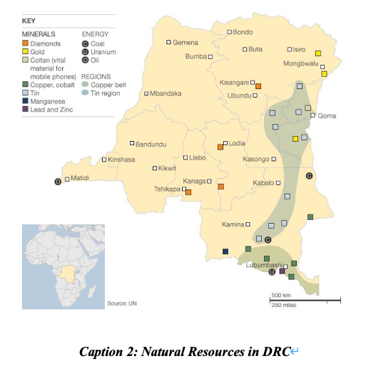
Cause – the curse of natural resources
Like Sudan, Liberia, and Angola, the most significant cause of the ongoing conflict in the Democratic People’s Republic of Congo is abundant natural resources. Although the initial cause may be the severe dictatorship in DRC, the conflict is still going on due to other countries wanting to take resources from DRC. DRC is a country where 3.4 million tons of cobalt (48.5% of all cobalt in the world), 150 million carats of diamond (20% of all diamonds in the world), 20 million tons of copper, and 110 thousand tons of tin exist. This has caused Rwanda, Uganda, and other Western countries that lack natural resources to fuel the conflict so they can illegally “acquire” resources behind the chaos.

Consequence
War crimes
Due to the long conflict, not only has it caused 5.4 million deaths, but ordinary people, especially women and children, are also exposed to war crimes. In DRC, it became more and more frequent to shoot, rape, and torture women. According to the UN, in North Kivu and Ituri, there has been recorded a total of 25,000 human rights abuses. Furthermore, these unacceptable crimes are not only done by rebels but also committed by government forces, police, and ordinary males. In 2011, it was estimated that 48 women were raped per hour, and 29 per 1000 women were raped, 58 times more than the USA. Furthermore, resistant force also takes children and trains them to be child soldiers, which is one of the most devastating consequences of the war. Because the government of DRC and UN forces are not taking proper actions, these demoralizing crimes have not been reduced until today.
Ecosystem destruction
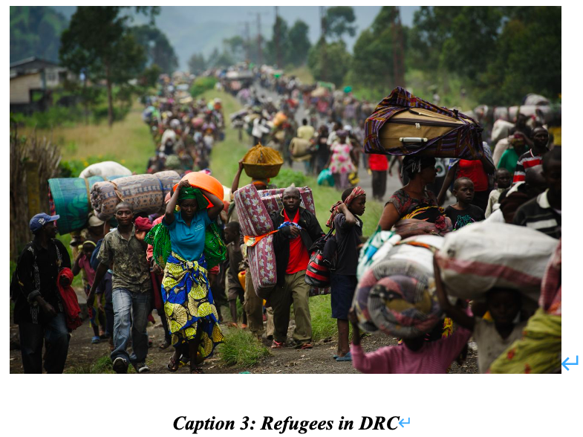
Due to the abundant resources available, DRC’s income level is not the lowest, but higher than that of countries like Chad, North Korea, and Yemen. However, due to ongoing conflict due to these resources, citizens’ suffering is far worse than those who are “normally poor.” However, DRC has been depleting its resources to maintain the existing income level. In addition to resistant forces and neighboring countries looting the resources, this destructive resource depletion has caused dreadful ecosystem destruction. The gorilla population has drastically reduced due to the destruction of their habitat, and the wild Northern white Rhinoceros species have gone extinct due to a lack of control over illegal poaching.
Hunger & Diseases
Due to endless war, in addition to refugees, there are also 5.5 million IDPs who were forced to move as their hometowns were no longer livable. In 2005, 71% of the entire population suffered malnourishment, higher than Ethiopia (46%) and Haiti (47%).
In the Democratic People’s Republic of Congo, there are currently 27 million people suffering severe food insecurity and 3.4 million malnourished children. DRC is currently one of the countries with the most perilous food crisis and one of WFP’s emergency rescue areas.
Ebola is the most threatening disease in DRC that has caused thousands of deaths, with more than 12 outbreaks of the Ebola virus occurring so far. There has also been suffering from measles for 25 months, causing more than 7000 deaths of children, which eventually ceased in 2021.

Political instability
Unlike the name Democratic People’s Republic of Congo, DRC is authoritarian and its government is very corrupt. It was ranked 170th out of 180 countries in the Corruption Perception Index in 2021, ranking at the bottom. Although the current economic crisis is mainly due to Rwanda’s support of the M23 armed organization, there has been continuous corruption and embezzlement by leaders, leading to chaos in the country. Furthermore, because neighboring countries are extremely against DRC’s growth, it is projected that DRC won’t get out of the world’s poorest position and won’t be stabilized in a short period. Incidentally, DRC’s Press Freedom Index was ranked 124th in the world in 2023, and the index of democracy was 162nd highest in the world in 2022.
Economic instability
Corruption was particularly beyond imagination in Mobutu Sesse Seko’s reign. Often called ‘theft politics,’ Mobutu embezzled about $4 billion USD, and his subordinates’ embezzlement is estimated at $30 billion USD. DRC was considered as rich as South Africa in the 1960s (average income $220 USD) due to its developed mining industry and agriculture (coffee, corn); however, this corruption was the main cause of the 1996 economic crisis, causing its economy to drop from 1970s and eventually became one of the world’s poorest countries in 1990s with average income $99.76 USD. The economy boomed in 2000, with average income increasing to $392.6 USD, but its economy has been growing exceptionally slowly since, having an average income of $577.2 USD in 2021. Despite this slow increase, due to high inflation, high prices, and uneven distribution of wealth, most citizens can only consume minimal needs, including unsanitary and low-nutritional local food.
Major Parties Involved
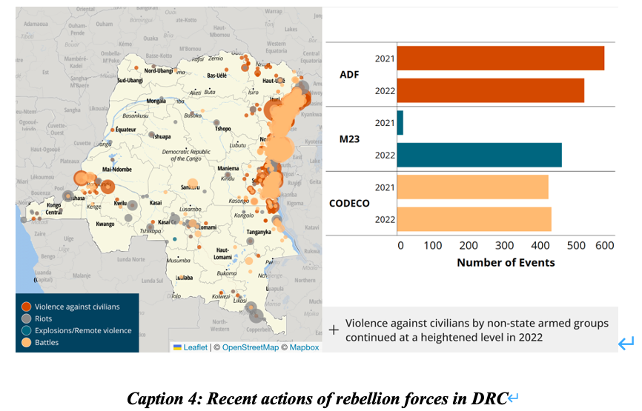
M23
M23 is a rebel force led by General Bosco Ntaganda, a member of Rwanda’s minority Tutsi tribe, arguing that the current government ignored the peace agreement and discriminated against the Tutsi tribe. Consisting of around 6000~7000 people, M23 had briefly taken over Goma, the key city in Eastern DRC with more than 1 million residents, although it was repelled by UN peacekeepers. They left the regular army and have been causing chaos in the country through murder, rape, and looting. They have also threatened to attack government forces and UN peacekeepers and “construct the new Congo,” causing international outrage. They are supported by Rwanda, highly likely because they plan to obtain underground resources in Eastern DRC.

Rwanda
There has been continuous political conflict between DRC and Rwanda, mainly due to ethnic issues. DRC gave refuge to ethnic Hutus who were the cause of the Rwandan genocide, resulting in Rwanda's rage at DRC and Rwandan forces being accused of hunting down and killing ethnic Hutu, even civilians, after sending its forces to DRC and causing the resistant forces to raise against the government.
Rwanda is the main cause of the ongoing conflict in DRC, supporting M23. One of the most likely reasons is DRC's natural resources. In 2013, Rwanda produced 28% of the entire coltan and the highest amount in 2014 as a country. However, it is recognized that this could only be possible by smuggling coltan from DRC. 70~80% of all coltan is buried in the Kivu region, where DRC's government has lost control.
Uganda
Uganda is one of the major countries that engaged in the Congolese civil war. From 1998 to 2003, Uganda supported rebels in the DRC and carried out military action in occupying territory within the DRC. These included the slaughter of civilians, human rights violations, and anti-humanitarian actions. Although there hasn't been official involvement of Uganda in the current civil war, there are some reports that there have been military activities at the border of Uganda and DRC.
Western countries
Western countries play an important role in the conflict in DRC. International organizations such as the UN and NGOs are actively providing aid to civilians as well as sending armed forces to cease the war as soon as possible. By working with the government, they are trying to resolve the conflict, as well as investigating human rights violations to hold criminals accountable.
On the other hand, some Western countries such as USA and Russia are not acting to stop the conflict but are even stimulating it to continue. Because these developed countries want to deprive natural resources in DRC, they are less likely to stop the opportunity of doing this actively during the period of chaos when DRC hasn't been stabilized, but instead support "resource colonialism."
China
China is one of the largest consumers of minerals from Africa. Natural resources take up 60% of all imports from Africa, which includes the import of copper and cobalt from DRC. Also, 30% of China's fossil fuel comes from Angola, Sudan, and Libya, chrome and platinum from South Africa, and copper from Zambia. China is actively supporting DRC in developing the mining industry as well as enhancing its infrastructure; by actively importing from and investing in DRC's industry, DRC's economy is being stabilized. China has also provided the Congolese government with drones and weaponry, which were used in fighting with M23 rebels.
However, as conflict and war can benefit China by purchasing natural resources at low price levels, China actively purchases resources from these countries instead of not taking strong action against ongoing conflicts. Also, investment for development in DRC could be unsustainable and may cause social and economic problems as the development is imbalanced.

The current government force of the DRC
The Congolese government has been constantly trying to have political conversations with resistant forces and negotiate with them. To bring peace as soon as possible, the government is also actively suppressing the rebels and enforcing strict laws regarding human rights and the punishment of criminals. Also, by reaching out to other countries, the Congolese government has been trying to stimulate the economy back to a higher level.

UN Involvement, Relevant Resolutions, Treaties, and Events
UNHAS has increased the accessibility of the airplane transport system. By locating an airport-like system in Kananga permanently, the UN can now transport food/water, basic needs, and medical equipment to provide foreign aid to refugees in the Kasai region.
UN dispatched MONUSCO (peacekeeping force) in 1999 to support the Congolese government and repel resistant forces such as M23. In February 2013, 11 African countries gathered in Ethiopia to resolve that Rwanda and Uganda would not intervene in the Congolese civil war. In March of the same year, MONUSCO's force was strengthened by adding 3069 peacekeeping soldiers. It was authorized to start active offensive operations on M23 for the first time in the history of the UN peacekeeping force, leading M23 to be officially disbanded in late 2013.
However, the Congolese Vice Prime Minster Christophe Lutundula and the head of MONUSCO Bintou Keita co-signed a note on the accelerated, gradual, orderly, and responsible withdrawal of MONUSCO from the DRC on November 21st, 2023, which contained a plan (consists of 3 stages) and a timeline for the complete withdrawal [UN Peacekeeping]. This is withdrawal after 24 years from dispatch, and it is believed that the reason is the constant request of the Congolese government to withdraw the peacekeeping force from DRC due to the lack of contribution of MONUSCO and even some conflict between the UN and the government.

Timeline
Date | Events
1960 | DRC was liberated from Belgium, but corruption, political instability, and conflict between regions had deepened.
1965 | A military coup led by Mobutu Sese Seko started the First Congo War
1971 | Mobutu's military coup took the control of DRC.
1977 | Mobutu was assassinated, but military rule continued.
1997 | Laurent Kabila-led rebels have started the Second Congo war against the current government force.
1998 | The rebels and other resistant groups escalated the civil war into complex conflict involving various military forces as well as other countries
1999 | UN had dispatched MONUSCO to DRC to minimize the conflict.
2003 | A peace agreement was signed between the government forces and rebel groups, but the civil war persisted with various clashes between government military force and resistance forces
2011 | Elections were held, but political instability and conflicts persisted. The rebel group M23 instigated significant military clashes.
2013 | MONUSCO was strengthened through an increase in the number of dispatchers, and the UN Stabilization Mission was officially deployed, leading the peacekeeping force to eventually engage in the war and actively support the government.
2018 | New presidential were held, and Félix Tshisekedi was elected as the new president.
2020 | The civil war in the DRC remains ongoing, with continued conflicts between the government and rebel groups. The international community is actively providing aid and putting efforts in place to resolve the civil war and bring peace and stability to DRC.
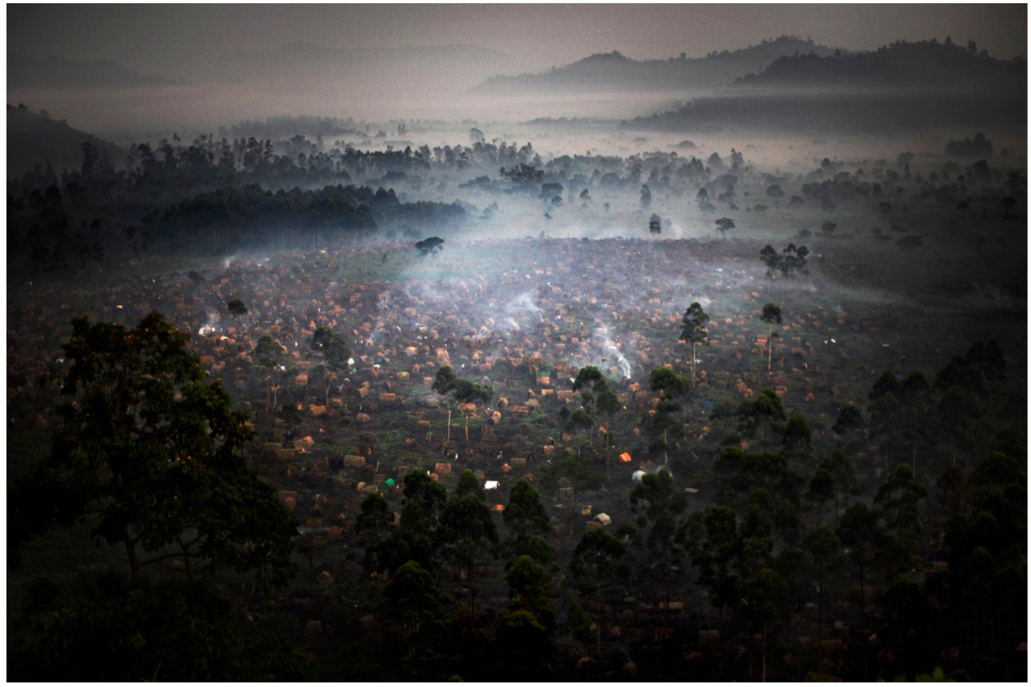

Caption 5: A refugee camp in a region of DRC
Possible Solutions
Adaptation
Food supply
Solutions for enhancing the living quality of ordinary people are necessary to minimize the current consequences of the Congolese war. WFP had been supplying basic food supplies such as cereal and salt to IDPs and refugees and nutritious food to malnourished people. They supported 450 thousand people in 2017 and 1.2 million people in 2018.
Enforcing stricter laws and policies regarding war crime
To reduce unending human rights violations, including murder, rape, and looting, the government would need to strengthen the level of legal framework and institutions that protect human rights. Reforms in the legal mechanism for safeguarding people, including civilians, children, and women, should be made. Collaboration with human rights organizations, improving education in a moral framework, human rights, and peaceful resolution, and raising awareness of values such as nonviolence, gender equality, and respect should be prioritized and conducted throughout the DRC.
Mitigation
International Rescue Committee
International Rescue Committee has provided medical equipment, medical services, sanitation, water, and other health-related supplies. It has also invested in doctors and educators to treat and prevent Ebola outbreaks and the impact of COVID-19. Furthermore, they write annual reports to list the problems of countries currently at risk and possible solutions to eradicate them, including the Democratic People’s Republic of Congo.
Indirect support
The UN has recently decided to withdraw UN peacekeepers from DRC due to the limitation of the force's ability to contribute to solving the conflict. Therefore, solutions such as raising awareness of the Congolese Civil War, reducing HICs' contribution to worsening the conflict to earn benefits, and providing economic support to stabilize the country would potentially be more effective methods than direct intervention in the war.

Research Guide
In the Security Council, lots of initial research should be done in order to fully understand the ongoing situation and feasible solutions according to it. Therefore, research from different perspectives is necessary. While focusing on comprehending the connection of the war with one's nation, research about the connection and relationship with various countries that are involved in the Congo war, as well as the nation's position on recent attempts of resolution, are also crucial. The use of AI, such as Chat GPT, to search facts and statistics is acceptable, but cross-checking must be done in order to use the information.
Below are some sources about the problem of ongoing conflict in DRC:
- https://reporting.unhcr.org/operational/situations/democratic-republic-congo-situation
- https://www.thedefensepost.com/2023/03/12/angola-army-dr-congo/
- https://www.crisisgroup.org/africa/central-africa/democratic-republic-congo/292-republique-democratique-du-congo-en-finir-avec-la-violence-cyclique-en-ituri
- https://www.cfr.org/global-conflict-tracker/conflict/violence-democratic-republic-congo
- https://news.un.org/en/story/2023/11/1143937
And below are videos containing more detailed information about the DRC Conflict and its urgency:
- https://www.youtube.com/watch?v=BF9WE5VE5WI
- https://www.youtube.com/watch?v=uxWahUxx2i8
- https://www.youtube.com/watch?v=ykf9Wh97uPk

Bibliography
History Guild. “Africa’s World War: The Congo War.” History Guild, 19 Jan. 2022, historyguild.org/africas-world-war-the-congo-war/. Accessed 18 Dec. 2023.
“Democratic Republic of the Congo Emergency: World Food Programme.” UN World Food Programme, www.wfp.org/emergencies/drc-emergency. Accessed 18 Dec. 2023.
Charlie, Lima. “Cobalt Mining, China, and the Fight for Congo’s Minerals.” Lima Charlie World, 5 Feb. 2018, limacharlienews.com/africa/cobalt-mining-congo/. Accessed 18 Dec. 2023.
Anna, Cara. “Explainer: Why Rwanda and Congo Are Sliding toward War Again.” AP News, AP News, 17 June 2022, apnews.com/article/politics-east-africa-rwanda-united-nations-49c5e58469496e272286dc5b82baa1a2. Accessed 18 Dec. 2023.
the Africa Center for Strategic Studies. “The Role of External Actors in the DRC Crisis – Africa Center.” Africa Center for Strategic Studies, 21 July 2017, africacenter.org/spotlight/role-external-actors-drc-congo-crisis-sadc-au-icglr-un-eu/. Accessed 18 Dec. 2023.
TheAfricaReport. “Uganda/DRC: Kampala Offers Security and Roads for Minerals.” The Africa Report.Com, www.theafricareport.com/92653/uganda-drc-kampala-offers-security-and-roads-for-minerals/. Accessed 18 Dec. 2023.
“Human Rights Abuses Intensifying in Eastern DR Congo - UNHCR | UN News.” United Nations, news.un.org/en/story/2021/09/1099582. Accessed 18 Dec. 2023.

Photos
Populationdata.net, 2017, en.populationdata.net/wp-content/uploads/2017/03/RDC-2e-guerre-Congo.png. Accessed 18 Dec. 2023.
The DRC, Explaining the Development Gap – MrB Geography IB. mrbgeographyib.mrbgeography.com/the-drc-explaining-the-development-gap/. Accessed 18 Dec. 2023.
Cnn.com, 2023, media.cnn.com/api/v1/images/stellar/prod/121123110824-congo-crowds-fleeing.jpg?q=w_3000. Accessed 18 Dec. 2023.
Acleddata.com, 2023, acleddata.com/acleddatanew/wp-content/uploads/2023/02/Screen-Shot-2023-02-08-at-9.42.26-PM.png. Accessed 18 Dec. 2023.
McConnell, Andrew. Crisis in Congo. andrewmcconnell.com/Congo’s-Wars/1. Accessed 18 Dec. 2023.

