Forum: World Health Assembly
Issue: Addressing the Silent Epidemic: The Global Rise of Non-Communicable Diseases (NCDs)
Student Officer: Yoon Seo Seo
Position: Co-Chair of World Health Assembly

Introduction
The issue of the global rise of noncommunicable diseases is critical given that they have a silent impact on the health and well-being of the global population. The non-communicable diseases (NCDs), often known as silent diseases, are a class of diseases that are not transmissible. These disorders are not caused by any specific infection. Long-term cancer, cardiovascular disease, diabetes, and lung disorders are examples of these diseases. The expanse of NCDs is shivering. These diseases afflicted 41 million people, resulting in 74% of fatalities. Seventeen million people perished, with 77% - 86% of them living in low and middle-income nations.
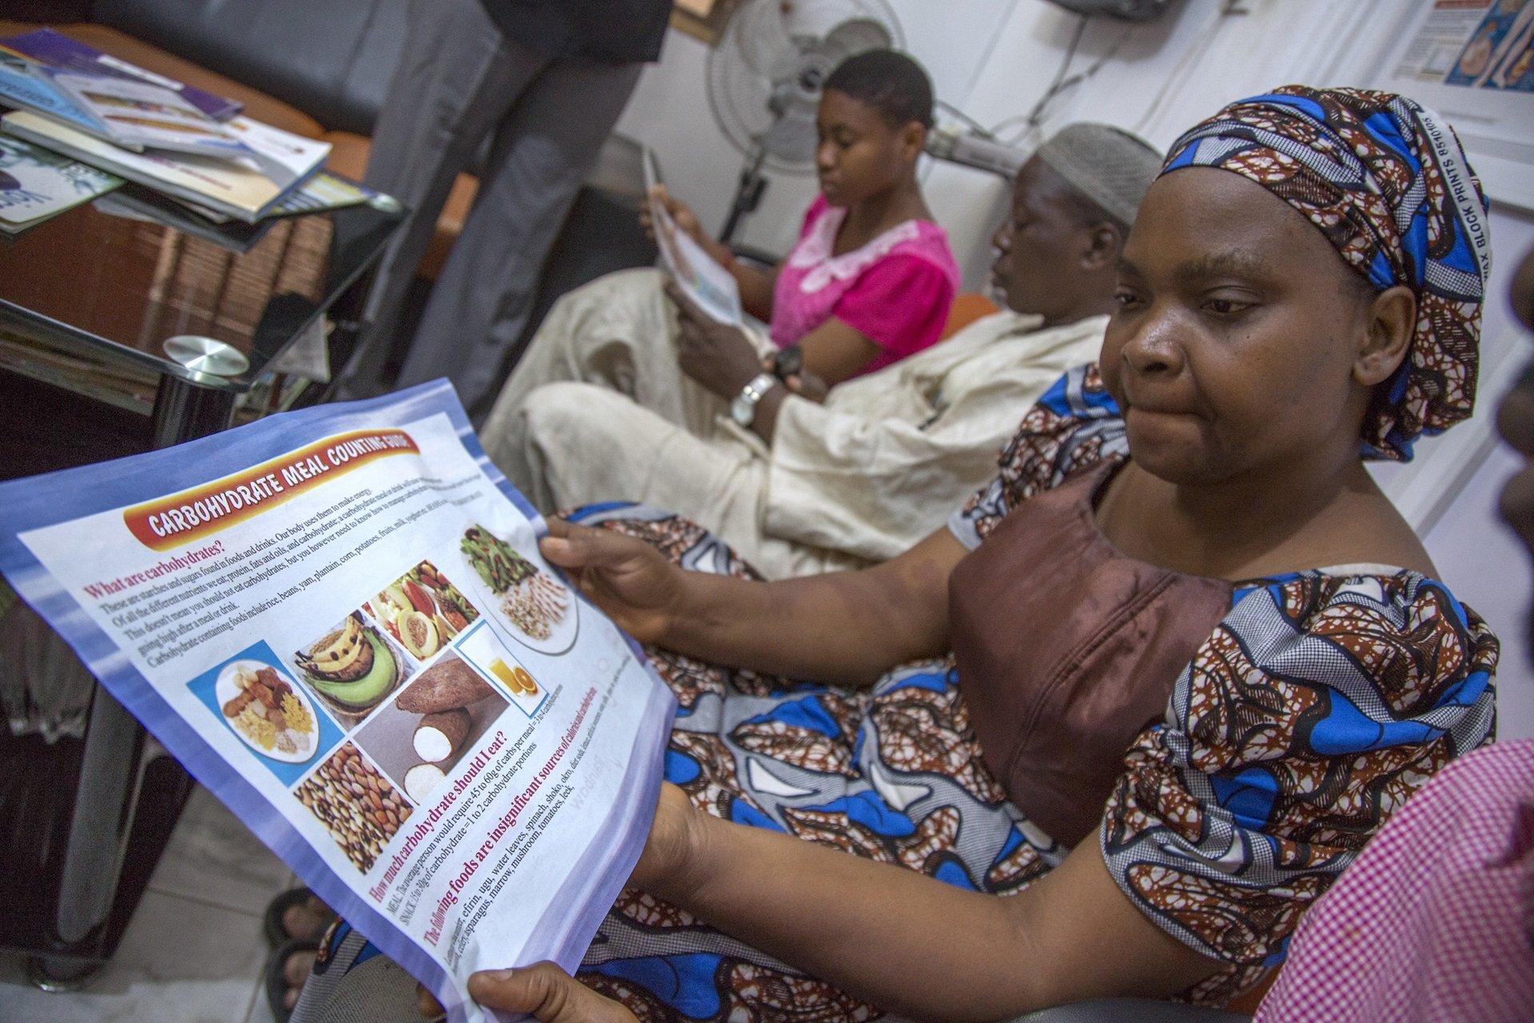
17.9 million people died from various diseases, including diabetes (2 million), chronic respiratory diseases (4.1 million), and cancer (9.3 million). NCDs are a threat to people of all ages. Either as a result of smoking, air pollution, poor diets, or laziness. Disadvantaged people die sooner than those who live in middle-class or wealthy nations, as seen by the sharp rise of NCDs in these nations. These populations have a higher risk of developing NCDs because they are more fragile and are exposed to prohibited materials. Consequently, the expense of medical services swiftly depletes the savings of households in low-income countries.
(Development of Implement Roadmap 2023-2030)
Citizens' awareness of social issues has increased as a result of the current non-communicable disease crisis. To improve the state of NCDs, the World Health Organization (WHO) has adopted a number of steps. They have put an end to the member states' collaboration on tobacco usage control. Thus, the member states' examination of risk factors and NCDs death rates was aided by the tracking and reporting of current population statistics. The World Health Organization (WHO), in particular, and the United Nations have tried to do everything possible to improve the emergency situation. Nonetheless, many individuals in low-income nations find it difficult to cope with the difficulties posed by NCDs and the possibility of preventing those illnesses.

Definition of Key Terms

Non-Communicable Diseases (NCDs)
The term Non-Communicable Diseases (NCDs) is also known as silent diseases. This refers to the diseases that cause death at the end. The NCDs are not transmitted by acute infection. It has long-term health consequences. A Common disorder that counts as NCDs are heart disease, chronic respiratory disorder, diabetes, and cancer.

Differentiation

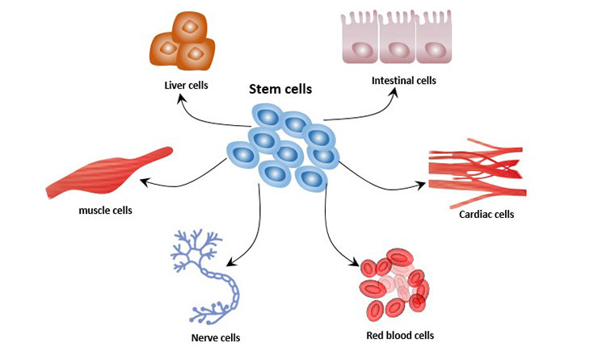
Differentiation is a scientific term that refers to cell specialization. In biological terms, the original unspecialized cell developed into a specialized structure. Once they are specialized, those cells now maintain their specific function and roles. Examples of differentiation are nerve, muscle, and blood cells.

(Cell differentiation of stem cells, CUSABIO)

Cancer

Cancer is a disease where some specific body cells grow tremendously. This growth of cancer cells in specific body parts can transfer or spread elsewhere. The cancer cell can start anywhere in any human body part. Normal human cells stop growing once they come upon another cell. However, cancer cells occupy into nearby areas and replicate their cells.

Gadgets

General Overview
The viruses have been developing in increasingly potent and widespread ways for a number of years. It was over this extended period of evolution that viruses became silent and non-silent. People today are frequently affected by NCDs, which can lead to major health problems. The flexibility of species has led to the creation of NCDs. When viruses go through a differentiation process, this procedure helps the tissues to develop more effectively. Differentiating frequently refers to the process of one unspecialized (undifferentiated) cell becoming specialized and acquiring certain organelle responsibilities and functions. This occurs when gene expressions and structures are altered. Furthermore, viruses are malleable and may adapt to almost any type of environment.
The problem of the development of viral differentiation and flexibility is made easier by the industrial component. Lifestyles and usual eating habits undergo significant changes as a result of urbanization and globalization. Greater food accessibility, a wider variety of nutritional options, and high-calorie snacks are common in urban settings. These diets hurt blood pressure, blood cholesterol, and insulin resistance. Conversely, an increase in NCD cases is a result of poorly managed health services. The availability and affordability of medical services can influence how NCDs develop. The rate of instances of recur of NCDs can be decreased with proper therapy. Nevertheless, the cost of medical care is a barrier for low-income households, which drives up the number of cases of NCDs.

Major Parties Involved

Albania

Currently, Albania is facing the highest risk of death from Non-communicable Diseases (NCDs). The three main risk factors that lead the Albanian population to death is arterial hypertension, nutritional-related impact, and abuse of illegal substances. Throughout the issue, the Albanian population has over 30% mortality rate due to dietary problems and smoking takes 16% of the mortality rate. While female smoking is increasing, the death rate of males who smoke increases as well. The large socioeconomic differences within other countries with lower social status bring challenges in caring for the NCDs. However, the country itself and the World Health Organization (WHO) have promoted good healthy nutrition absorption and physical activities to Albanian citizens. Thus, the country has also progressed anti-smoking policies against students in school.

South Korea
South Korea is a country that has the most effective disease prevention. Medical technology has dramatically increased through industrialization. They have scored 8.3% risk of death from NCDs. There are several reasons why the rate of death in South Korea is the lowest overall. The government enterprise plays a role in the reason. The South Korean government has tooled various public health care programs including healthy living style and anti-smoking against the Students. Moreover, the healthy diet habits that South Koreans have reduce the chance of getting NCDs. Usually, most South Koreans absorb vegetables, seafood, and fermented food which are all highly nutrient-dense.

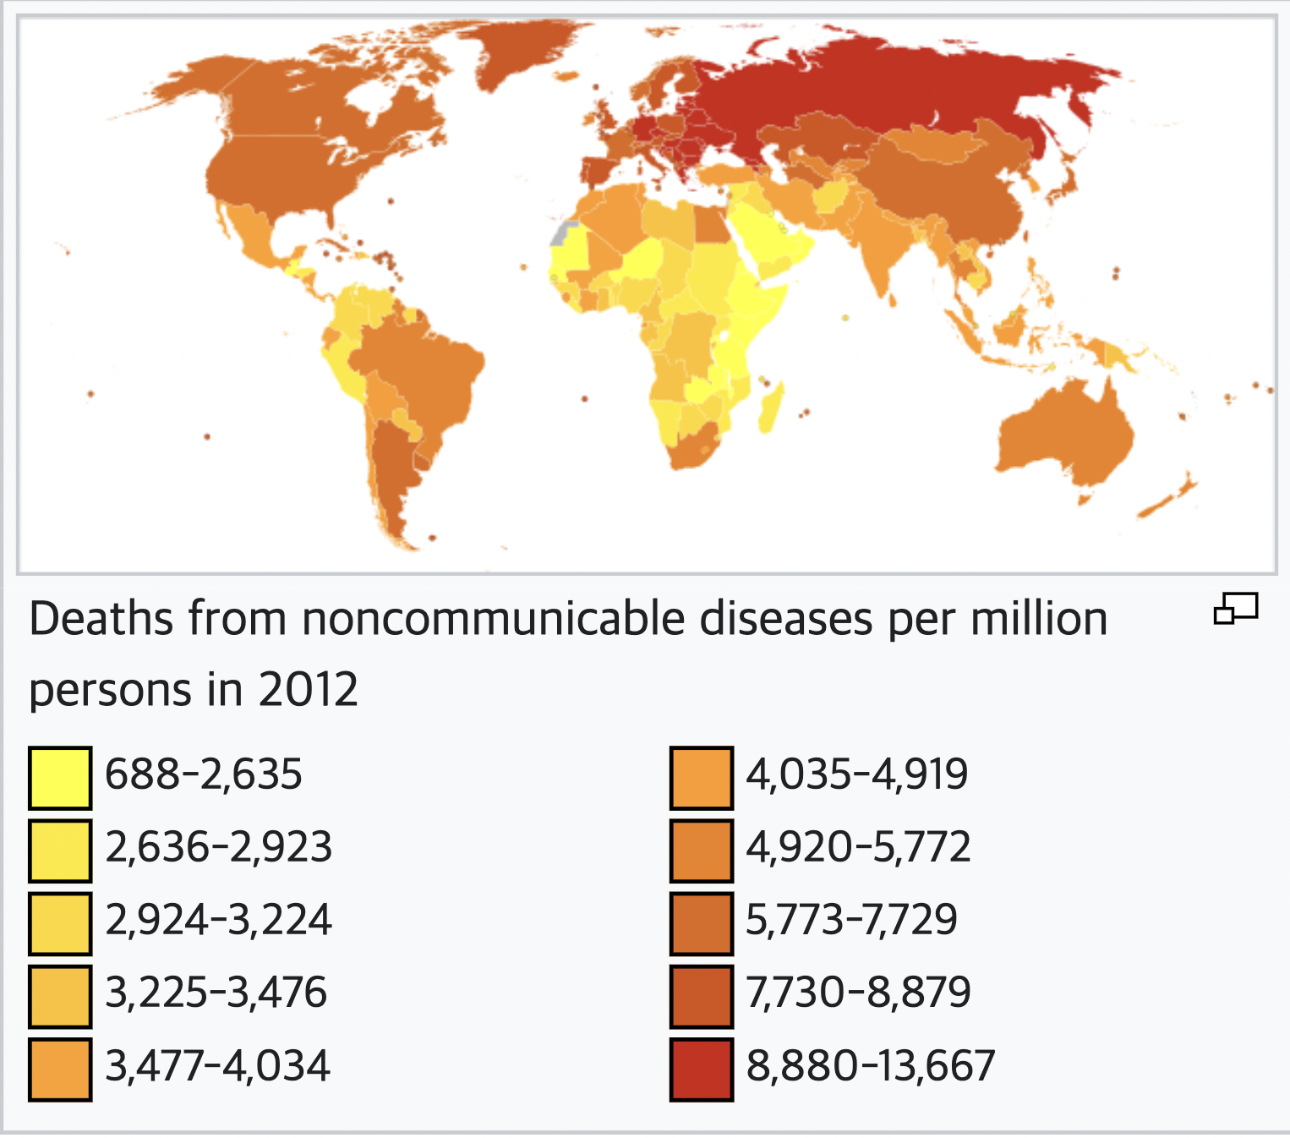
(Death rate from NCDs per millions in 2012)

World Health Organization (WHO)

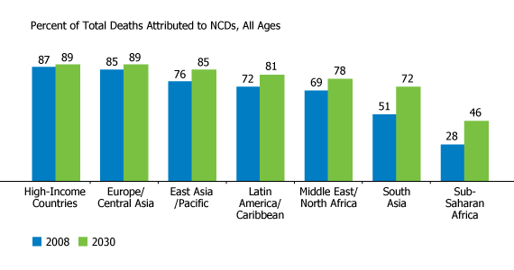
The World Health Organization (WHO) has participated actively in reducing the causes and effects of NCDs. They have approached various ways to reduce the NCDs. They have played the Framework Convention on Tobacco Control (FCTC). This action has increased the awareness of tobacco abuse and decreased the assumption of tobacco. Not only tobacco, however, they have promoted different physical activities and dietary program to reduce the chance to get NCDs.

(Rate of NCDs and prediction of each region)

UN Involvement, Relevant Resolutions, Treaties and Events
Recognizing the significant effect that non-communicable diseases (NCDs) have on open wellbeing and economic improvement, the United Nations (UN) has taken an active part in combating this global issue. The UN's engagement in the battle against NCDs is demonstrated by a number of programs, associations, and international systems that center on prevention, treatment, and control. The UN's Sustainable Development Goals (SDGs) are a remarkable project that contains an objective (SDG 3.4) committed to bringing down early passing from non-communicable illnesses. This reflects the understanding that one of the greatest barriers to accomplishing general wellbeing and well-being is the nearness of NCDs. In this way, the UN has played a critical role in advancing worldwide collaboration to address NCDs by highlighting the relationship between well-being and other features of improvement.
In an effort to progress the discussion on NCDs and encourage some countries to deliver these concerns best needed on their national motivation, the UN has organized high-level conferences and meetings in later a long time. In 2018, the UN General Assembly facilitated a High-Level Meeting on the Anticipation and Control of Noncommunicable Diseases (NCDs), giving leaders an environment to conversation issues, trade best practices, and resolve to require facilitated activity. Such occurrences highlight how crucial it is to have a coordinated, worldwide reaction to NCDs.

Despite these efforts, problems with NCDs still exist. One consistent stress is how NCDs are influenced by the COVID-19. NCD preventive and treatment services have been disturbed as a result of the pandemic's disruption of well-being frameworks, misallocation of resources, and acceleration of vulnerabilities. The UN has been forcefully handling these issues and pushing for the consideration of NCD administrations in efforts to respond to and recover from pandemics.

Timeline of Events
In arrange to supply a thorough timeline for Non-Communicable Diseases (NCDs), important policies, events, and advancements within the information, treatment, and prevention of NCDs must be highlighted. The arrangement of events may differ by region and country; subsequently, it is sure that typically it is a harsh timeline.
Date | Description of event
May 20, 2000 | The World Health Organization (WHO) has passed the committee of World Health Organization (WHA) 53.17 which detects and alarm the issue of global health.
April 13, 2002 | The unbiased WHO/FAO expert report on diet, nutrition, and the prevention of chronic diseases, which supports to decrease salt intake as a way to lower the risk of hypertension and suggests reducing the intake of free sugar as a way to lower the risk of diabetes, is being attacked and undermined by the Salt Institute and other industry lobbying groups.
April 23, 2003 | The WHO publishes its Diet, Nutrition, and the Prevention of Chronic Diseases Report. In it, the organization expressly recommends cutting back on salt and consuming less sugar.

December 3, 2003 Oxford Health Alliance is founded. The Oxford Health Alliance, formerly known asOxford Vision 20/20, was established in 2003 as a collaboration between Novo Nordisk A/C and the University of Oxford. Its goal is to prevent epidemic chronic disease by addressing the three major risk factors in a coordinated manner, involving all stakeholders.

February 8, 2007 Derek Yach, a former executive director of the World Health Organization's (WHO) Noncommunicable Diseases and Mental Health cluster, is named Director of Global Health Policy at PepsiCo

March 2, 2007 KEI addressed a letter to WHO regarding the Essential Medicines List, listing many NCD medications as well as other potentially essential medications "if available from competitive generic suppliers at generic prices."

September 15, 2007 Following a summit on NCDs, the Caribbean states (CARICOM) are forced to endorse a UN General Assembly resolution that calls for a high-level meeting in 2011.

Previous Attempts to Resolve the Issue

Global efforts to fight non-communicable diseases (NCDs) have grown significantly over time because of a number of programs, laws, and cooperative projects. The effort to fight against non-communicable diseases (NCDs) gained steam in the second part of the 20th century and since then created, exhibiting an increased awareness of the complicated problems posed by illnesses like cancer, diabetes, cardiovascular disease, and chronic respiratory conditions.

The World Health Organization (WHO) Global Strategy for the Prevention and Control of NCDs was established in 2000, marking an important turning point in the course of NCD prevention and control. This acknowledged the need for a coordinated and comprehensive approach for addressing NCDs, and it was a turning point in the leadership of global health. In order to address the rising burden of NCDs, the strategy comprised significant measures, such as emphasizing the importance of lowering risk factors, encouraging healthy lifestyles, and strengthening health systems.

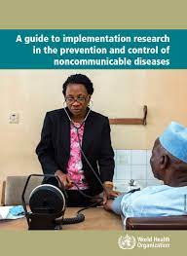
(Guide to Implementation research in the prevention and control of non-communicable diseases, World Health Assembly)

The WHO introduced the Global Action Plan for the Prevention and Control of NCDs 2013-2020 in response to the high-level meeting. This action plan, which prioritized lowering the number of deaths from NCDs, expanding access to treatment, and enhancing health and well-being, set high goals for its member nations. In order to address disparities in health and social factors that influence of health, the plan also acknowledged the relationships among NCDs and other development goals.

Possible Solutions
Addressing and raising awareness of Non-Communicable diseases (NCDs) requires a scientific approach to the issue and solutions. It is essential to focus on the issue of health and equity for this purpose. Here are some possible solutions for the reduction of NCDs' global dispersion.
One key road for tackling NCDs lies in preventive strategies that target modifiable risk components. Advancing healthy ways of life, counting standard physical activity, balanced sustenance, and tobacco cessation, can essentially decrease the incidence of NCDs. Open wellbeing campaigns, education programs, and community interventions can raise awareness almost the significance of way of life choices in avoiding diseases such as cardiovascular disorders, diabetes, and certain cancers. Governments and healthcare organizations play a crucial part in making situations that support and empower more advantageous behaviors, from planning urban spaces that encourage physical movement to actualizing arrangements that check tobacco utilization and advance nutritious food choices.
Improving healthcare systems to superior oversee and treat NCDs is crucial to moving forward results. This includes expanding access to fundamental drugs, demonstrative devices, and specialized care for chronic conditions. Coordinates and patient-centered approaches that focus on early discovery, normal observing, and personalized treatment plans can improve the quality of care. Furthermore, contributing to the preparation of healthcare experts, extending essential healthcare administrations, and leveraging advanced well-being advances can contribute to more productive and impartial healthcare delivery. Strengthening well-being frameworks is especially basic in low- and middle-income nations where the dispersion of NCDs is rising.
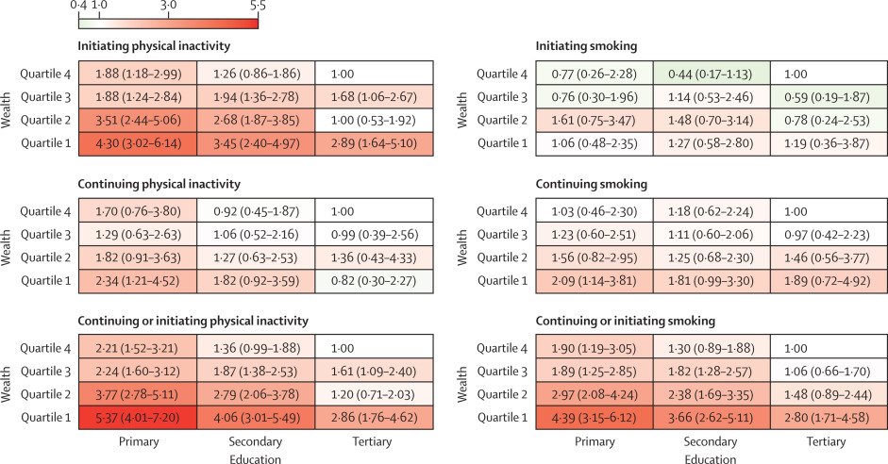
(Behaviour Change Before and After NCD Education, The Lancet Public Health)
Other possible solutions for NCDs reduction can be collaborative action within other organizations. Addressing NCDs requires a coordinated and collaborative effort on a worldwide scale. Governments, international organizations, civil society, and the private division must work together to share best practices, pool resources, and advocate for approaches that prioritize NCD prevention and administration. Activities just like the Worldwide NCD Collusion Gathering and the WHO’s approach to NCDs provide platforms for collaboration and information trade. Promotion efforts can raise awareness around the financial and social impacts of NCDs, mobilizing support for approaches that advance well-being and avoid diseases. Worldwide solidarity is fundamental to stand up to the transnational nature of NCDs and guaranteeing that all communities have access to the resources required for effective anticipation and treatment.
Last but not least, one another possible solution can be made by more data analysis and resoltions. Continued investigate and development are significant within the fight against NCDs. Contributing in research that investigates the genetic, natural, and behavioral determinants of NCDs can lead to a better understanding of hazard variables and potential interventions. Progresses in accuracy in medication and personalized treatments hold promise for more focused on and effective medicines. Additionally, development in technology, such as wearable gadgets for wellbeing checking and telemedicine arrangements, can improve healthcare delivery and enable people to effectively oversee their wellbeing. Support for inquire about teaching, public-private associations, and activities that foster development in healthcare is essential for creating unused devices and methodologies to address the advancing challenges posed by NCDs.

Research Guide
In the own research stand, it is essential to look up for the guideline for delegates on how to engage in further information collection.
The website: Diffit is a good source that delegates are free to find the information and to cater to different reading levels. Use this to simplify your writing if needed. Thus, it is essential to find the country’s stand.

Conducting Research for Preambulatory and Operative Clauses

Preambulatory clauses contain information that can explain the importance of addressing the issue and provide reseasons for the resolution. Thus, it sets the arrangement for the proposed actions within the operative clauses. Operative clauses include the information that recommends the delegates provide possible solutions to address the issue. It outlines the specific steps and policies that delegates can infer: https://www.justia.com/

Research For Understanding of Country’s Stand on the Issue

It is important to understand the country’s stand in making speeches or resolutions. The exploration of public opinion, consideration of domestic factors, and understanding of their national interest can help the understanding of the country’s stand on the issue.

It is essential to look up to the public opinion of the country on a given issue. This can include research about how the country receives the issue. The research can be done through media (news) or articles that contain information about the public reaction.

Consideration of domestic factors might deliberate the data of national income or benefits. Delegates are free to look up the information about the issue.

Bibliography
“About Global Ncds.” Centers for Disease Control and Prevention, Centers for Disease Control and Prevention, 17 Dec. 2021, www.cdc.gov/globalhealth/healthprotection/ncd/global-ncd-overview.html#:~:text=Noncommunicable%20diseases%20(NCDs)%2C%20such,an%20emerging%20global%20health%20threat.
Ballard, Clive and Ian Lang. “Alcohol and Dementia: A Complex Relationship with Potential For Dementia Prevention” The Lancet, Aug. 2022, www.thelancet.com/journals/lanpub/article/PIIS2468-2667(18)30031-8/fulltext.
Burazeri, G. “Burden of Non-Communicable Diseases and Behavioral Risk Factors in Albania.” OUP Academic, Oxford University Press, 30 Sept. 2020, academic.oup.com/eurpub/article/30/Supplement_5/ckaa165.848/5914631?login=false.
“The Burden of Noncommunicable Diseases” - Paho, www.paho.org/en/enlace/burden-noncommunicable-diseases. Accessed 26 Dec. 2023.
“Cell Differentiation Determines the Fate of Cells.” CUSABIO, www.cusabio.com/c-20927.html. Accessed 17 Dec. 2023.
“Chair Report.” Microsoft Sway, sway.office.com/Qt8zr8c01sClU3f8?ref=email. Accessed 16 Aug. 2023.
“Differentiation - Definition and Examples - Biology Online Dictionary.” Biology Articles, Tutorials & Dictionary Online, 11 Apr. 2023, www.biologyonline.com/dictionary/differentiation.
“A Guide to Implementation Research in the Prevention and Control of Noncommunicable Diseases.” World Health Organization, 29 May 2019, knowledge-action-portal.com/en/content/guide-implementation-research-prevention-and-control-noncommunicable-diseases.
“List of Countries by Risk of Death from Non-Communicable Disease.” Wikipedia, Wikimedia Foundation, 14 Sept. 2023, en.wikipedia.org/wiki/List_of_countries_by_risk_of_death_from_non-communicable_disease.
Mahruk Rashidi, et al. “Healthy Life Skills and Related Factors among University Students: A Cross-Sectional Study in Istanbul, Turkey.” BMC, 6 Dec. 2023, www.biomedcentral.com/collections/NCDC.
“Non Communicable Diseases.” World Health Organization, World Health Organization, 16 Sept. 2023, www.who.int/news-room/fact-sheets/detail/noncommunicable-diseases.
“Noncommunicable Diseases.” PAHO/WHO | Pan American Health Organization, Pan American Health Organization , www.paho.org/en/topics/noncommunicable-diseases#:~:text=Chronic%20noncommunicable%20diseases%20(NCDs)%20are,long%2Dterm%20treatment%20and%20care. Accessed 14 Dec. 2023.
“Responding to the Challenge of Non-Communicable Diseases.” UNDP, 16 Oct. 2019, www.undp.org/publications/responding-challenge-non-communicable-diseases?gad_source=1&gclid=EAIaIQobChMItYbYoN-xgwMVGs5MAh0XzgGIEAAYASAAEgJJA_D_BwE.
“Timeline on Global Health Norm Setting on Non-Communicable Diseases.” Knowledge Ecology International, 15 Feb. 2018, www.keionline.org/timelines/ncd.
“What Is Cancer?” National Cancer Institute, 11 Oct. 2021, www.cancer.gov/about-cancer/understanding/what-is-cancer.
Yoon, Jihyun, et al. “The Non-Communicable Disease Burden in Korea: Findings from the 2012 Korean Burden of Disease Study.” Journal of Korean Medical Science, U.S. National Library of Medicine, Nov. 2016, www.ncbi.nlm.nih.gov/pmc/articles/PMC5081297/.

