Forum: General Assembly 1
Issue: Establishing preparedness protocols for epidemics and pandemics
Student Officer: Marcus Wang
Position: Chair of General Assembly 1

Introduction
Establishing preparedness protocols for epidemics and pandemics is of critical importance due to the rapid spread of infectious diseases. As seen in the recent case of the novel coronavirus pandemic, a lack of preparedness can have devastating consequences. Preparedness protocols are essential for health authorities to identify, contain, and respond to the spread of a virus before it becomes a pandemic. For example, protocols might include having proper testing and monitoring in place, providing personal protective equipment to health care workers, and ensuring public education about how to prevent the spread of an infectious disease.
Preparedness measures also help to minimize the economic and social impacts of epidemics and pandemics by providing early warning systems and establishing effective communication strategies. In September 2021, Health Affairs medical journal estimated that between 50,000 and 83,000 COVID-19 deaths in the United States could have been prevented if the country had implemented more stringent social distancing measures one week earlier in March 2020. Further stressing the paramount importance of preparedness protocols as an invaluable tool for protecting public health, reducing mortality rates, and helping to control the spread of infectious diseases.
Although the importance of preparedness protocols to mitigate destructive pandemics and epidemics is clear, such protocols can be exceedingly difficult to formulate, as epidemics and pandemics can be complex and rapidly evolving threats that are difficult to predict and control. It can be challenging to create a protocol that can effectively respond to such complex challenges.

Definition of Key Terms

Epidemic:

An epidemic is a sudden increase in the number of cases of a disease above what is normally expected in a specific geographic area. An epidemic can be limited to a specific community, region, or country, or it can spread to multiple countries or continents. When an epidemic outbreak grows to certain extent, it becomes a pandemic.

Pandemic:

A pandemic is a widespread outbreak of a disease that occurs over a large geographic area and affects an exceptionally high proportion of the population. A pandemic is different from an epidemic, which is a sudden increase in the number of cases of a disease in a specific geographic area.

Disease:

A disease is defined as a condition of the living animal or plant body or of one of its parts that impairs normal functioning and is typically manifested by distinguishing signs and symptoms such as sickness.

Virus:

A virus is a tiny infectious agent that replicates only inside the living cells of an organism. Viruses are much smaller than bacteria and lack the ability to grow or reproduce on their own. Instead, they rely on the host cells to provide the necessary resources for their replication. Some viruses cause disease in humans, such as the common cold, flu, and COVID-19, while others cause disease in plants and animals.

Pandemic preparedness:

The process of preparing for a pandemic, including the development of response plans, the allocation of resources, and the education of the public.

General Overview



Brief history on pandemics and epidemics

The history of pandemics and epidemics dates to ancient times and has had a profound impact on human societies throughout history. Some of the earliest recorded pandemics include the Antonine Plague, which struck the Roman Empire in the 2nd century AD, and the Plague of Justinian, which devastated the Byzantine Empire in the 6th century. In the 14th century, the Black Death, also known as the Bubonic Plague, swept across Europe, killing millions of people, and leading to major social and economic changes.

In the 20th and 21st centuries, several pandemics and epidemics have occurred, including the Spanish Flu, which killed an estimated 50 million people worldwide in 1918-1919, and the H1N1 (Swine Flu) pandemic in 2009-2010. The most recent and ongoing pandemic is the COVID-19 pandemic, which was first identified in Wuhan, China in 2019 and has since spread globally, leading to widespread disruptions to daily life and economies.

Throughout history, pandemics and epidemics have been a constant reminder of the importance of preparedness, early detection, and effective response. They have also highlighted the interconnectedness of populations and the need for global cooperation in addressing public health challenges. Today, advances in technology, communication, and transportation have made it easier for diseases to spread rapidly across borders, making it more important than ever to be prepared for the next pandemic.

General information on pandemics and epidemics

The causes of pandemics and epidemics can be complex and can include the emergence of new viruses, the spread of existing viruses to new populations, changes in the environment that allow the virus to spread more easily, or the breakdown of public health measures. In some cases, pandemics and epidemics are triggered by zoonotic viruses, which are viruses that are transmitted from animals to humans.

The rapid spread of disease during pandemics and epidemics can lead to hospitalizations, deaths, and disruptions to daily life. It can also have significant economic impacts, as people may become too ill to work, businesses may close, and supply chains may be disrupted.

Forms of epidemic and pandemic transmission

Person-to-person transmission: This occurs when an infected person comes into close contact with others and transmits the disease through respiratory droplets, saliva, or other bodily fluids. This is common in diseases such as influenza, tuberculosis, and COVID-19.

Vector-borne transmission: This occurs when a disease is transmitted to humans through the bite of an infected insect, such as mosquitoes. This is common in diseases such as dengue fever, Zika virus, and malaria.

Food-borne transmission: This occurs when a disease is transmitted through contaminated food or water. This is common in diseases such as norovirus, salmonellosis, and E. coli. Animal-to-human transmission: This occurs when an infected animal transmits the disease to humans. This is common in zoonotic diseases, such as avian influenza, SARS, and COVID-19.

Environmental transmission: This occurs when a disease is transmitted through contaminated air, water, or surfaces. This is common in diseases such as Legionnaires' disease and Legionellosis.

Major parties and organizations involved.

World Health Organization (WHO):

The WHO is the leading international organization responsible for coordinating global public health efforts, including the response to pandemics and epidemics. The WHO works closely with member countries to monitor disease outbreaks, provide technical guidance, and coordinate the international response. 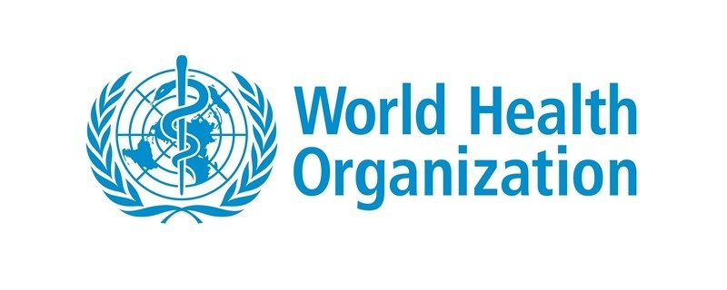

Centers for Disease Control and Prevention (CDC)

The CDC is the leading public health institute in the United States, responsible for protecting the public from health threats, including pandemics and epidemics. The CDC provides surveillance, detection, and response capabilities for infectious diseases in the United States and works closely with other countries and organizations to address global health threats.

National Institute of Allergy and Infectious Diseases (NIAID)

The NIAID is a division of the National Institutes of Health (NIH) in the United States that conducts and supports research on infectious diseases and other immune-mediated illnesses. The NIAID plays a key role in the development of treatments and vaccines for pandemics and epidemics.

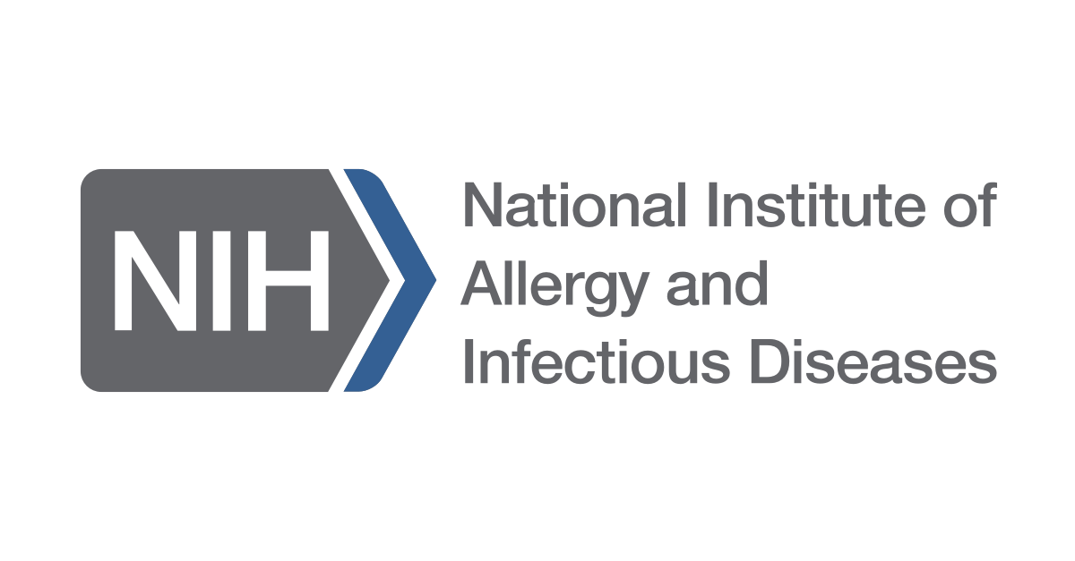

Ministry of Health

Each country has a Ministry of Health that is responsible for addressing public health issues, including pandemics and epidemics, within its borders. The Ministry of Health works with other government agencies and international organizations to monitor disease outbreaks, implement response plans, and coordinate the response to pandemics and epidemics.

Non-Governmental Organizations (NGOs)

NGOs play a critical role in addressing pandemics and epidemics, particularly in low- and middle-income countries. NGOs provide critical health services, including disease detection, treatment, and care for infected individuals, as well as support for communities affected by pandemics and epidemics.

UN involvement, relevant resolutions, treaties, and events

The United Nations have passed multiple resolutions attempting to resolve this issue including but not limited to:

1. UN General Assembly Resolution 70/1: This resolution, passed in September 2015, declared the need for a global response to the Ebola outbreak and called for increased international cooperation and coordination to address future health emergencies.

2. UN General Assembly Resolution 71/1: This resolution, passed in 2016, focused on the need for sustained and coordinated global action to prevent, detect, and respond to future health emergencies, including pandemics and epidemics.

3. World Health Assembly Resolution WHA69.1: This resolution, passed in May 2016, called for increased preparedness and response to health emergencies and endorsed the Global Health Emergency Workforce Strategy.

4. World Health Assembly Resolution WHA72.10: This resolution, passed in May 2019, aimed to enhance global preparedness and response to health emergencies, including pandemics and epidemics, and called for increased investment in preparedness and response efforts.

5. World Health Assembly Resolution WHA74.2: This resolution, passed in May 2021, focused on the ongoing response to the COVID-19 pandemic and called for increased international cooperation and coordination to address the pandemic and prepare for future health emergencies.

- The UN also established the World Health Organization which had its own program that advertised and raised awareness on the issue through the use of TV and other media.

- The UN, through the UNTV and their official site, have been posting videos and information in order to raise awareness on preventive measures

Timeline of Events
Date | Description of event
(430 BC) | Plague of Athens: One of the first recorded pandemics, the Plague of Athens, is believed to have been caused by the bacterium Yersinia pestis. The pandemic is estimated to have killed a significant portion of the population of Athens and neighboring city-states.
(541-542 AD) | Justinian Plague: This pandemic, caused by Yersinia pestis, swept through the Byzantine Empire, and is estimated to have killed up to 50 million people.
(1331-1353) | Black Death: One of the deadliest pandemics in human history, the Black Death, caused by Yersinia pestis, is estimated to have killed up to 200 million people in Europe and Asia.
(1918-1919) | Spanish Flu: A pandemic caused by the H1N1 virus; the Spanish Flu is estimated to have killed 50-100 million people worldwide.
(1981-present) | HIV/AIDS Pandemic: The HIV/AIDS pandemic is caused by the human immunodeficiency virus (HIV) and has affected millions of people worldwide, with an estimated 37 million people living with the virus as of 2021.
(2002-2004) | SARS: A viral respiratory illness caused by the severe acute respiratory syndrome coronavirus (SARS-CoV), the SARS pandemic affected over 8,000 people globally and resulted in over 700 deaths.
(2009-2010) | H1N1 Influenza Pandemic: The H1N1 Influenza Pandemic was caused by a new strain of the H1N1 virus and affected millions of people worldwide.
(2019-present) | COVID-19 Pandemic: The COVID-19 pandemic, caused by the SARS-CoV-2 virus, has affected millions of people globally and resulted in over 100 million confirmed cases and over 2 million deaths as of 2021.

Previous Attempts to Resolve the Issue

1. International Health Regulations (IHR): Adopted by the World Health Organization (WHO) in 2005, the IHR are a set of global rules and standards aimed at enhancing the surveillance and response to public health emergencies of international concern, including pandemics and epidemics.

2. Global Health Security Agenda (GHSA): Launched in 2014, the GHSA is a global partnership aimed at strengthening countries' capacities to prevent, detect, and respond to public health threats, including pandemics and epidemics.

3. Global Health Emergency Workforce Strategy: Adopted by the WHO in 2016, this strategy aims to strengthen the capacity of countries to respond to public health emergencies, including pandemics and epidemics, by developing a skilled, flexible, and well-coordinated health emergency workforce.

4. World Health Assembly Resolution WHA74.2: This resolution, passed in May 2021, focused on the ongoing response to the COVID-19 pandemic and called for increased international cooperation and coordination to address the pandemic and prepare for future health emergencies.

5. Global Preparedness Monitoring Board (GPMB): Established in 2018, the GPMB is an independent body that assesses the state of global preparedness for public health emergencies, including pandemics and epidemics, and makes recommendations to enhance preparedness efforts.

These attempts to resolve the issue of establishing preparedness protocols for pandemics and epidemics demonstrate a continued commitment to improving global preparedness and response efforts. However, ongoing challenges remain, including inadequate funding, limited political commitment, and the need for better coordination and cooperation among countries and international organizations.

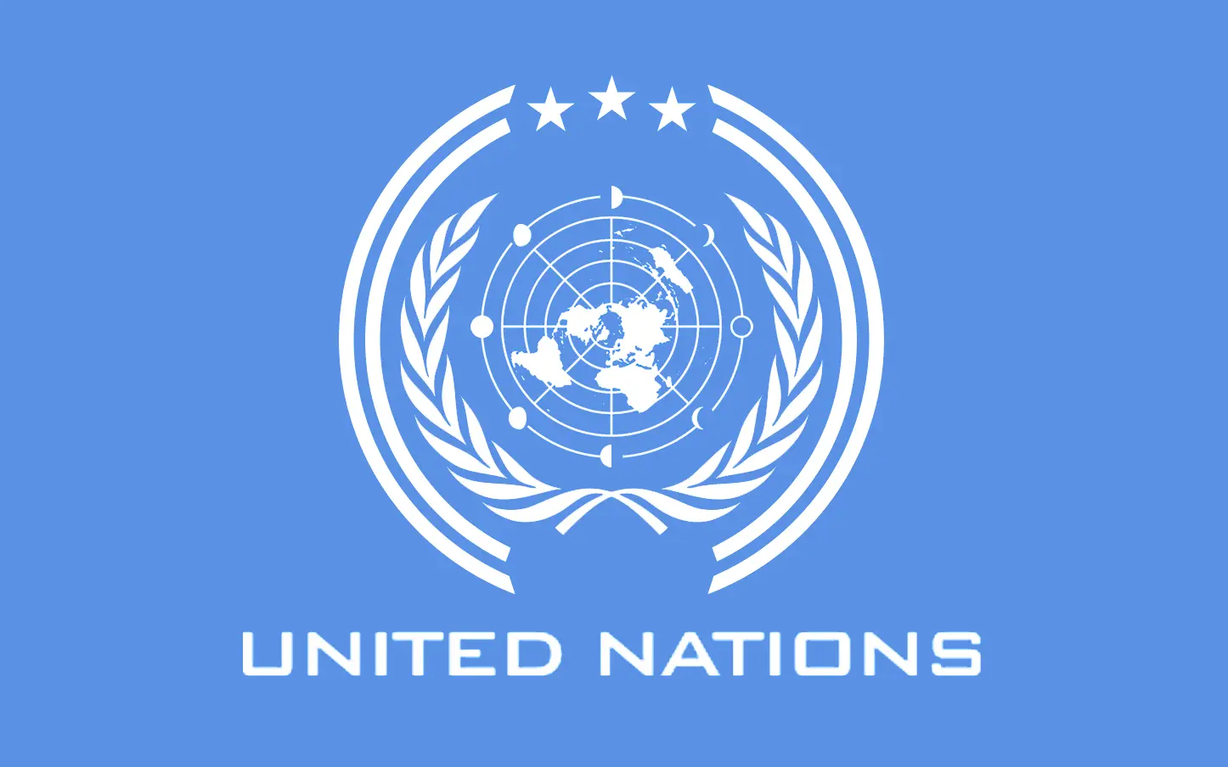

Possible Solutions

1. Develop and regularly update a comprehensive preparedness plan that outlines roles and responsibilities, communication protocols, and specific measures to be taken in the event of an epidemic or pandemic.

One of the most critical steps in establishing preparedness protocols for epidemics and pandemics is to create a comprehensive preparedness plan. This plan should outline roles and responsibilities for all stakeholders involved in the response effort, including healthcare providers, government agencies, and other relevant organizations. The plan should also include communication protocols to ensure that accurate and timely information is shared among stakeholders, as well as clear guidelines for specific measures to be taken in the event of an outbreak. This plan should be regularly updated to reflect new information and changing circumstances.

2. Maintain an adequate stockpile of essential medical supplies and personal protective equipment (PPE), such as masks, gloves, and gowns.

Another critical component of preparedness protocols is to maintain an adequate stockpile of essential medical supplies and PPE. During an epidemic or pandemic, the demand for these items can quickly exceed the available supply, leading to shortages and putting healthcare workers and the public at risk. Having a robust stockpile of these items can help to ensure that they are readily available when needed.

3. Establish and regularly train a dedicated response team that can quickly mobilize and coordinate efforts to contain and manage an outbreak.

A dedicated response team is essential for a rapid and coordinated response to an epidemic or pandemic. This team should be comprised of experts from various fields, including healthcare, public health, and emergency management. They should be trained regularly on the latest outbreak response protocols, communication strategies, and the proper use of PPE.

4. Implement surveillance systems to monitor and detect outbreaks early, allowing for prompt responses and interventions.

Early detection of outbreaks is critical for containing and managing their spread. Implementing surveillance systems can help to identify outbreaks early and provide important data to inform the response effort. These systems can include monitoring of disease trends, laboratory testing, and syndromic surveillance.

5. Educate the public on basic hygiene practices, such as handwashing and cough etiquette, and promote vaccination programs.

Education of the public is critical in preventing the spread of infectious diseases. Public health campaigns should emphasize the importance of basic hygiene practices, such as handwashing and cough etiquette, and promote vaccination programs to prevent the spread of diseases.

6. Work with international partners to share information and coordinate responses across borders, recognizing that infectious diseases are a global threat.

Infectious diseases do not respect national borders, and a coordinated response across countries is essential for effective epidemic and pandemic preparedness. International partnerships can help to share information on disease trends and outbreaks, coordinate response efforts, and share best practices for outbreak management. By working together, the global community can help to prevent and mitigate the impact of infectious diseases.

Bibliography
- Center for Disease Control and Prevention. “Pandemics.” CDC, Centers for Disease Control and Prevention, 8 Jan. 2019, https://www.cdc.gov/pandemic-preparedness/index.html.
2. Centers for Disease Control and Prevention. “Preparedness 101: Zombie Apocalypse.” CDC, Centers for Disease Control and Prevention, 8 Jan. 2019, https://www.cdc.gov/cpr/zombie/index.html.
3. World Health Organization. “Pandemic Influenza Preparedness and Response.” WHO, World Health Organization, 24 Apr. 2019, https://www.who.int/influenza/pandemic-preparedness/en/.
4. World Health Organization. “Emergency Preparedness, Response.” WHO, World Health Organization, 24 Apr. 2019, http://www.who.int/about/emergency-preparedness-response/en/.
5. National Health Security Preparedness Index. “National Health Security Preparedness Index.” The Robert Wood Johnson Foundation, Robert Wood Johnson Foundation, May 2017, http://www.nhspi.org/
6. Centers for Disease Control and Prevention. “Public Health Preparedness Capabilities: National Standards for State and Local Planning.” CDC, Centers for Disease Control and Prevention, 22 June 2017, https://www.cdc.gov/phpr/publichealthsystem/pns.htm.
7. Global Health Security Agenda. “Global Health Security Agenda (GHSA).” GHSA, Global Health Security Agenda, https://www.ghsagenda.org/.
8. Al-Ghamdi, Abdulaziz et al. “Pandemic Preparedness: Challenges and Opportunities.” Research Square, American Association for the Advancement of Science, 5 May 2019, https://www.researchsquare.com/article/rs-41809/v1.
9. Centers for Disease Control and Prevention. “Public Health Preparedness and Response.” CDC, Centers for Disease Control and Prevention, 4 Apr. 2019,
10. Huremović, Damir. “Brief History of Pandemics (Pandemics throughout History).” Psychiatry of Pandemics, 2019, pp. 7–35, 10.1007/978-3-030-15346-5_2.

